3D Modelling Techniques
Please use these words to describe a modelling technique the word in brackets is the word that is associated with Inventor only.
- Loft
- Extrusion along a path (sweep)
- Helix (Coil)
- Extrude Union (extrude join)
- Extrude Subtraction (extrude cut)
- Extrude Intersection (extrude intersect)
- Revolve

3D Modelling Edits
Please use these terms for any edit that you make to the technique applied.
- Chamfer
- Fillet
- Mirror
- Circular/Rectanguar Array (pattern)
- Thread
- Shell
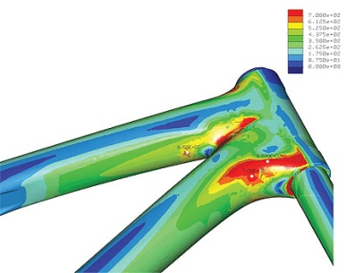
3D Modelling Uses
3. a. example of FEA
- CADCAM – Computer controlled manufacture of poducts
- Simulation – Training AND Predicting
- Testing – Stress testing of material when pressure/loads applied
  - FEA – Finite Element Analysis
Sectional Views
You must be able to identify and explain the purposes of the various sectional views listed:
- Section
- Part/Local
- Half
- Stepped
- Revolved
- Removed

DTP
Some unfamiliar explanations that you must know are:
Crop Marks – The lines that identify where the page is to be cut once printed. Also identifies and Bleeds or partial Bleeds
Registration Marks – A mark that allows colours to line up so you know that the page is correctly aligned within the printer to prevent the images, coloured areas becoming fuzzy.
CMYK – Cyan, Magenta, Yellow and Black reference to the make-up of the colour you finally see.
Leading – The distance between two lines of text. If your page has a small leading your page will be dark in tone to lighten your page increase the leading so the lines are spaced out more lowering the intensity of the body text.
Kerning – Kerning is the spacing between letters. If the kerning is low the letters will be closer together ie the FedEx logo, a very powerful image however it can sometimes blend words and make unusual words, normally rude.
Digital Rights – The ownership of the image. How can you access an image legally when someone else owns the image?
Watermark - The transparent copyright or business name across imagery that belongs to someone else.
Stock Imagery - A bank of images that a company has produced. These are generally owned by a company and you must pay to use these in your work.
Vector Image – An image that uses mathematical formulas when resized. This ensures that the user has a high quality image that is more flexible than a bit map. It also requires less memory space than a bit map.
Bitmap/Raster Image - An image that is made up of pixels. When this is resized it can lose quality and you begin to see the blocky squares of the pixel.
Edge to Edge printing - A colour that exceeds the boundaries of the page resulting in a full coloured background.
Partial Bleed – When a page has a bleed that does not exceed all of the page boundaries.

