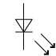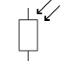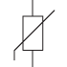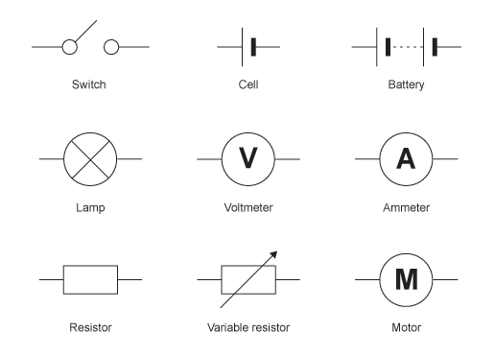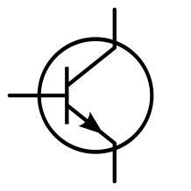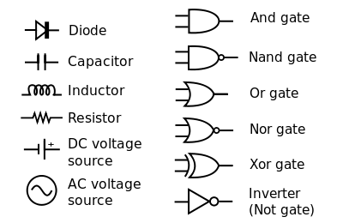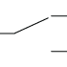

**National 5 Engineering Science**

**Homework 4**

**Electrical and Electronic Symbols**

Write the name of the component each symbol represents.

**9 marks**