S3 Design and Manufacture
WOOD JOINTS HOMEWORK
- Name the following woodwork Joints
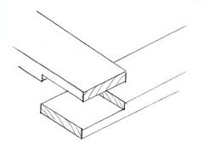
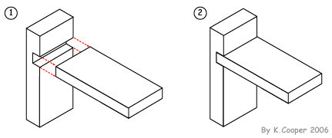
a b.
.

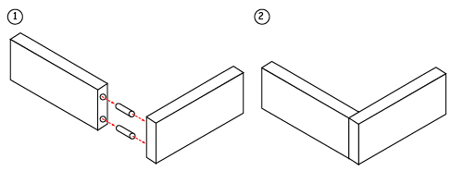
c.

3 Marks

- Name a suitable joining technique for the following pieces of furniture
- Joining the rails to the legs of a chair

- The joint to secure the shelves in a bookcase

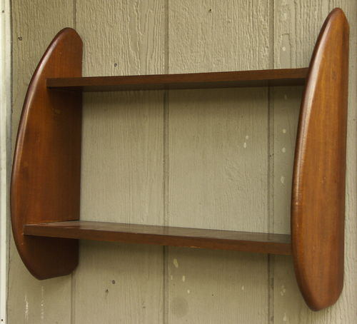

2 Marks

