Name: Class: Teacher:
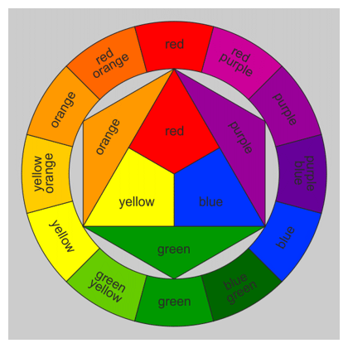
The image below is a colour wheel. It explains how each of the colours we see in our day to day lives are created. The centre of the colour wheel has our primary colours, with these 3 colours a wide variation of colours can be mixed.
1. Name the three primary colours:
1.________________ ______
2. ______________________
3. ______________________

2. Is it possible to produce the primary colours by mixing colours?
______________________________________________________________________________________________________________________________________________________

3. Complete the table below by adding the missing colours.
YELLOW | + |  | = | GREEN
BLUE | + | RED | =
 | + | YELLOW | = | ORANGE

4. What are secondary colours?
______________________________________________________________________________________________________________________________________________________
5. What is your favourite colour? And Why do you like it?
______________________________________________________________________________________________________________________________________________________
6. If you wanted to make something stand out what colours would you use?
1.______________ 2. ___________________ 3. __________________

