National 5 Engineering Science (Prelim Revision) Logic Gates
Q1a). Complete the truth table for the following circuit.
b) Provide the boolean expression for the circuit

Q2a). Complete the truth table for the following circuit.
b) Provide the boolean expression for the circuit

Q3a) Using logic gates draw the circuit for the following problem
b) Draw a truth table for the electronic system shown below
c) Describe a sitaution in which the electronic sytem could be used
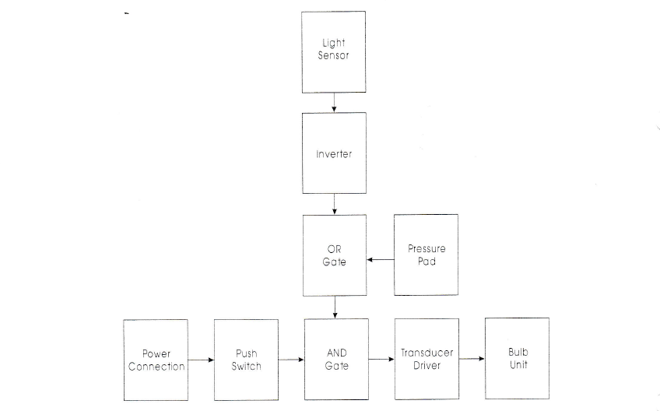

Q4a) Draw up a truth table for the circuit below and complete the boolean expression

b) Draw up a truth table for the circuit below and complete the boolean expression

c) Draw up a truth teble for the following circuit below and complete the boolean expression

d) Draw up a truth table for the following circuit below and complete the Boolean expression

