- Two chairs are shown below.
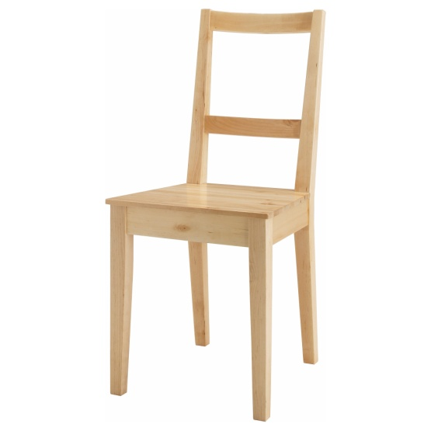
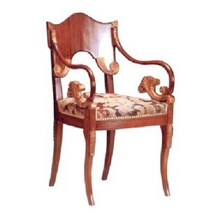

Chair A – solid mahogany with a carved details Chair B – solid pine

- Why is chair B easier to mass produce than Chair A?

- Chair B is made of pine from a sustainable source. Explain what is meant by a ‘sustainable source’.

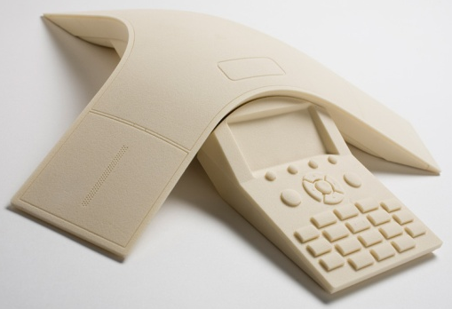
- A rapid prototype model is shown below.

- State two advantages of modelling ideas instead of sketching.

- You have been asked to design a new domestic kettle. Give two benefits of using each of the following types of model during the design process:

    - CAD model
    - Sketch model
    - Appearance model
    - Rapid prototype model

- A Smart car designed for the city is shown below.
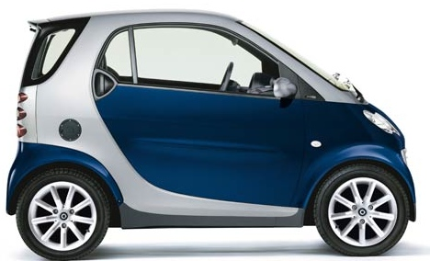

- The body panels are made from a thermoplastic material.
    - State what is meant by the term “thermoplastic”.
    - State a suitable thermoplastic that could be used for the body panels.
    - State two properties of a thermoplastic that make it a good choice of material for body panels.

- The body panels were manufactured through the process of injection moulding. Give three reasons why injection moulding is a suitable process to manufacture the panels.

- The car was designed to be environmentally friendly. Give two reasons why you think the car could be classed as ‘environmentally friendly’.
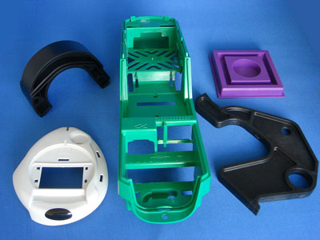

- (a) These plastic components above have been manufactured by injection moulding.
Describe the following features that would be found on a product that has been injection moulded:
- Injection point
- Webs
- Ejector marks
(b) Initial ‘set up’ costs for injection moulding can be very high. State two of the costs in the initial ‘set up’ for injection moulding.
(c) Despite these initial ‘set up’ costs, injection moulding is still regarded as a ‘cheap’ production method for producing plastic products. Give two reasons for this.
- State the name of one thermo plastic suitable for injection moulding.

1. A modern kettle is shown below.
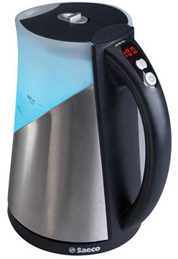

- How has the design of this kettle been influenced by the following areas of ergonomics:
    - Physiology
    - Psychology
    - Anthropometrics
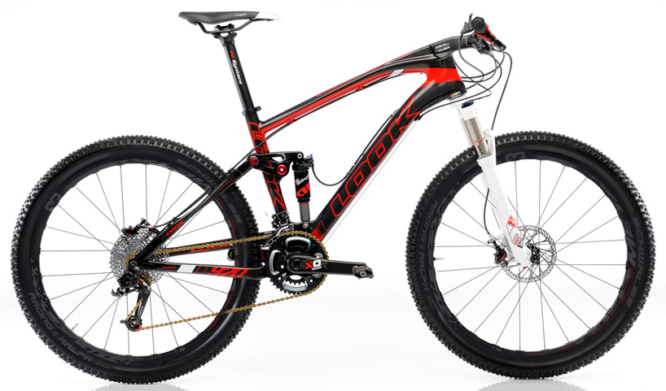
2. The mountain bike shown below is made of aluminium.

- During the design of the mountain bike the designer considered using steel for the frame.
    - Give two possible reasons why steel was rejected as a material for the frame.
    - Give two possible reasons why aluminium was selected as the material for the frame.
    - Suggest a permanent joining technique that could have been used to join each section of the frame together?

- Describe the aesthetics of the bike and explain why they are effective for a mountain bike.
3. A modern tennis racket is shown below.

The racket is to be evaluated in order to investigate ergonomics, aesthetics, value for money and durability. Which of the following research methods could be used to evaluate each of these four design factors:
Test rig / User trial / product comparison / questionnaire

