1. The metal casing of a bicycle pump shown below has been manufactured using the process of extrusion.

(a) (i) Sketch and label the equipment used for extruding metal. 2
(ii) Describe the process of extruding metal. 1
(b) (i) State the name of a metal that could be used for extrusion. 1
(ii) Explain why the material chosen in (b)(i) is suited to the manufacture of this product. 2

The casing of the pump could have been made from extruded polypropylene instead of metal.

(c) State the effect on the design of the component if the designer had chosen polypropylene instead of metal. 1
(8)

2. Sand Casting and Die Casting are two manufacturing processes that use similar materials.

(a) Use annotated sketches to describe both processes. 3,3
(b) State a product that could be made by sand casting and explain
why it is suited to this manufacturing process. 2
(c) State a product that could be made by die casting and explain
why it is suited to this manufacturing process. 2

3. The handle lid for a teapot is shown below. The designer has the choice between two manufacturing processes for this component:
- Pressure die casting
Or
- CNC Turning
Lid Assembly
Lid Handle
Teapot Lid Handle
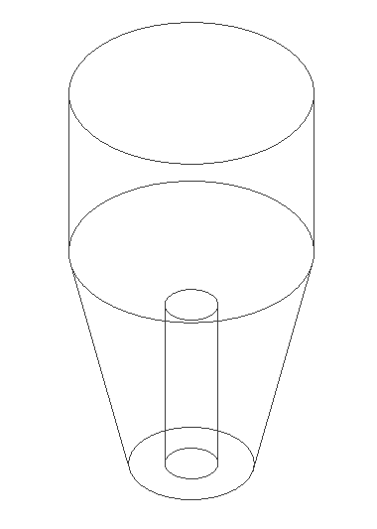
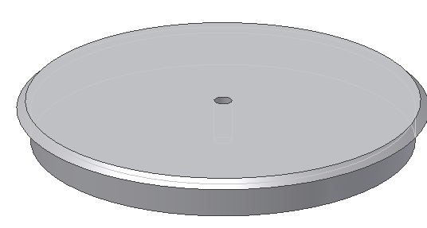
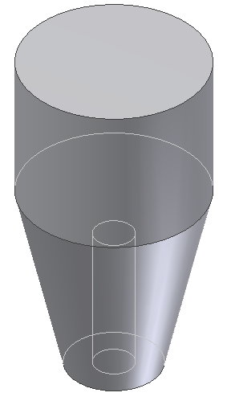
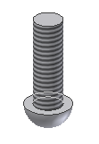
Threaded Hole
Underneath

Lid

Screw

(a) Describe, with the aid of sketches, each of the above processes 4,4
(b) Select one of the processes and justify why it would have been suitable for the manufacture of the lid handle. 4
(12)

