Higher Product Design
Homework 8
Plastic Processes 2

- A plastic bottle and lid for use on a bicycle is shown below.
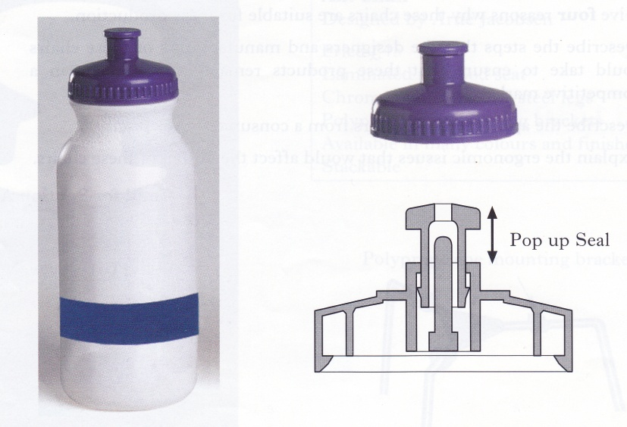

The bottle was manufactured by the process of blow moulding and the lid components were manufactured by the process of injection moulding.

- Justify why each of these two processes was used to manufacture theses components.
4 marks
- State and justify a plastic that could be used for the bottle or cap 2 marks
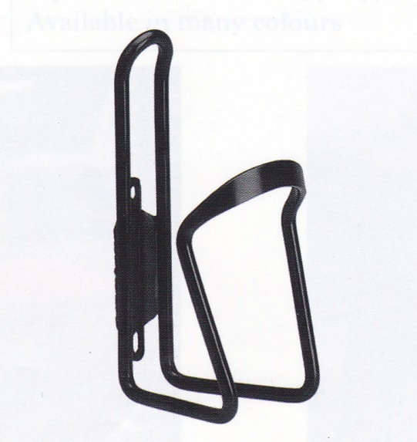

The bottle is held onto a bicycle frame in the bottle cage shown below.

- Describe the issues that the designer would have to consider when designing the bottle cage. 2 marks

Total Marks 8 marks

- The camera shown has been manufactured for a well known company. The casing of the camera has been made by injection moulding ABS plastic.

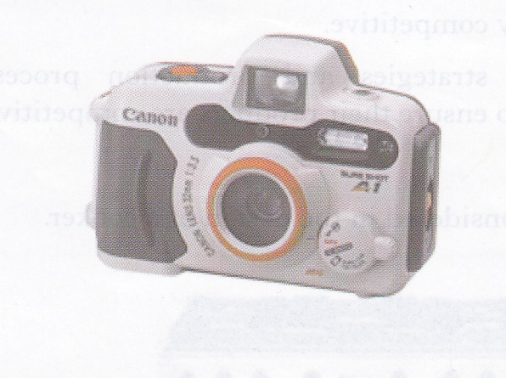
- Describe two benefits of using this process to manufacture the camera casing. 2 marks

- Give two characteristics of ABS that make it a suitable material for the camera casing 2 marks

Total Marks 4 marks

- Vacuum forming and injection moulding processes were used to manufacture the containers shown below.

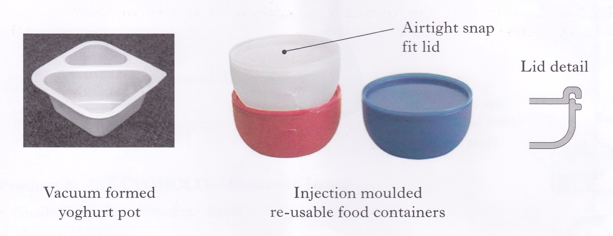

- Explain why these processes are suitable for each container shown.
4 marks

- What visual evidence would indicate whether a product had been injection moulded or vacuum formed? 2 marks
- State a suitable plastic for each process. 2 marks

Total Marks 8 marks

