Strip Heater  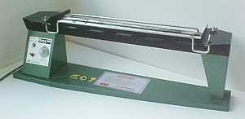  Explain the steps involved in using the strip heater and explain where in a day to day real life product strip heater would be used.  5 marks | 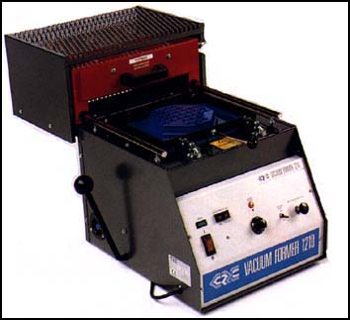  Vacuum Former  Explain the steps involved in using the vacuum former and explain where in a day to day real life product strip heater would be used.  5 marks | Plastic Oven  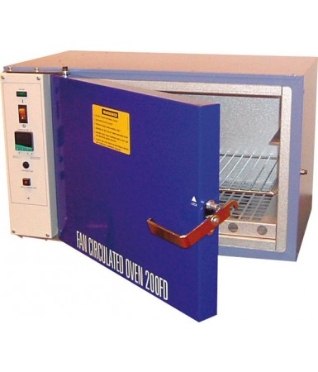  Explain the steps involved in using the plastic oven and explain where in a day to day real life product strip heater would be used.  5 marks
Explain suitable safety equipment that should be used when using machinery that involves heat treatment.
3 marks

