St. Machar Academy
Homework 6
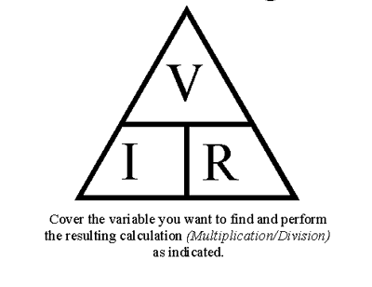
Ohms Law and Power
V = IR
I =V/R
R =V/I
Ohm's law states that the current through a conductor between two points is directly
proportional to the voltage across the two
points, and inversely proportional to the
resistance between them.

- The resistance in the circuit below was 220Ω and the voltage was 6 volts. Calculate the current (I). Answer in the box provided.

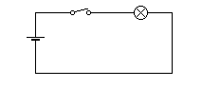
6V

- Calculate the resistance in a circuit which has a voltage of 6 Volts and the current is 0.06 amps. Answer in the box provided.

- Calculate the voltage in a circuit if the resistance was 24 Ω and the current is 0.5 amps. Answer in the box provided.

The power in an electric circuit depends both on the amount of current (I) flowing and the voltage (V) applied. To calculate the power in a circuit you can use the following rule.

P= IV

- a) Calculate the current in a circuit. The resistance in the circuit is 12 Ω and the voltage is 6 volts. Answer in the box provided.

- b) Using the information in part (a). Calculate the power in the electric circuit the answer will be in Watts. Answer in the box provided.

