St. Machar Academy
Homework 3
Logic Gates 2
Complete the truth tables for the circuits below.

A | B | C | Z
0 | 0
0 | 1
1 | 0
1 | 1
- Complete the truth table for the circuit below.
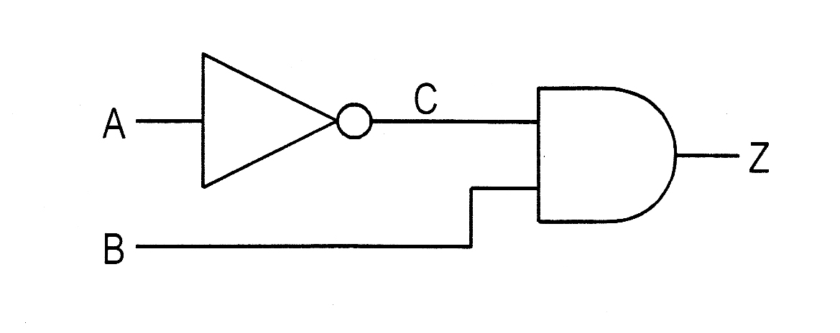

- Complete the truth table for the circuit below.
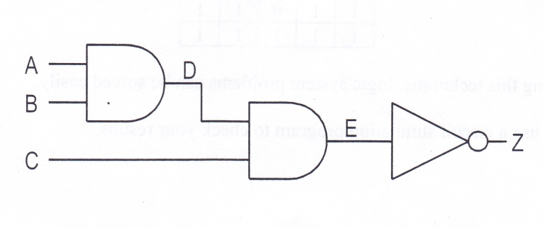
A | B | C | D | E | Z
0 | 0 | 0
0 | 0 | 1
0 | 1 | 0
0 | 1 | 1
1 | 0 | 0
1 | 0 | 1
1 | 1 | 0
1 | 1 | 1

- Complete the truth table for the circuit below.

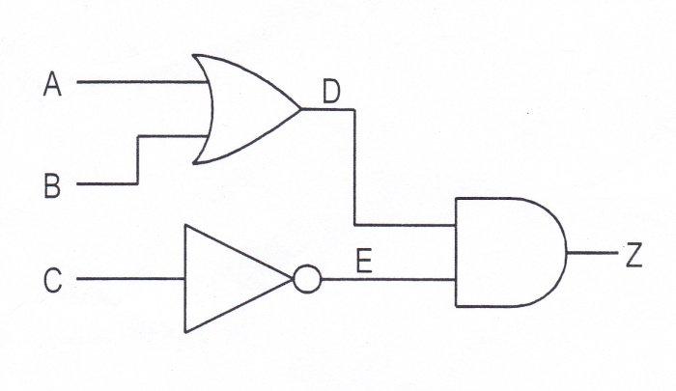
A | B | C | D | E | Z
0 | 0 | 0
0 | 0 | 1
0 | 1 | 0
0 | 1 | 1
1 | 0 | 0
1 | 0 | 1
1 | 1 | 0
1 | 1 | 1

Name: Class:

