Higher Graphics: DTP Homework, Producing a Layout

Task
On the page below you have been given the component parts to a promotional graphic. On an A4 word document (landscape or Portrait) you must produce a promotional a graphic for the release of the new Lego movie on DVD and various games console formats.

You must make use of all text and graphics but you do not have to use any/all of the colour fills provided. You will need to manipulate the text and graphics in order to produce an effective graphic layout that has both visual impact and clarity.

You must justify your layout by making reference to design principles, elements and features. This can be written up on the page after your A4 layout.

You should not print your completed layout. Please hand your work in on USB pen drive.

The greatest movie ever assembled

Own it on Blu-Ray and DVD now!

Also available on the following games consoles

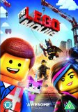
The Lego Movie

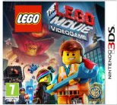
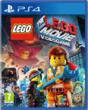
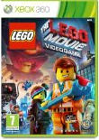
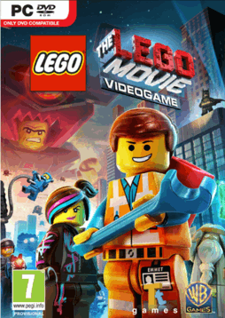
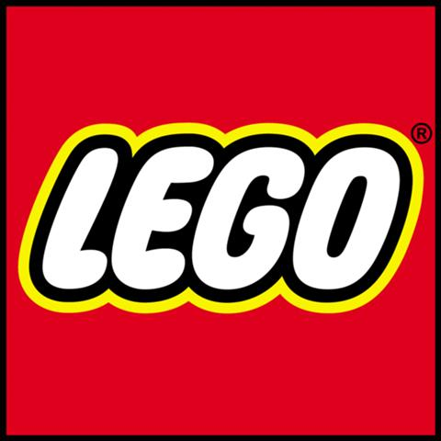
www.thelegomovie.com

