National 5 Engineering Science
Homework 3 – Analogue Circuits and Components
- What is the full names of the following a) A.C. b) D.C.

- What does Potential Difference mean when we are measuring voltage?

- What is the function of the following input devices:

- Light Dependent Resistor (LDR) b) A Thermistor

- Explain the operation of a Transistor?

- Explain what a relay does?

- A diode allows current to flow in two directions. Tick the box you think is correct

TRUE FALSE

- When measuring Amperes (A) using a multimeter do we measure the circuit in Parallel or Series ?

- What are the names given to the circuits shown below?
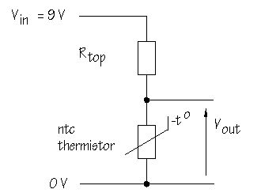
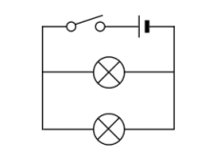

14 Marks
Name :

