For each of the following DTP promotional graphics identify the target audience and justify how design principles have been used to make them suitable for that market.
(a) (b)

(c)

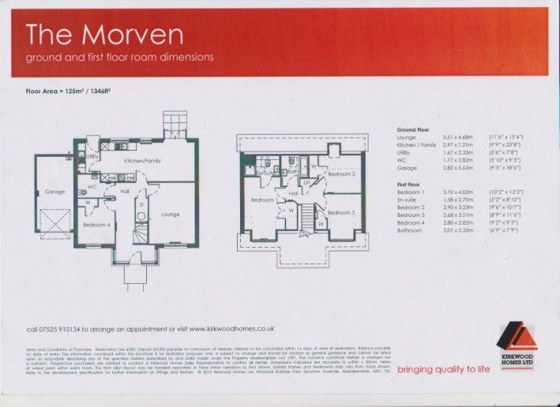
(d)

4 marks are awarded for each of the promotional graphics (a) – (d).

