**National 5 Engineering Science**

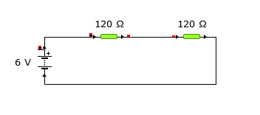 **Homework – Series and Parallel Circuits**

1. Calculate the total resistance and current of the circuit shown

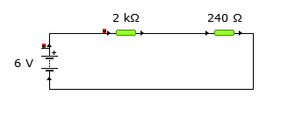

1. Calculate the total resistance and current of the circuit shown

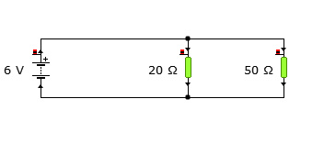

1. Calculate the total resistance of the circuit shown and the current at the point indicated.

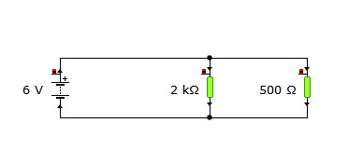

1. Calculate the total resistance of the circuit and the current at the three places indicated.

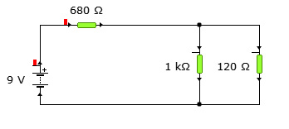

1. Calculate the total resistance of the circuit and the current at the three places indicated.

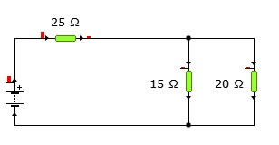

1. Calculate the total resistance of the circuit and the voltage of the battery. The current at the point indicated is 250mA or 0.25A