Identify 3 types of technology used to support the production of technical graphics and design process. Evaluate how they contribute to ensuring the technical graphics effectively and efficiently meet the needs of the Design Team:

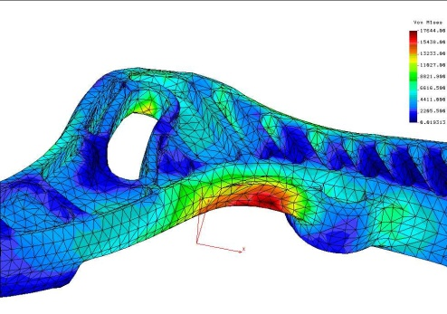
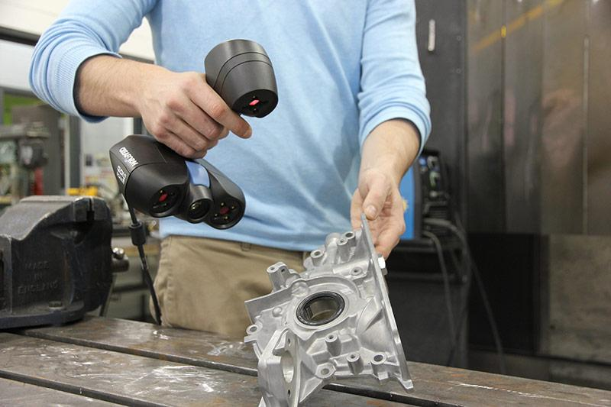

You should:

- Identify 3 types of technology used in the design process.
- Produce a presentation that identifies each technology identified and how it supports the production of technical graphics and the design process.
- Create a report with images that that identifies each technology identified and how it supports the production of technical graphics and the design process.

For example you may want to consider 3D Scanning to create graphic models for example production purposes, CAD modelling, creating animations or simulations. You can discuss personal experiences.

