St. Machar Academy
Homework 5
Types of Motion
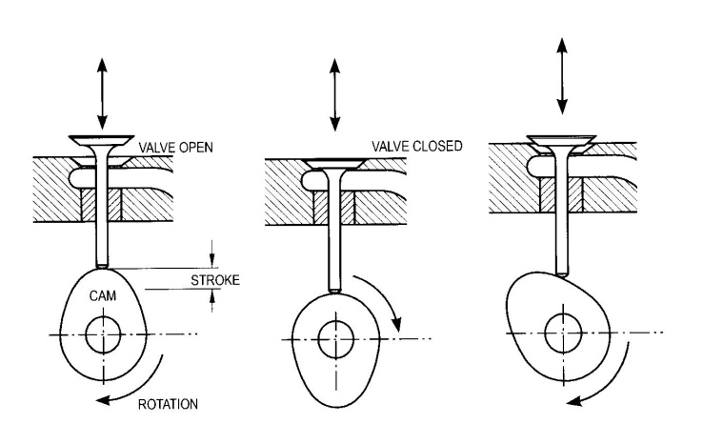
All the images below show various types of motion write in the box provided the type of motion produced

Input Motion

Output Motion
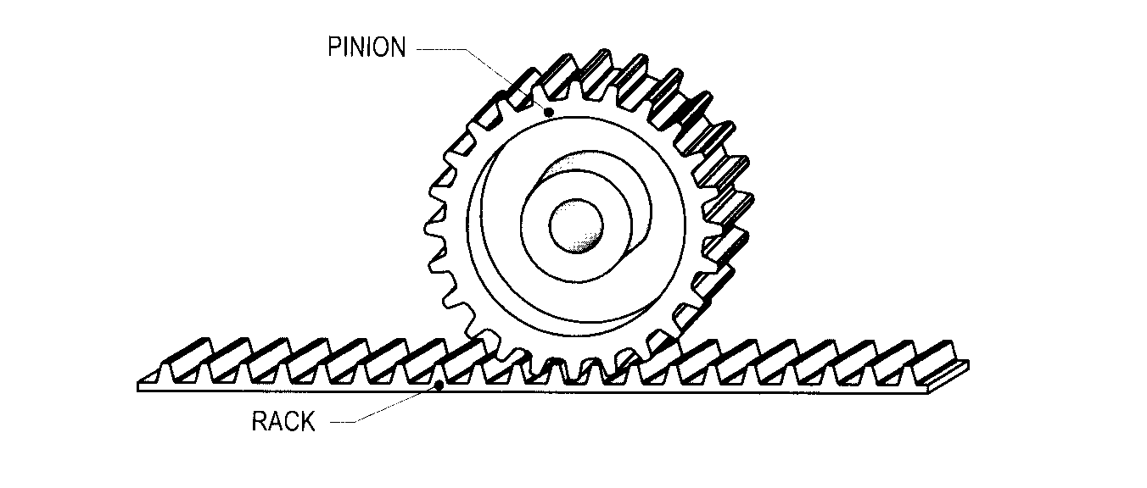

Input Motion

Output Motion
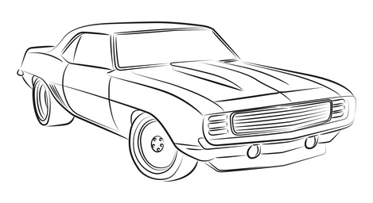

Motion of the Car
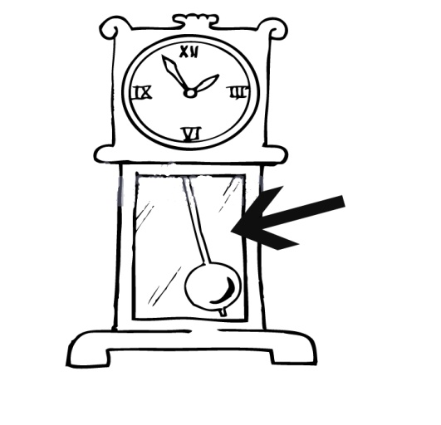

Motion of the Pendulum
Pendulum

TOTAL MARKS 6

Four Types of Motion

