Advanced Higher Product Design
Homework
The Designer and Their Products

Every decade has a number of key designers recognised for their products and/or style.

Identify a designer from a period of your choice and explain how they have influenced the design of products.

You should make reference to the following when answering the question:

• Your chosen designer’s motivation, design ideals and philosophy.

• Products, projects or work that exemplifies your designer’s contribution to design.

• The key features that identify your designer’s products or style.

• How your chosen designer’s work was influenced by external factors.

• The impact of your designer’s work on consumers’ lifestyles and the work of other designers.

Here are a list of Designers you can choose from:
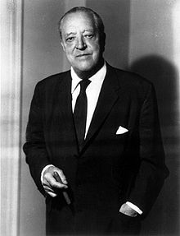  - Ludwig Mies Van de Rohe 1886 -1969 | - Phillippe Stark 1949-
- Jonathan Ive 1967 - | 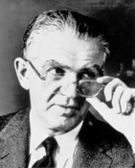  - Henry Dreyfus 1904 - 1972
- William Morris 1834 - 1896  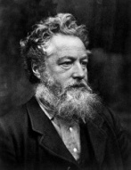 | - Charles Eames 1907 - 1978
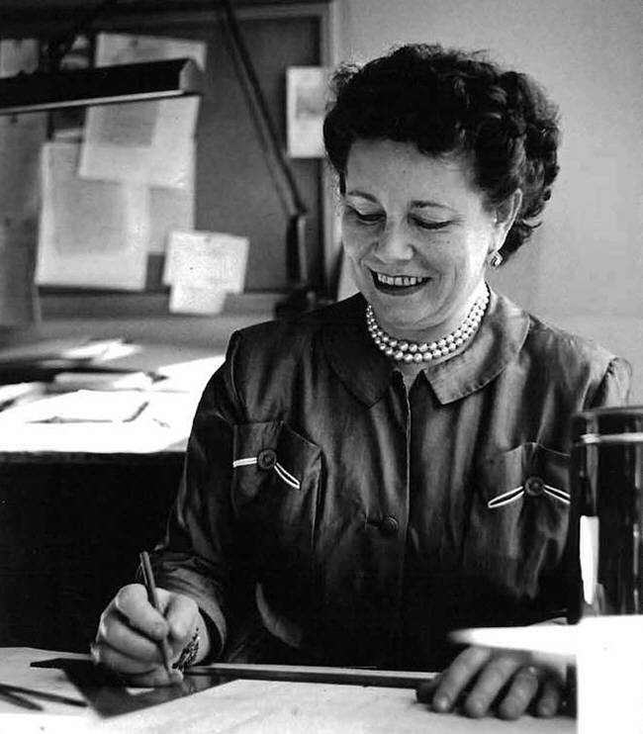  - Belle Kogan 1902 - 2000 | 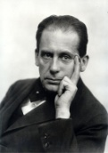  - Walter Gropius 1883 - 1969
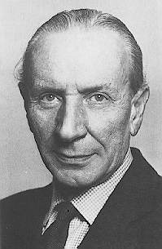  - Alec Issigonis 1906 - 1988 | - Nicole Rouillac
- James Dyson 1947 - | - Richard Sapper 1932 -

10 Marks

