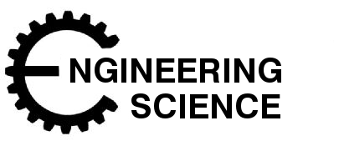

**Structures**

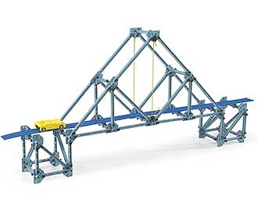

**Introduction**

In this section of work you will be learning about different types of structures. Structures are all around us and can be seen in different shapes and sizes.

*Structures can be Manmade or Natural*.

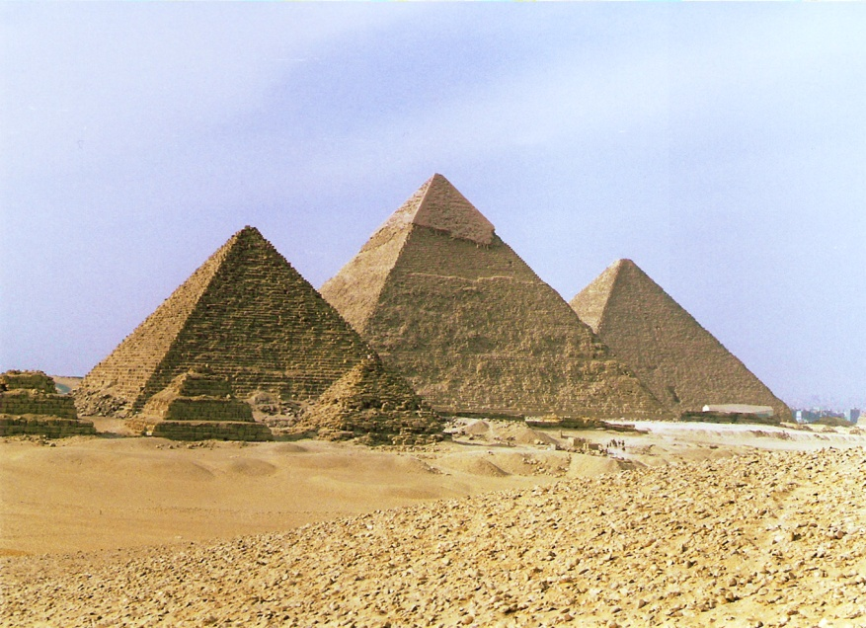Manmade Structure s

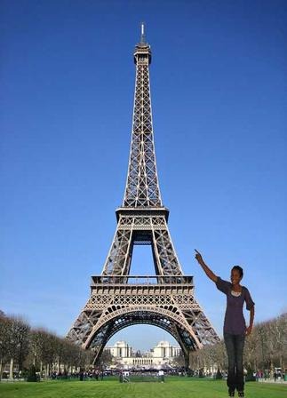

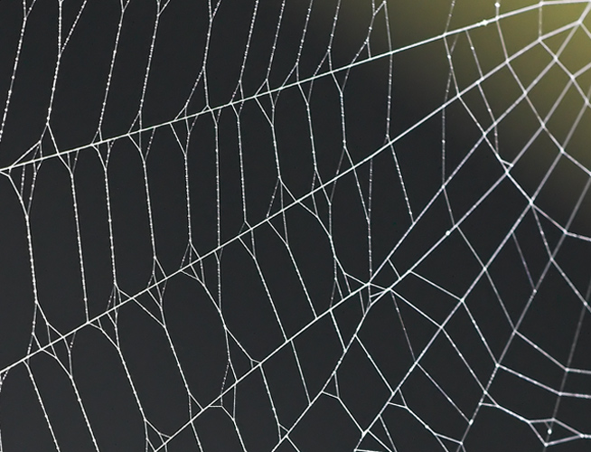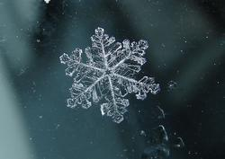Natural Structures

**Solid, Frame, Shell**

There are three main types of structures; Solid, Frame and Shell. The three items below are examples of Solid, Frame and Shell structures.

j0329263

tn00051_

fd00232_

The structure of a Clock Tower is an example of a Solid structure. The bricks are a **solid** concrete material.

The milk carton is an example of a **shell** structure because it is hollow on the inside.

The bridge is an example of a **frame** structure. The metal beams are built up in frames and attached together to span the river.

Structures must all carry weight: the weight of themselves first and the weight of what else they need to carry.

**Structures also help us by doing four main jobs.**

* **Support**
* **Span**
* **Protect**
* **Contain**

## Task 1

Look at four of the structures again.

j0391412Copy and complete the sentences below, using the four words stated above.

The walls of a house hold up the roof.

They \_\_\_\_\_\_\_\_\_\_\_\_ the roof.

The bridge carries traffic across a river or a valley.

j0233641j0290768It \_\_\_\_\_\_\_\_\_\_\_\_\_\_\_the gap.

The can is filled with coca cola.

It \_\_\_\_\_\_\_\_\_\_\_\_\_\_\_the liquid.

The egg box holds a number of eggs which break easily.

j0215943It \_\_\_\_\_\_\_\_\_\_\_\_\_\_\_ the eggs from damage.

**Task 2**

Complete the table below. The first one is completed for you.

|  |  |  |  |  |  |  |  |  |  |
| --- | --- | --- | --- | --- | --- | --- | --- | --- | --- |
| **Structure** | **Man-made** | **Natural** | **Support** | **Span** | **Contain** | **Protect** | **Solid** | **Frame** | **Shell** |
| **Coke can** | ✓ |  | ✓ |  | ✓ |  |  |  | ✓ |
| **Feather** |  |  |  |  |  |  |  |  |  |
| **Bookcase** |  |  |  |  |  |  |  |  |  |
| **Water Bottle** |  |  |  |  |  |  |  |  |  |
| **Eifel Tower** |  |  |  |  |  |  |  |  |  |
| **Car** |  |  |  |  |  |  |  |  |  |
| **Construction Crane** |  |  |  |  |  |  |  |  |  |
| **Skeleton** |  |  |  |  |  |  |  |  |  |

**Triangulation**

In order to build a structure engineers have to consider the best method to use.

When building a bridge there are similarities to building a tower but there are also structural differences.

Triangulation is often used in structures to strengthen it.

**Member**

**Node**

When a structure uses beams that connect together the beams are called **Members** and the connection points are called **Nodes**.

Ties are members in

Tension

Tie

Strut

Struts are members in Compression

Push

**Forces in Tension and Compression**

***Struts and Ties***

When a force is applied to a structure then some members are in compression and some are in tension.

**Task 3**

Use the fischer technik equipment to test out the structures shown by your teacher. Which shape(s) work best?

**Structures and forces**

There are 5 ways in which force can act on parts of a structure:

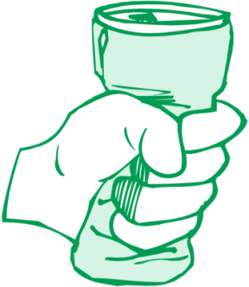1. **Compression**. When a member is being pushed at either end it is said to be in compression.

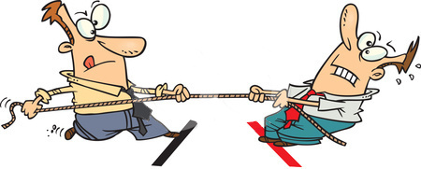2. **Tension**. When a member is being pulled at either end it is said to be in tension. Members which are in tension are known as ties.

3. **Torsion**. Torque is a twisting effort applied to an object that tends to make the object turn about its axis of rotation. A member being intentional rotated under torque is

called a shaft.

4. **Bending**. When a load is applied such that one side gets longer (in tension) and the other side gets shorter (in compression) then the member is said to be in bending.

A member in bending can be called a ***beam***.

Bending **down** the way is called ***sagging***.

Bending **up** the way is called ***hogging***.

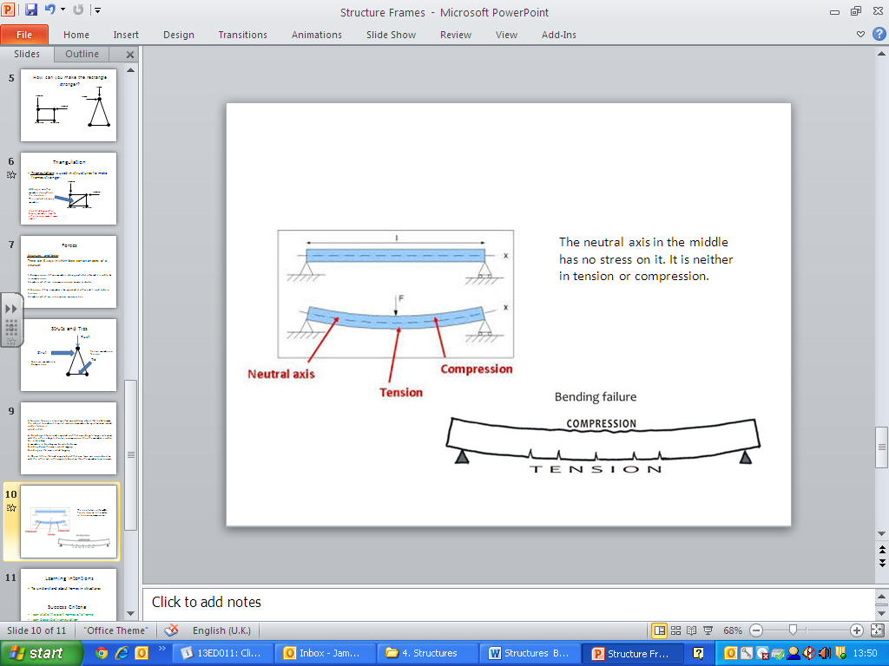

When a beam fails it will crack from the amount of force applied on it.

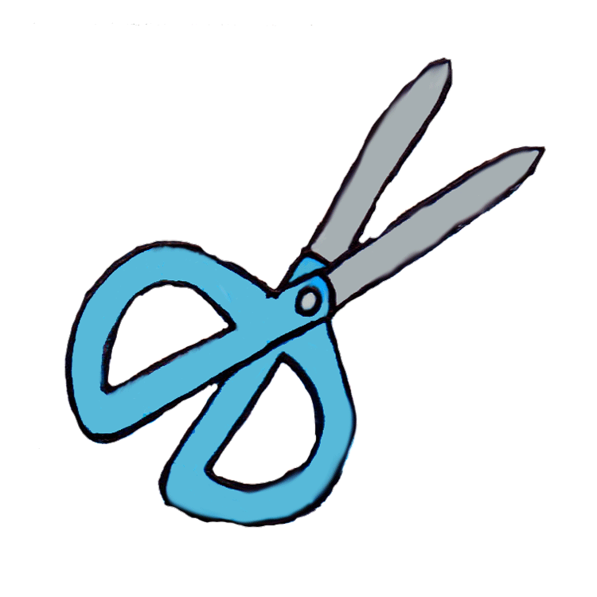5. **Shear**. When a load is applied such that one force acts in one direction and the other acts in the opposite direction then the member tears or cracks.

**Tower Building**

**Task 4**

Plan and build a tower structure using the sheets your teacher provides and the knowledge you have just gained.

**Principle of Moments**

***Free body diagram***

This is an example of a free body diagram showing a class experiment.

Metal Bar

4N

Goggles

0.5N

Masking Tape

1N

150mm

50mm

?

In the experiment the pupil conducting it forgot to write down the distance away from the fulcrum for the metal bar.

However there is enough information provided to calculate it using the principle of moments.

**Σ clockwise moments = Σ anticlockwise moments**

**(principle of moments)**

*Note: One side must equal the other*

Before we work out the more complicated equation we will try a simplified equation.

One way of thinking of the moments equation is to think of it as

**Force x distance=force x distance**

Force is measured in ***Newtons.***

Distance is measure in ***metres.***

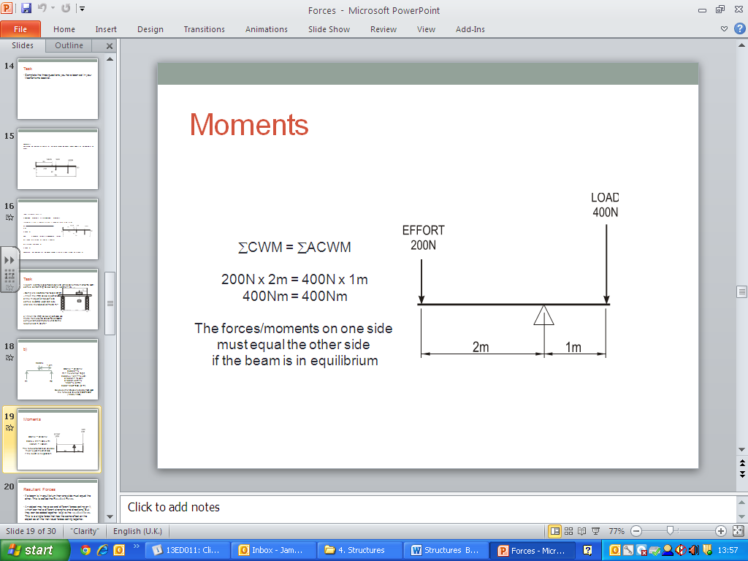Here is a simple equation to show how this is completed.

When you have more than one force on a side then you add the two together. Make sure that you calculate the distance away from the fulcrum when doing this.

Here is another example

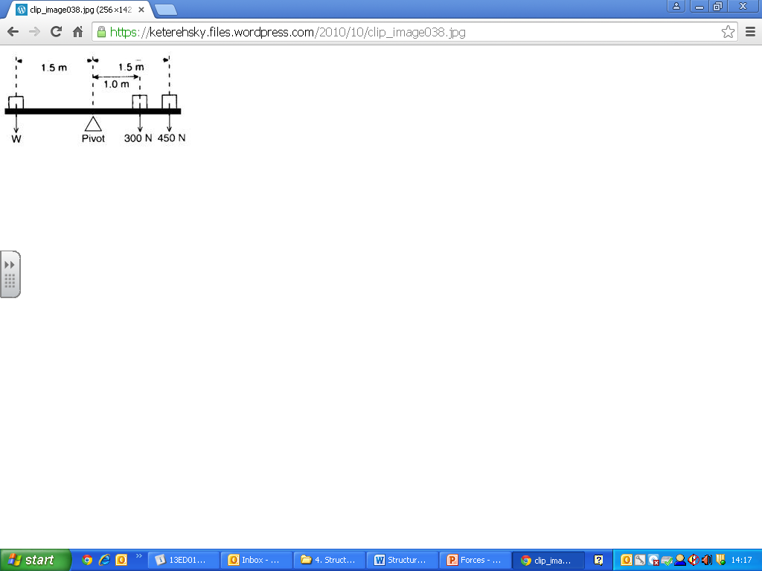

W x 1.5m = 1mx 300N + 1.5m x450N

W x 1.5m = 300Nm + 675Nm

W X 1.5m = 975Nm

W = 975Nm/1.5m

W = 650N**Task 5**

Complete these questions on moments:

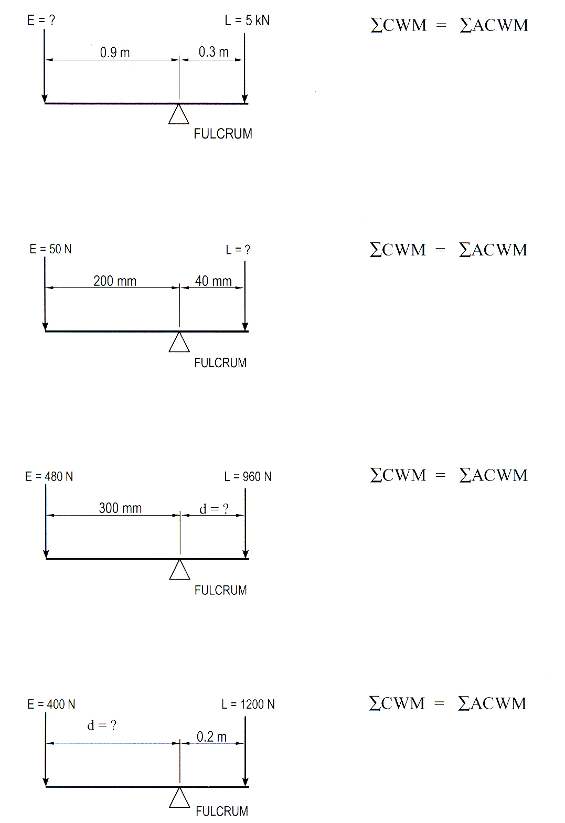

Q4

Q3.

Q2.

Q1.

We are now ready to try and work out the class experiment!

The beam is balanced so it follows the same rule that one side must equal the other.

***Note: Remember that when using Force x Distance that the distance needs to be converted to meters***

This means:

**Goggles + Masking tape =Metal Bar**

(0.5N x200mm) + (1N x 150mm) = 4N x ?mm

(0.5N x0.02m) + (1N x 0.015m) = 4N x ?mm

0.01Nm + 0.015Nm = 4N x ?mm

0.025Nm = 4N x ?mm

0.025Nm = 0.00625m

4N

**Distance =6.25mm**

Try out the experiments in your class and see if your calculations are correct.

**Dynamic and Static Forces/Resultant Forces**

If a beam is in equilibrium then one side must equal the other. This is called the Resultant Force.

An object may have several different forces acting on it, which can have different strengths and directions. But they can be added together to give the resultant force. This is a single force that has the same effect on the object as all the individual forces acting together.

***Acceleration***

*You should know that objects accelerate when the resultant force is not zero, and understand the factors that affect the size of the acceleration.*

**Calculating Resultant Forces**

A simple diagram of forces acting on an object is shown. If the Force is shown next to the arrows then you simply add or subtract the numbers as shown.

**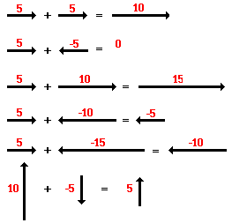**

**Resultant Forces**

Calculating Moments about a beam.

Sometimes engineers need to calculate the forces acting on a structure, such as a bridge.

To do this they need to calculate the forces acting on both sides.

**Remember**:

***Σ clockwise moments = Σ anticlockwise moments* *(principle of moments)***

Here is a more complex diagram of a beam with forces acting on it.

page39

=

To calculate the forces acting on each side we need to have a pivot point, this is called “taking moments about”.

In this diagram we will take moments about R1.

=

R1 is now the pivot point (the equals sign).

To write out the equation in full think of R1 as the =

=

(10,000 N × 2 m) + (500 N × 2.5 m) + (6000 N × 4 m)

R2 × 5 m

=

R2

20,000 Nm + 1250 Nm + 24,000 Nm

5 m

=

**R2**

**9050 N**

**Also Remember:**

***Σ upwards forces = Σ downwards forces***

R1 + 9050 N = 10,000 N + 500 N + 6000 N

R1 = 16,500 N – 9050 N

**R1**= **7450 N**

Therefore the reactions for the beam supports are

**R1 = 7450 N and R2 = 9050 N**

Because

10,000N+500N+6000N =9050N+7450N

16,500N =16,500N

**Task 6**

Complete these questions on moments:

Q1.

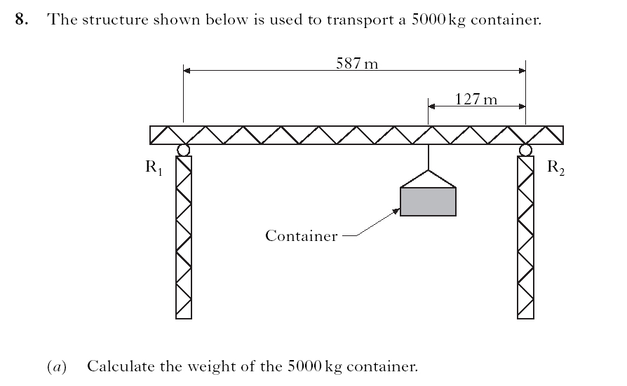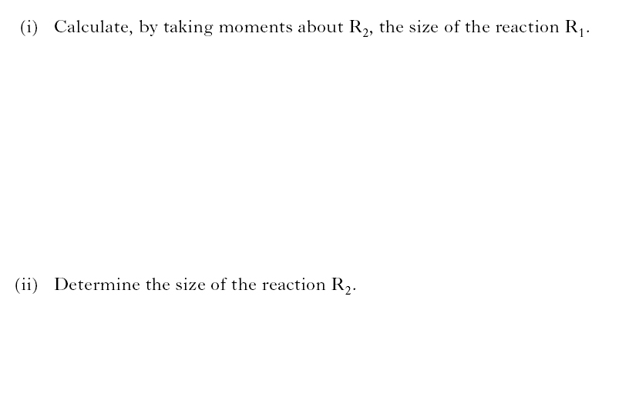

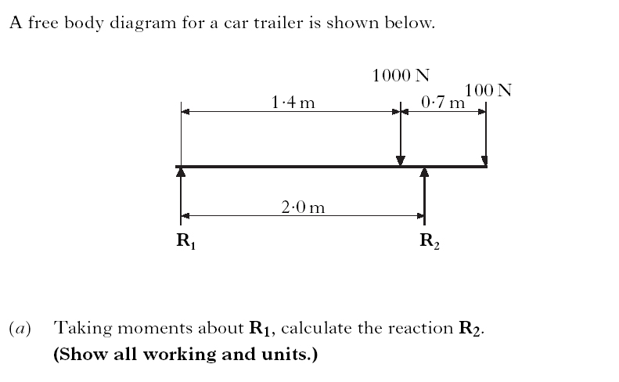

Q2.

**Building Structures**

Structures have to be weatherproof and be able to hold their own weight as well as other loads.

If they don’t manage to survive their own weight they will fail quickly.

Structures must be able to adapt to the weather which is crucial to their survival.

Eg.

[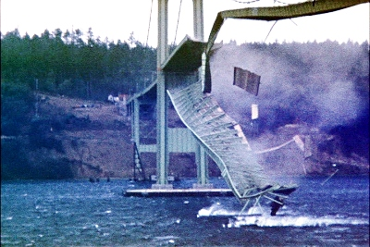](http://upload.wikimedia.org/wikipedia/en/5/5c/TacomaNarrowsBridgeCollapse_in_color.jpg)

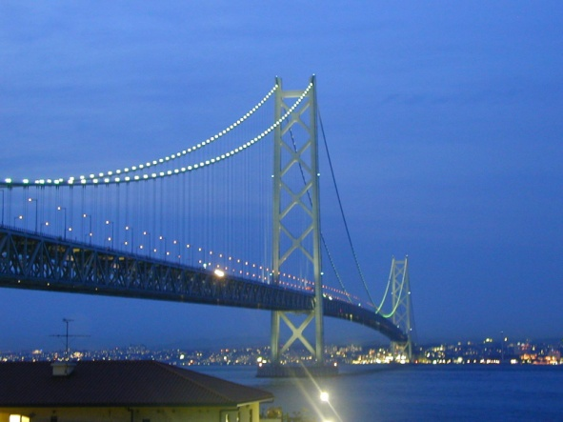

The Tacoma Narrows Bridge only survived a four months before collapsing due to a 42mph wind

The Akashi Kaikyo Bridge is the longest suspension bridge in the world (2015). It was so well designed that it has survived an earthquake.

**Task 7**

Your teacher will now show you different types of beams. Discuss what type of beam is the strongest and why.

Build a beam using the materials provided and test which is the strongest is using the weights provided.

Evaluate you bridge using the sheet provided by your teacher.

**Summary of your Knowledge and Understanding of this unit.**

|  |  |  |  |
| --- | --- | --- | --- |
|  |  |  | ***I can…*** |
|  |  |  | Understand the four types of motion |
|  |  |  | Understand the types of forces acting on a structure |
|  |  |  | Understand the principle of moments |
|  |  |  | Calculate the force or distance required to place a lever in equilibrium |
|  |  |  | Calculate resultant forces |
|  |  |  | Describe the parts of a frame, knowing which parts are struts and ties |
|  |  |  | Describe Triangulation |
|  |  |  | Understand how to make a structure stronger, using appropriate materials |
|  |  |  | Understand technical terms used to describe structural materials |
|  |  |  | Identify structural failures using appropriate terminology. |

**On a scale of 1 to 10 in which 1 is very poor and 10 is the best how do you think you performed.**

**Achievement**

**Effort**

**Behaviour**

**Completion of Unit Yes No Teachers Signature**: