S3 Design and Manufacture
Information Sheet
WOOD
Wood can be divided into 3 main groups; Hardwood, Softwood and Manufactured Boards. Hardwoods and Softwoods are known as natural timbers as they grow from nature. Manufactured boards are manmade. Both have their advantages and disadvantages depending on the product you are designing.
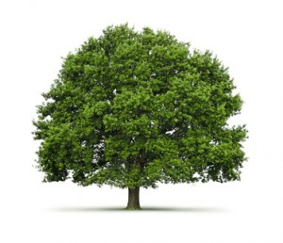
Hardwoods
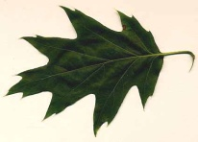
Hardwood trees are known as deciduous trees, this means that they lose their leaves. The leaves produced by Hardwood trees are broad leaves, due to the trees shedding their leaves in Autumn this means for a period of time these trees do not grow therefore they take an exceptionally long time to grow and the wood can be expensive due to this. Hardwood does not mean that the wood is tougher it only describes the tree type.
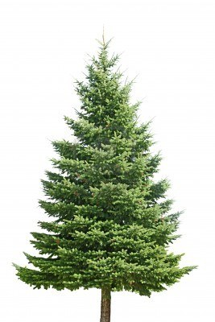
Examples of Hardwoods are: Mahogany, Oak, Teak, Beech and Walnut.
Softwood
Softwood trees are known as coniferous trees, this means that they grow all year round are said to be evergreen. Softwood trees grow quick and are therefore lower in price compared to Hardwood. These trees have needles as opposed to leaves and often produce cones.
Examples of Softwood trees are: Pine, Spruce, Larch and Fir.
Manufactured Boards
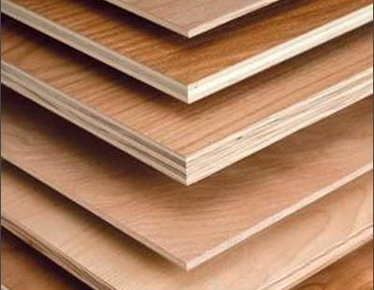
Manufactured boards are manmade they are made up in a variety of different ways that always include using off cuts or chips of natural timber and gluing them together to produce a large board. Advantages manufactured boards has over natural timber are it is less expensive, less likely to warp, can come in large boards and at times be stronger that natural timber. However it does not always look attractive whereas natural timber reveals the woods natural grain and this can be very decorative for designs. In order for manufactured Boards to look attractive a plastic laminate coating can be applied to the outside of the board.
Eaxmples of Manufactured Boards are: Plywood, Chipboard, Blockboard, and Medium Density Fibreboard (MDF)

