S3 Design and Manufacture
Information Sheet
PLASTICS
Plastics can be broken down into two groups Thermoplastics and Thermosetting Plastics.
Themoplastics – These types of plastics can be heated into shape used for a period of time then recycled as they can be reheated and reshaped into their original state. This is known as plastic memory. The plastic we use in school belongs to this group and is known as Acrylic. Other thermoplastics which are common are: Polystyrene, Nylon, Acrylonitrile Butadiene Styrene, also known as ABS, Polythene.
Thermosetting Plastics – These types of plastics are heated into shape however they cannot be recycled as they don’t soften or reform when heated. Thermosetting plastics are often used when a product needs resistance to extremes in temperature, electrical current, chemicals and general wear. Commonly used thermosetting plastics are: Urea Formaldehyde (UF), Melamine Formaldehyde (MF), Epoxy Resin (ER).
Coding Systems used with Plastics – 42% of all plastics are used in packaging products and the majority is recyclable. The problem is at present a lot of these plastics end up in land fill. The plastics industry has introduced a system to encourage people to recycle. Below are codes which are present on household goods.
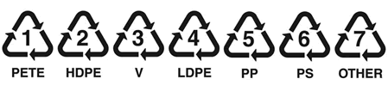
Bending Plastic Using the Strip Heater
This machine heats up a narrow line of plastic (strip) allowing you to make one bend at a time. When you see the Acrylic sag across the heated line then it is ready for bending.

Bending Plastic using the Oven

When making complex shapes or bends it is best to heat the Acrylic all over by placing it in the oven. It can be pressed against a former to ensure the shape is coerrectly produced.

