St. Machar Academy
Homework 7
Calculating Resistance Values
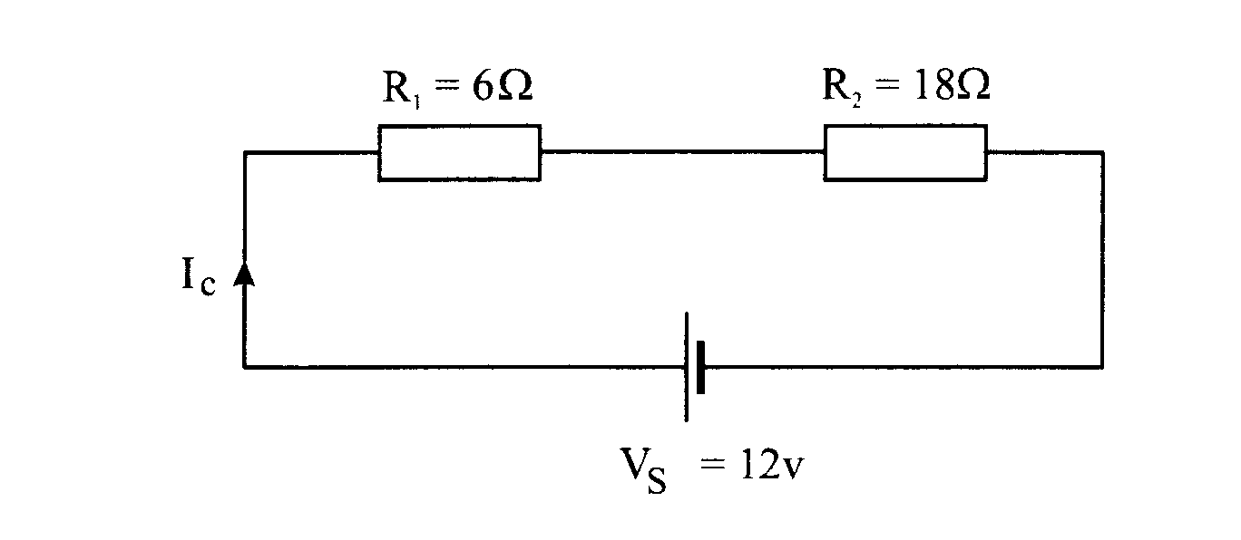
When resistors are connected in series you just add the resistance together.
R1
R2

R _{total} = R₁ + R

When resistors are connected in parallel you can use the formula shown below.
R1
R2
Rt = R1 x R2
R1 + R2

Calculate the total resistance of each circuit
R1=17Ω
R2= 20Ω

RT=
RT=

