

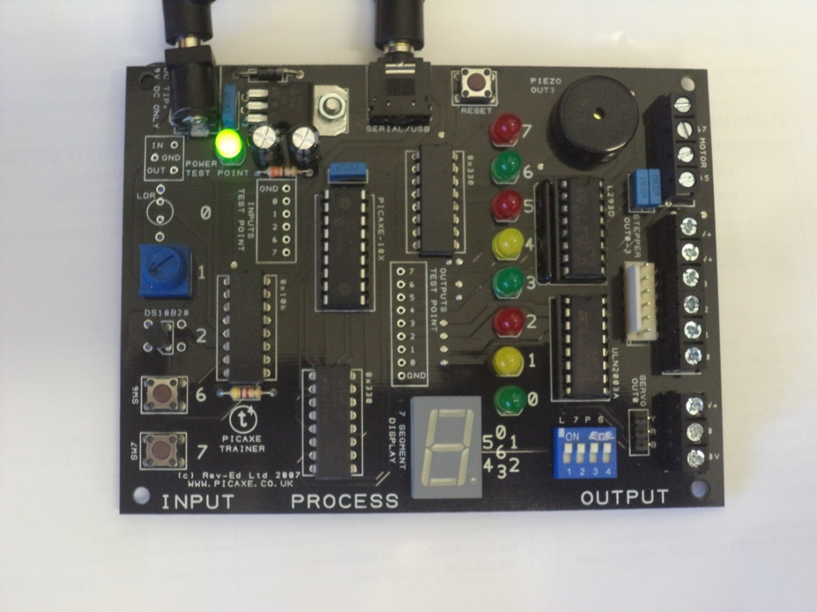

**Programmable Control**

**Circuit Boards**

In the first unit of Programmable Control you learned about Flow Charts and how they connect to circuit boards. In this section you will learn how to program a circuit board using computer programming code on Picaxe Editor and the PICAXE T4 CONTROL BOARD. This board is a teaching tool used to help you understand how access to the world of microcontrollers. The system you are using has been assembled with a full range of inputs and outputs ports.

To fully understand how it works you need to understand the very basics of computer programming.

**Binary**

Binary numbers are the fundamental level of how a computer microcontroller works.

A binary number is either “1” or “0” (one or zero). In electrical terms that could be “on” or “off”( or even “high” or “low”).

To understand binary numbers you need to remember how we count in decimal. If you ask anyone to count the first ten numbers the will most likely star with 1, 2, 3…. All the way up to 10. When in fact “0” is the first number and “9” is the tenth number. After the tenthnumber the decimal system runs out of numbers as there are only ever ten numbers used. If we go into double figure then we need two figures. For example 10 is technically one “ten” and zero “units” the process repeats on through the 100’s (111= one “hundred” one “ten and one “unit”.

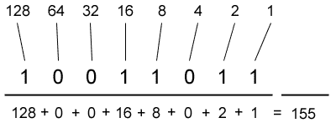Binary works on a similar principal. However it works on a slightly different scale. See the diagram below.

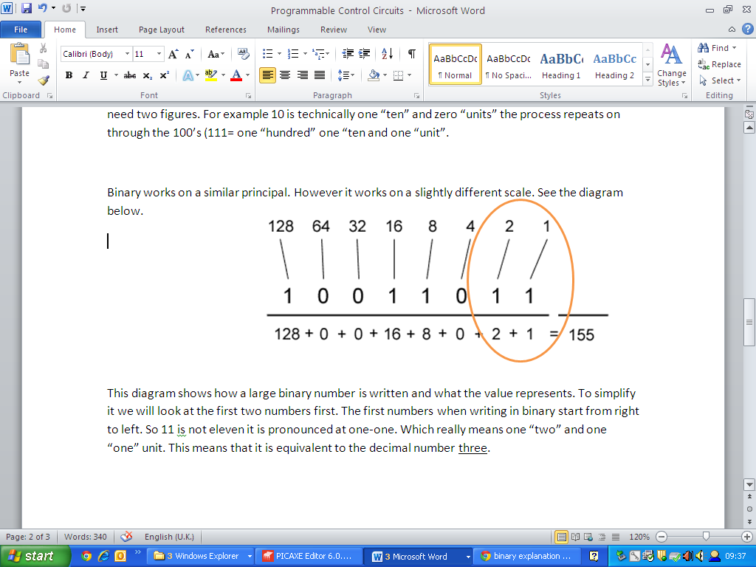This diagram shows how a large binary number is written and what the value represents. To simplify it we will look at the first two numbers first. The first numbers when writing in binary start from right to left. So 11 is not eleven it is pronounced as one-one. Which really means one “two” and one “one” unit. This means that it is equivalent to the decimal number three.

Binary Questions

<http://www.bbc.co.uk/education/guides/z26rcdm/revision>

LSB MSB

1)

Convert each of these decimal numbers into binary.

1. 17
2. 23
3. 11
4. 38
5. 33
6. 137
7. 46
8. 147

2)

Convert each of the following binary numbers into decimal.

1. %11110000
2. %11000011
3. *%01010101*
4. %10101010
5. %00001001
6. %11111010
7. %10101011
8. %00010000

**Writing Computer Code using PICAXE**

What do the buttons/commands mean?

**High** means ON

**Low** means OFF

**Wait** means delay in seconds

**Pause** means delay in milliseconds

**Main** means main program

**Goto** means go to a section of the program

**End** means end the program

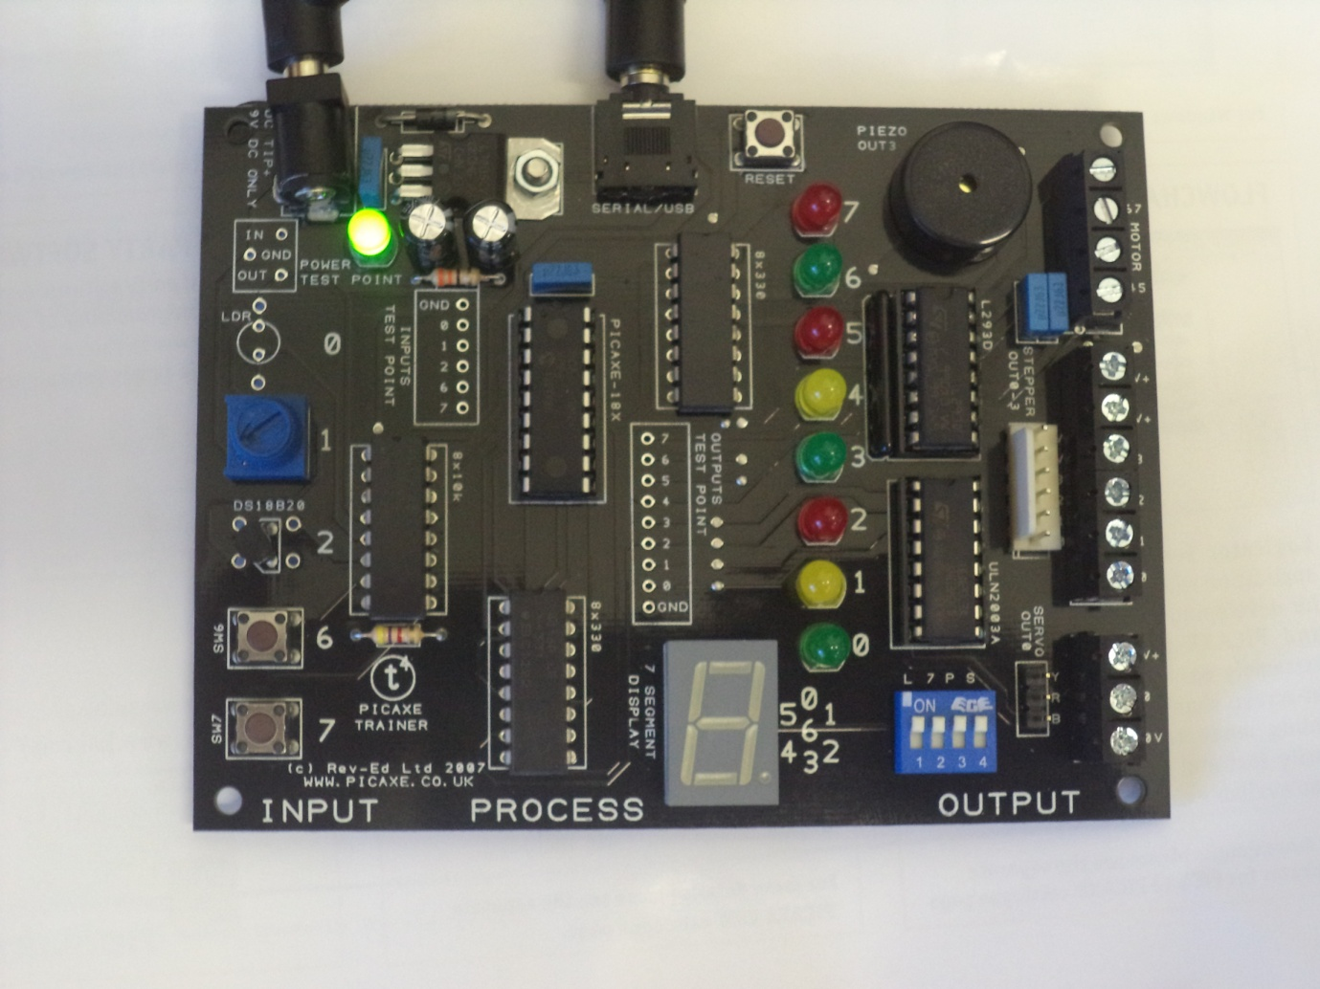Time to get to know your PICAXE T4 Control Board

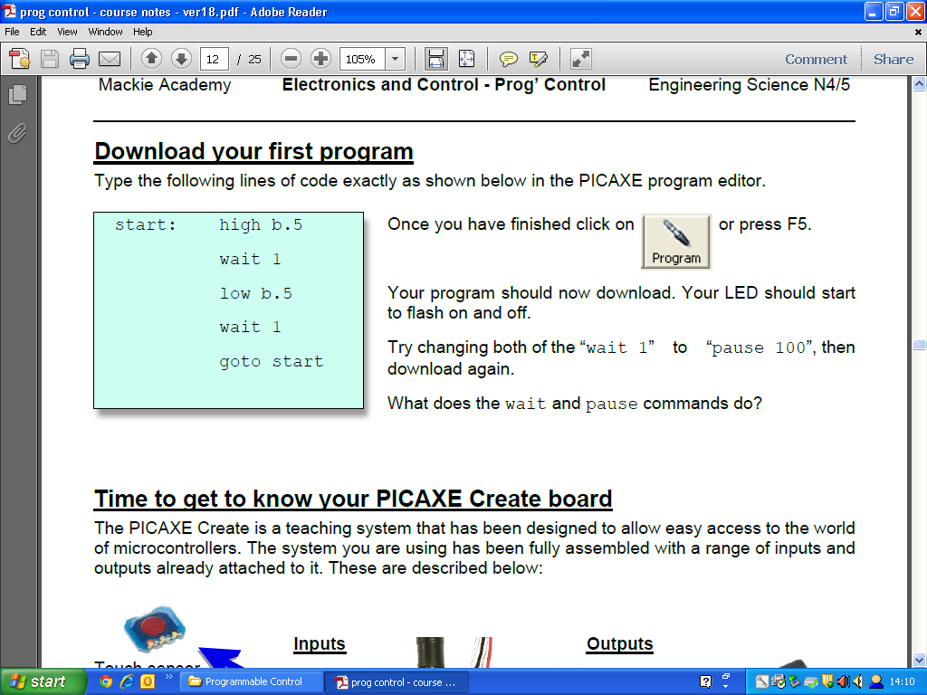

**Assignment 1:**

You could also use the following program to answer the above question:

main:

high **7** 'set pin 7 (red LED) on'

pause **1000** 'keep pin 7 on for 1 second'

low **7** 'set pin 7 (red LED) off'

pause **2000** 'wait for 2 seconds

goto main 'jump back to main'

Either can be used when programming.

**Remember:**

*Pause means milliseconds.*

*Wait means seconds.*

“high 7” works for this program but specifying “b.5” tells the user and the program that it is an output being used “high 7” does not.

***b.5 means output pin 5***

***c.5 means input pin 5***

It is important to remember this when programming so that you do not get confused when creating a program for your board.

**Assignment 2:**

You have now learned what you need to write and how to control the pins on your T4 board. You now need to write out a program to control traffic lights. The program should put a green light on for 8seconds, then amber on for 3 seconds, red on for 6 seconds then finally red and amber for 2 seconds before repeating the sequence over and over. Use appropriate coloured LEDs as outputs.

Write out a flowchart for what will happen below to help plan your program.

Go to the Shared Area on your computer and access the document called **“Using Picaxe Editor Starter**”. Find it by accessing it using the following folders:

Design & Technology>Engineering Science>S3 Eng Science>Programmable Control> Using Picaxe Editor Starter

**Complete the Tasks on this document using Picaxe Editor.**

**Assignment 3:**

A microwave operates using the following sequence:

Light, Turntable and Magnetron on for 20 seconds

Magnetron off for 10 seconds

Turntable off

Buzzer on for one second

Buzzer and light off

End

Complete a flow chart for the scenario and then write out a program using the following pins as outputs:

* Magnetron pin 7
* Turntable pin 6
* Light pin 5
* Buzzer pin 4

**Assignment 4**

**Task 4A:**

Using your flow chart of Pulse Width Modulation (from Task 10D in the previous booklet) complete a computer program to control the speed of the motor.

Use your programming skills to create a program to show digital displays on the T4 board. Each output pin refers to a number on the digital display.

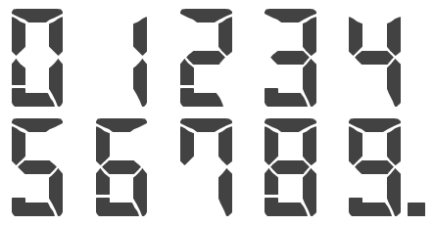

For Example the number 1 looks like this:

It was created by typing the following code

main:

high 1

high 2

pause 2000

goto main

To make it flash you need to add in low signals and a time too.

For Example:

main:

high 1

high 2

pause 2000

low 1

low 2

pause 2000

goto main

Can you create a countdown timer that flashes all of the numbers in the correct order?

|  |  |  |  |
| --- | --- | --- | --- |
|  |  |  | *I can…* |
|  |  |  | List advantages and disadvantages of using microcontrollers. |
|  |  |  | Give examples of the use of microcontrollers. |
|  |  |  | Explain what ALU, RAM and ROM mean. |
|  |  |  | Explain what the clock and the data bus do in a microcontroller. |
|  |  |  | Draw diagrams to show inputs and inputs to the Basic Stamp controller. |
|  |  |  | Draw a flowchart with a loop. |
|  |  |  | Draw a flowchart with a counter. |
|  |  |  | Write a program that switches on an output. |
|  |  |  | Write a program that has an if/then loop. |
|  |  |  | Write a program that has a continuous loop. |
|  |  |  | Add comments to a program to explain what it does. |
|  |  |  | Write a program that has a pause command. |
|  |  |  | Explain the term EEPROM. |
|  |  |  | Write a program that will allow a motor to move forward and reverse. |
|  |  |  | Convert decimal to binary. |
|  |  |  | Convert binary to decimal. |
|  |  |  | Write a program that has a counter (a for/next loop). |

**Summary of your Knowledge and Understanding of this unit.**

**On a scale of 1 to 10 in which 1 is very poor and 10 is the best how do you think you performed.**

**Achievement**

**Effort**

**Behaviour**

**Completion of Unit Yes No Teachers Signature**