Programmable Control

Introduction

What is Programmable Control?
Electronic devices have been developed to make life easier. To do this they have an electronic control system usually in the form of a micro controller.
Microcontrollers have a computer and a memory all built into a single chip. They are small and relatively inexpensive and can be built into electronic devices to make products easier to use and to be more intelligent.
In this unit we will use a circuit board made up of microcontrollers. The name of which is an 18M2 Picaxe training board. As we go through this unit you will learn about the circuit board its parts and how it operates.

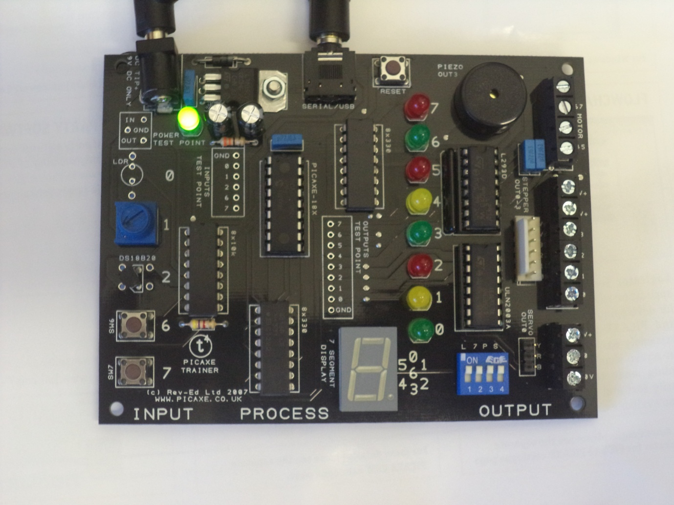
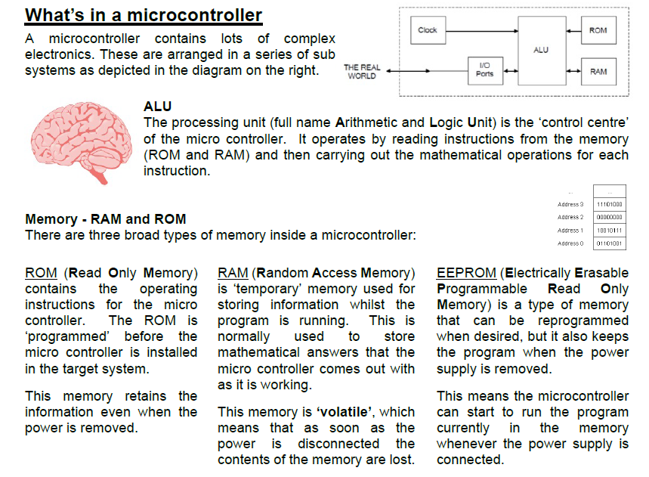

Flow Charts
As with all parts of engineering the engineers analysing problems simplify the problem before expending lots of effort on the final solution.
Using Flow Charts is one way that engineers break down a problem to work out the best possible solution.
On the next page are the parts used in a Flow Chart and how to use them.

Here are some example flowcharts:
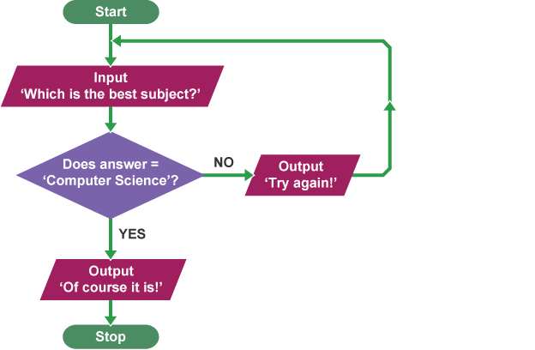
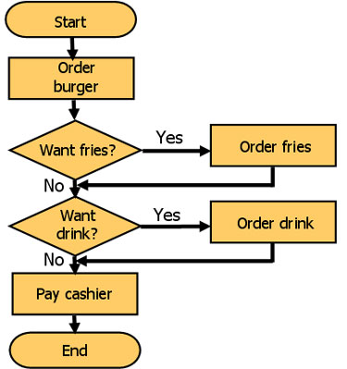
Answer= Des Tech?

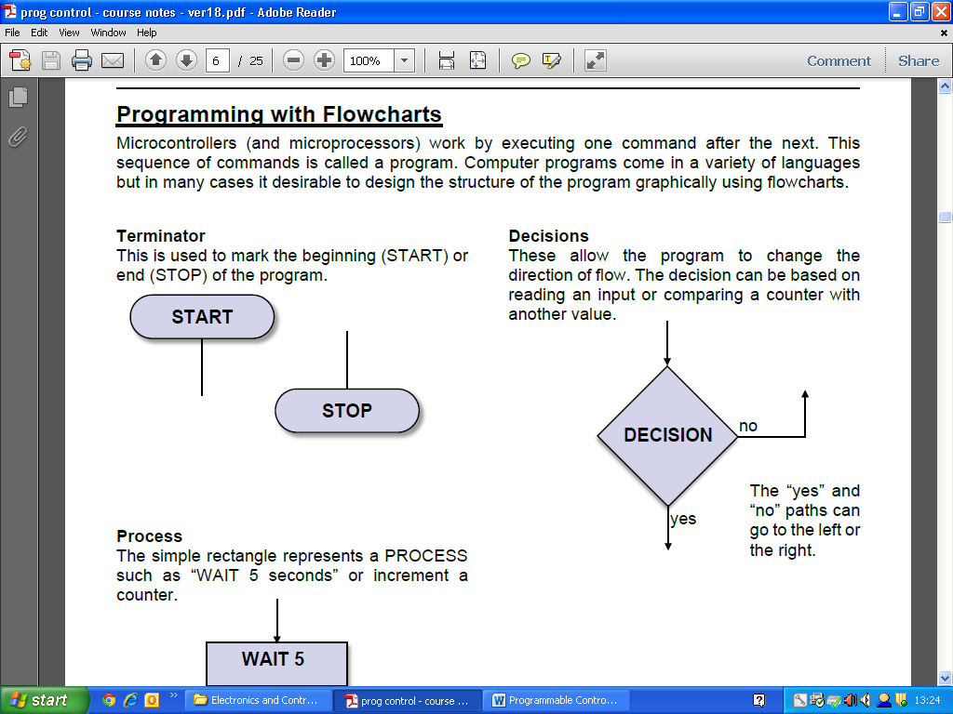
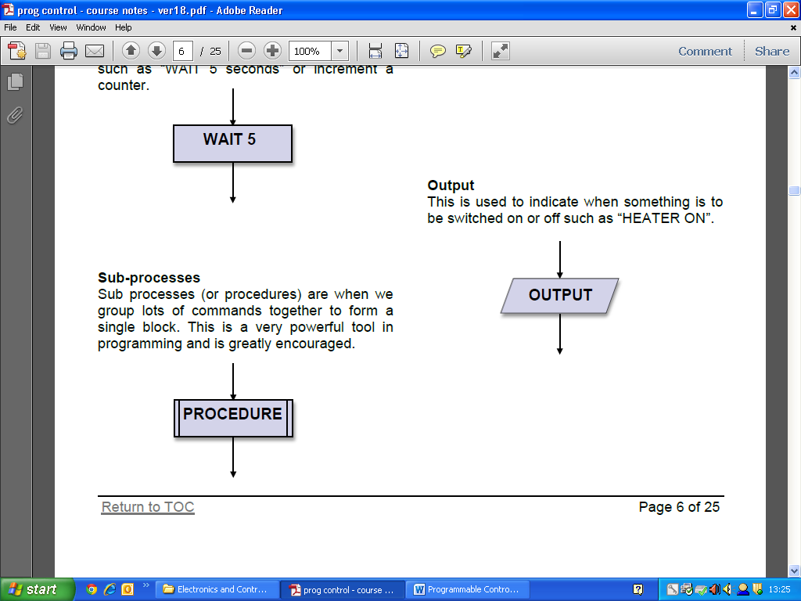
Here is a basic Flow Chart for a flashing light:

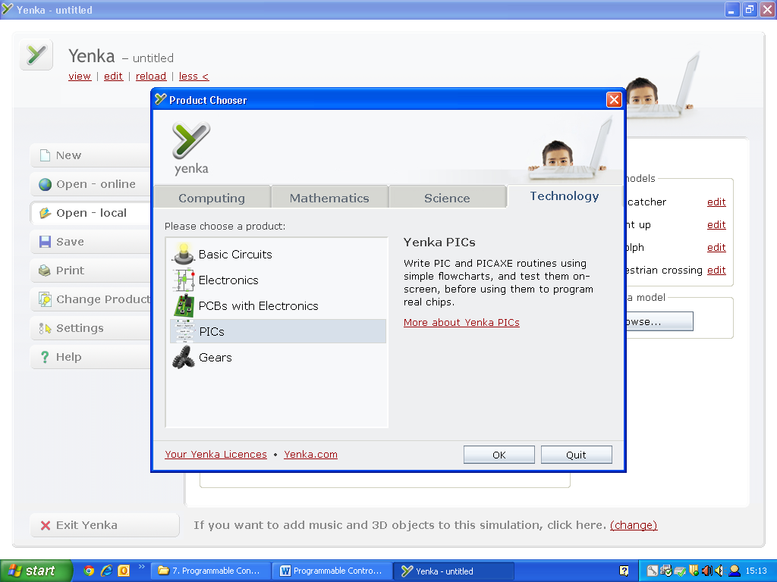
Now that you know how to write a flow chart we are going to use Yenka software to create a simulation of your flow chart to test it works.
Use the Technology section and Yenka PICs in the menu.

Task 1A:
Create a flowchart on Yenka.
You are now going to use the Programming with FlowCharts tutorial on Yenka to test how a flowchart links with a microcontroller.

Task 1B:
Now create your traffic lights flowcharts on Yenka. Remember to select the 18M2 microcontroller to connect it to.
Q1. Did the program you produce work correctly?

Q2. If it didn’t which changes did you need to make?

Flow Charts are an essential problem-solving skill used to write computer programs for microchips. They are compatible with most software packages and will be used by us in Yenka and in PIC AXE Programming Editor. Flow charts will also be assessed in exam conditions so make sure you revise them!
Here is a useful link to revise: http://www.bbc.co.uk/schools/gcsebitesize/design/electronics/logicrev7.shtml

Using the flowchart you designed in Assignment 2 simulate your flowchart using Yenka.

Q1. Did the program you produce work correctly?

Q2. If it didn’t which changes did you need to make?

Assignment 3:
Decision Making Boxes can be very useful as highlighted by the Pelican Crossing. Inputs such as vending machines can work on similar systems. When you add money then the vending machine works.
Task 3A:
Create a flowchart for a vending machine in the space below. Ensure that it that allows you to receive a can of juice when a coin is inserted into the machine.

Task 3B:
Simulate the flowchart on Yenka.
Assignment 4:
Motors can also be programed by a microcontroller. The micro controller can even simulate how to operate the motor, explaining if it has to go backwards/forwards or left/right.
Task 4A:
Create a flowchart that would make a wheel move.
The wheel should go forwards for 10 seconds, stop for 5 seconds then go backwards for 10 seconds before stopping again.

Task 4B:
Simulate the flowchart on Yenka.
Assignment 5: Sub procedures
Sub procedures are often used to help a program be easier to understand and allow complex programs to be shown in a simpler diagram.
To use a sub procedure the correct term in a program is called “Go Sub”. Each sub procedure is labelled so that the program tells the correct instruction at each stage. (e.g. “Go Sub Motor”)
Task 5A:
Create a flowchart for a motor makes the motor move like in Task 4A but this time it uses sub procedures to complete the task.
Simulate your test on Yenka once you have drawn out your design.

Assignment 6:
Now you are going to use Yenka to program a gear system. Use the tutorial on the Gears section of Yenka to figure out how it works.
Task 6A:
Test a Motor and a crank with the tutorial.
Task 6B:
Open the gear ratio tutorial. To work out the speeds of the gear systems edit the gear systems to see how they change on the graph below.
To edit the number of teeth in the gears just adjust the number scale. To edit the number of teeth on the opposite wheel click on the words and it will allow you to change the gear selected.
In a control system you will need to program circuit boards to allow the gears to move at a variety of speeds to help control what a motor needs to do. You will also need to interpret questions to help answer how to create a flow chart based on certain commands.
Assignment 7:
“For Next” Loop:
In a program is it likely that you will have to put on a program for a specific amount of time. You have controlled the time using the wait command in the previous exercises. If a program needs to repeat tasks for a particular length of time then it may be easier to use the “For Next” command. This allows a program to repeat For a certain time before performing the Next step, hence the name “For Next”.
Task 7A:
Copy the diagram to repeat a motor staying on for one second but repeating for 5 loops. Remember to add in the 18M2 microcontroller and the animated wheel to test that your flowchart works.
Task 7B:
Add in a lamp to output 2 and keep it in the same cycle. Make sure you save this flowchart as you will need it for later tasks.

Task 7C:
Write down five systems or scenarios that this type of program could be used in.
___________________________
___________________________
___________________________
___________________________
___________________________

Assignment 8:
You will now have to apply this knowledge in different scenarios to help you understand how to create a control system that allows you to complete multiple tasks at once. After all that’s why microcontrollers are used, to make our daily lives easier and to increase production of products!
Task 8A:
Construct a flow chart that will be suitable for a burglar alarm system. An alarm should sound if a pressure pad has been pressed or if there has been sound sensed. The alarm should have a sub procedure that allows it to be reset. The system should then switch off when the reset button has been pressed.
Test the system on Yenka once you have drawn out your diagram in the space below.

Task 8B:
Now add in a sub procedure that allows a light to flash 5 times before it returns to the main program. Draw the sub procedure for the flashing light below.

Assignment 9
As an engineer you will have to ensure that you understand how microcontrollers can change the speeds of motors. This can be done in a variety of ways such as pulsing the motor and attaching the microcontroller to gears to increase the speed using the gear ratio.

Task 9A
Use the motor flowchart that you created in Task 7B and the gears section in Yenka to help answer the following question. To evidence your work you need to screen shot (using the print screen button on the keyboard) what you have completed and save it on Microsoft word to print and show your teacher what you have done is successful.

On Yenka create a motor to stay on for one second but repeat for 5 loops. The motor should link to a gear system that will be 10 times faster than the input speed.

Assignment 10
Task 10A:
Create a circuit that meets the following requirements:
- The circuit must be operated by the press of a button.
- It must display a light when the button has been pressed.
- It must operate a motor that will allow a fly wheel to operate at a ratio of 4:3.
- It must also allow a plastic wheel to operate at a ratio of 1:10 compared to the flywheel.
Plan your design in the space below.

Task 10B:
Create a circuit that operates a slider mechanism when a button is pressed. The slider should activate after three warning lights have flashed for one second. When the lights flash a beep should sound. The system should be able to be reset.
Screen shot the working out to evidence what you have done on Yenka. Use the space below to draw a flow chart for your design.

Task 10C:
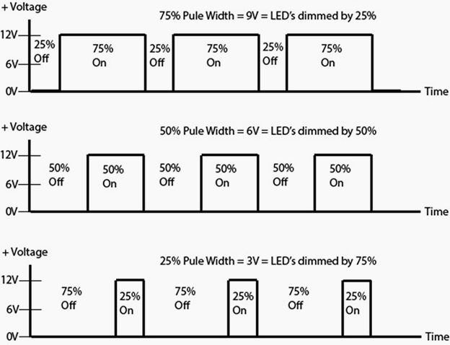
You are now going to create a flow chart showing Pulse Width Modulation. PWM allows a motor to be controller by either speeding it up or slowing it down electronically depending on the time that the motor is on for. This can be shown in a graph like the one for a dimmer light below.

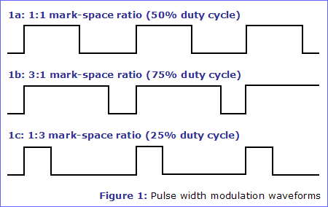
A simpler diagram could be shown to explain how it is used. This shows the Mark-Space Ratio of how it works. Mark referring to the motor being on and Space referring to it being off. This type of control allows a motor to be controlled without the use of gears.

A flow chart showing pulse width modulation would look like this:

Task 10D:
Copy and complete the diagram above and test to see how it works.

