

**Mechanisms**



**Four Types of Motion**

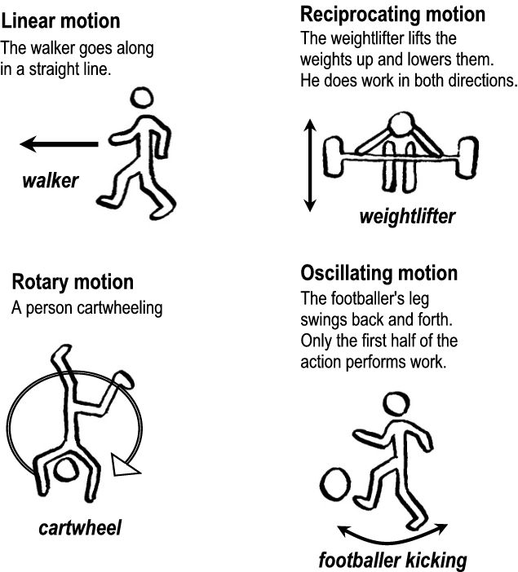

**Gears: Simple Gear Systems**

Gears consist of toothed wheels fixed to shafts. The teeth interlock with each other, and as the first shaft (the **driver shaft**) rotates, the motion is transmitted to the second or **driven shaft**. The motion output at the driven shaft will be different from the motion input at the driver shaft - in place, speed, direction and other ways.

A number of gears connected together are called a **gear train**. The input (eg a motor) is connected to the driver gear. The output, (eg the wheel of a buggy) is connected to the driven gear.

**Spur gears**

The photograph below shows a simple gear train made up of a couple of spur gears. These are the common gears (or cogs) that look like wheels with teeth around the rim. Next to it is a diagram showing how you would draw this gear train in an exam.

In the drawing, the centre of each gear is shown by a cross. Each gear is drawn as two circles, one slightly larger than the other to show where the teeth would be. Teeth do not have to be drawn, but the number of teeth is written next to the gear, in this case 60 teeth and 15 teeth. Arrows indicate the direction that the gears are moving. Note that with two connected gears, they will be rotating in opposite directions.

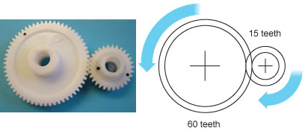

**Idler gear**

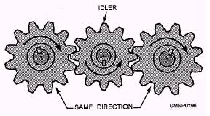One gear turning another will always reverse the direction of motion. This is not always the desired result. To overcome this, you can insert an idler gear between the drive gear and the driven gear, as shown in figure 4-4. The idler reverses the direction of motion coming from the drive gear. This allows the driven gear to be turned in the same direction as the drive gear.

**Gear ratio and output speed**

Where there are two gears of different sizes, the smaller gear will rotate faster than the larger gear. The difference between these two speeds is called the **velocity ratio**, or the **gear ratio**, and can be calculated using the number of teeth. The formula is:

**Gear ratio = number or teeth on driven gear ÷ number of teeth on the driver gear**

So the gear ratio for the simple gear train above, if the smaller gear is the driver gear, is:

**Gear ratio = 60 ÷ 15 = 4**.

In other words, the driver gear revolves four times to make the driven gear revolve once.

If you know the gear ratio, and the speed input at the driver gear, you can calculate the speed output at the driven gear using the formula:

**Output speed = input speed ÷ gear ratio**

So if the gear ratio is 4 and the driver gear is revolving at 200 *rpm* then the **output speed = 200 ÷ 4 = 50 rpm**

**TASK 1**

Build up the following simple gear system and observe the gear ratios of the following and write in your answers.

|  |  |  |
| --- | --- | --- |
| Number of teeth on Driven Gear | Number of Teeth on Driver Gear | Gear Ratio |
| 40 | 30 |  |
| 40 | 10 |  |
| 20 | 40 |  |
| 10 | 30 |  |
| 30 | 10 |  |
| 10 | 20 |  |

***We do not need to build up a mechanical system to work out how it will perform?***

**Compound Gear Trains**

Where very large speed reductions are required, several pairs of gears can be used in a compound gear train. A small gear drives a large gear. The large gear has a smaller gear on the same shaft. This smaller gear drives a large gear. With each transfer, the speed is significantly reduced.

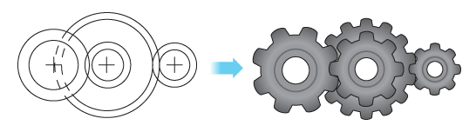

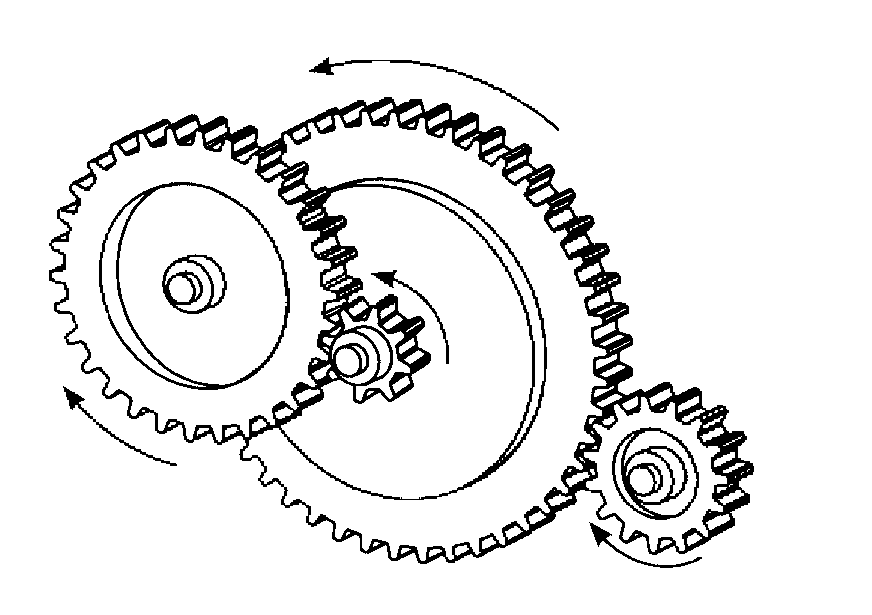

The pictures below show the way to build up a compound gear train

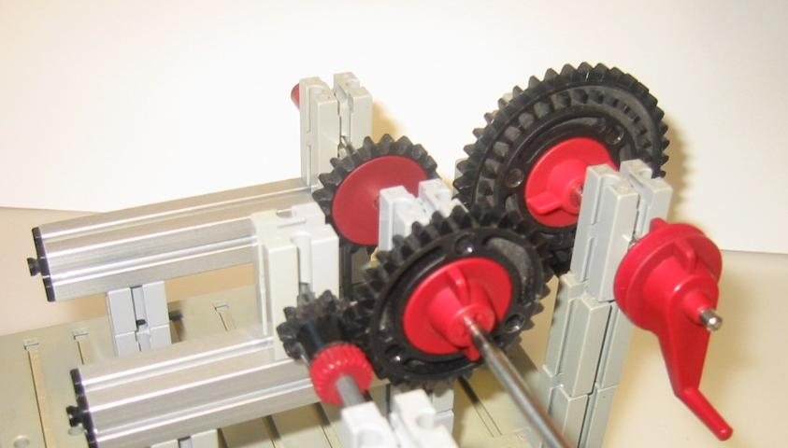

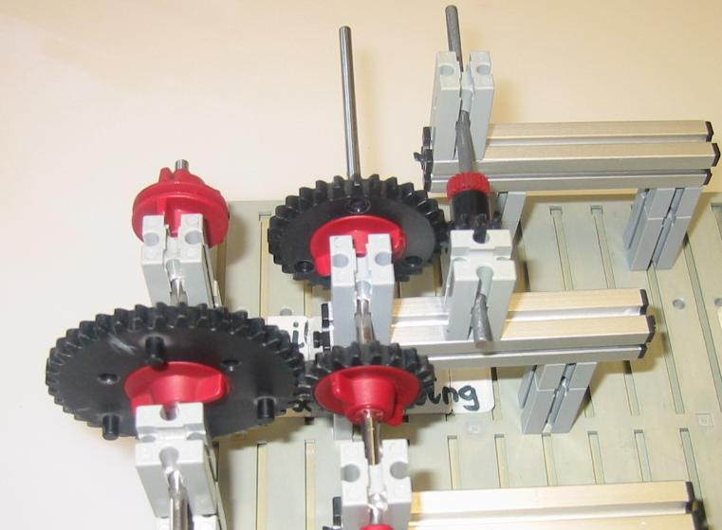

**Build up the above compound gear train and calculate the gear ratio.**

**The large gear is the DRIVER GEAR**

**Example**

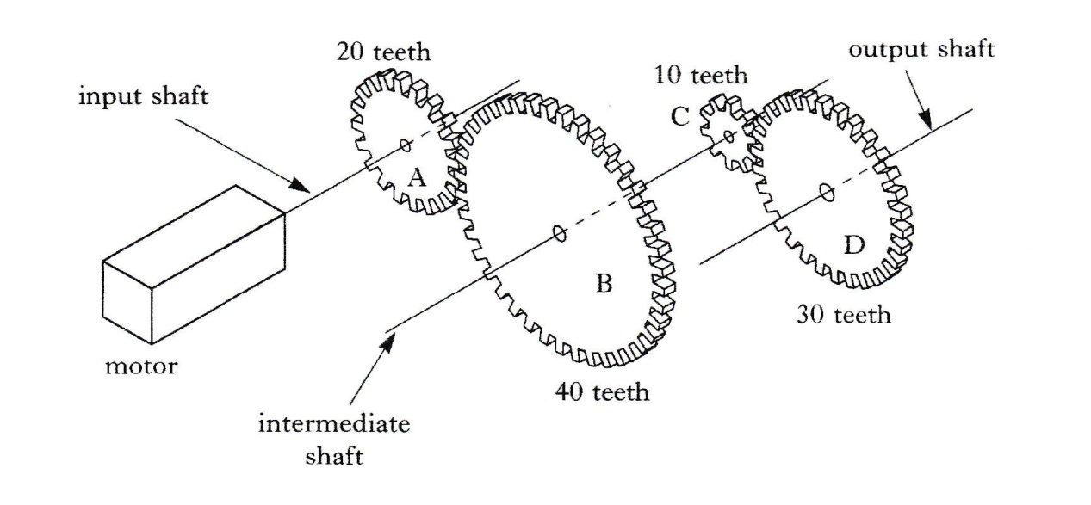

To calculate the gear ratio of the above example:

G.R. = Number of teeth on driven gear

Number of teeth on driving gear

Between A & B = 40 = 2 Between C & D = 30 = 3

20 1 10 1

Because B and C are on the same axle then they must be going the same speed

The Gear Ratio between D & A is found by multiplying: 2 x 3 = 6

1 1 1

Therefore we have a gear ratio of 6:1. Meaning the driven gear D is six times faster than the driver gear A.

**Question** Calculate the gear ratio of the compound gear system shown below

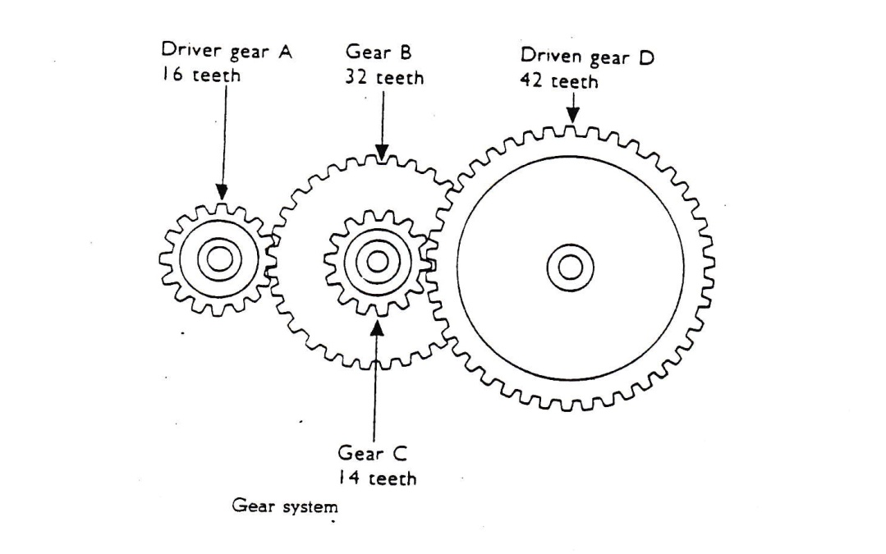

**Worm and Wheel**

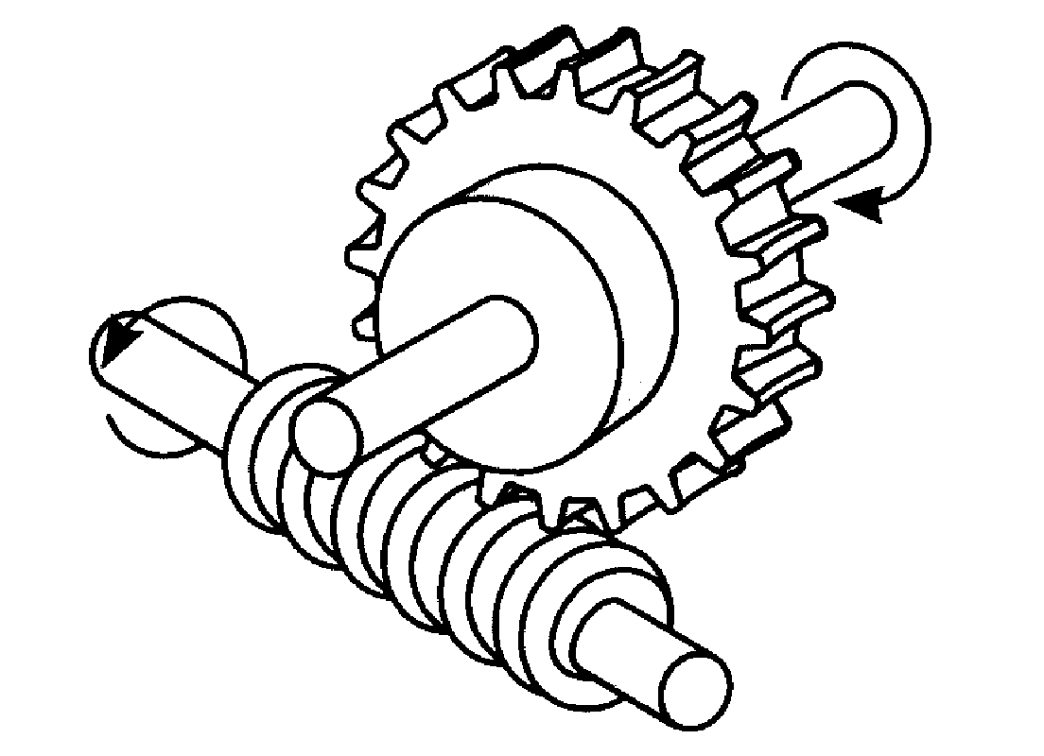Another way of making larger speed reductions is to use a worm and wheel. The worm, which looks rather like a screw thread, is fixed to the driver shaft (sometimes directly onto the motor shaft). It meshes with a worm wheel, which is fixed to the driven shaft. The driven shaft runs at 90’ to the driver shaft.

You should think of the worm wheel as a gear with only 1 tooth. This allows a huge reduction in speed which takes up very little space.

***Construct a worm and wheel and observe how they operate***

**Bevel Gears**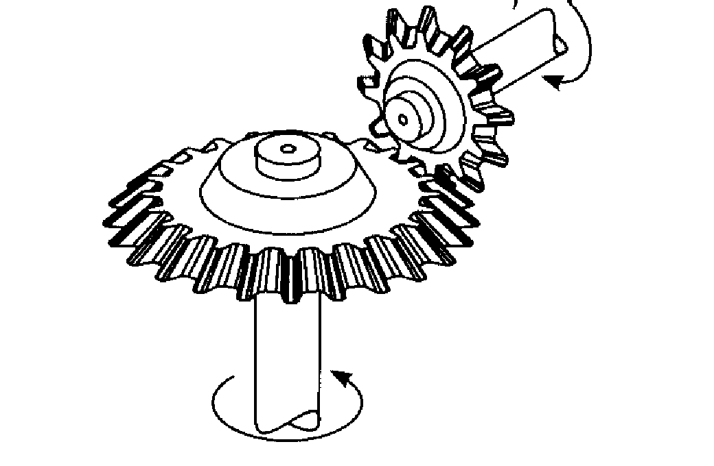

Bevel gears, like worm wheels, use shafts at 90 degrees to each other. A whisk which uses bevel gears to change the direction motion through 90 degrees as does the gears in a wind turbine.

***Construct two bevel gears and observe how they operate***

**Rack and Pinion**

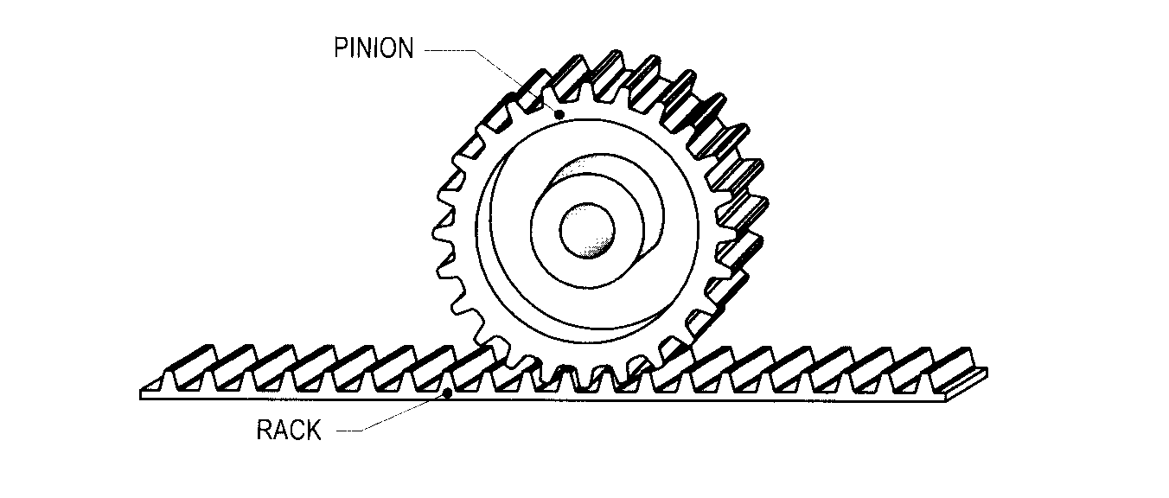

A rack & pinion mechanism is used to transform rotary motion into linear motion, or linear motion into rotary motion. A round spur gear, the pinion, meshes with a rack that can be thought of as a spur gear with teeth set in a straight line.

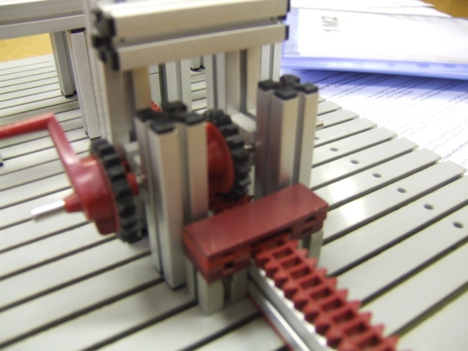

***Construct a Rack and Pinion and observe how it operates***

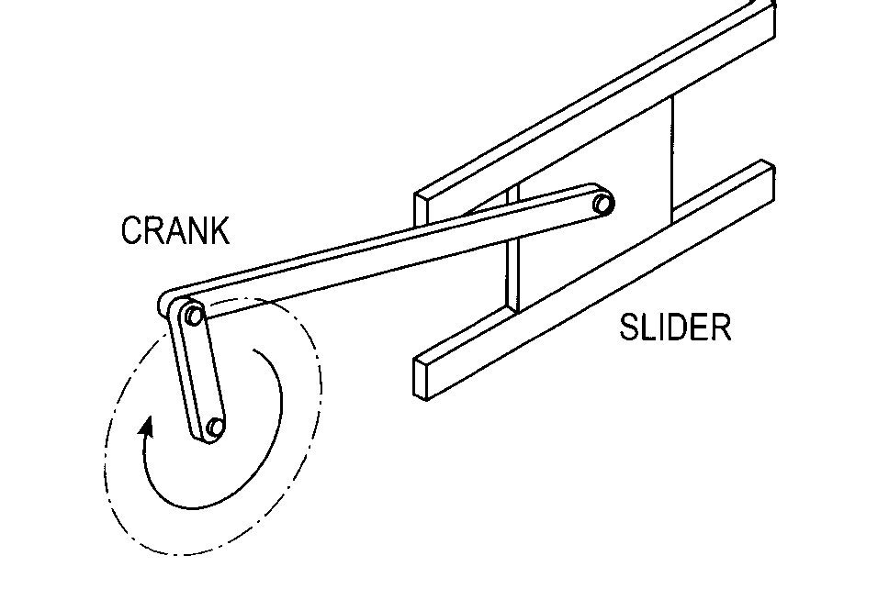**Crank and Slider**

Crank & slider mechanisms involve changes between rotary and reciprocating motion. The crank rotates while the slider reciprocates. The longer the crank the further the slider will move.

***Construct a Crank and Slider and observe how it operates***

**Cams**

A cam is a specifically shaped piece of material, which can be used to change an input rotary motion to an output motion that is oscillating or reciprocating.

The cam operates by guiding the motion of a follower held against the cam, either by its own weight or by a spring. As the cam rotates the follower moves. The way that it moves and the distance it moves depends on the cam’s shape and dimensions.



**Cam Motion**

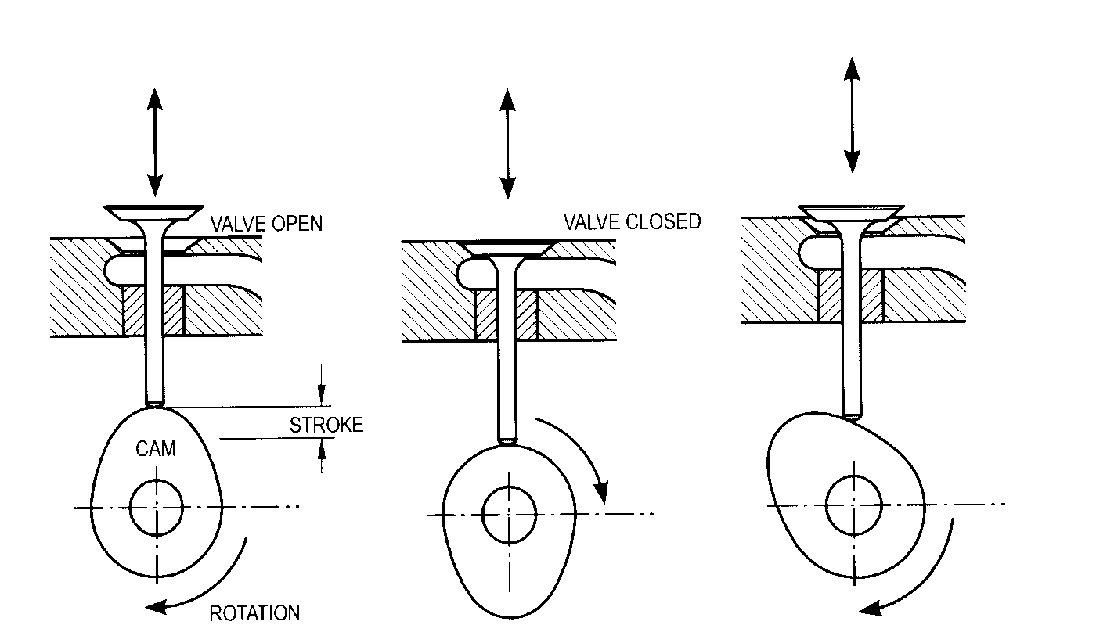Pear-shaped cams are often used for controlling valves. For example they are often used on motor-car cam shafts to operate the engine valves.

A follower controlled by a pear-shaped cam remains motionless for about half a revolution; during the other half revolution of the cam the follower rises and falls. As the pear-shaped cam is symmetrical, the rising motion is the same as the falling motion. When the follower is not moving we call this the dwell part of the cam.

In a car engine, cams are fixed on a



camshaft. As each cylinder has two

valves, an inlet and an exhaust valve,

there are two cams on a camshaft for

each cylinder as shown.

***Construct a Cam and Follower and observe how it operates***

**Chain Drives**

Where large forces have to be transmitted and there can be no slippage allowed chain drives are used. A toothed wheel known as a sprocket is used. This is the universal system used on bicycles.

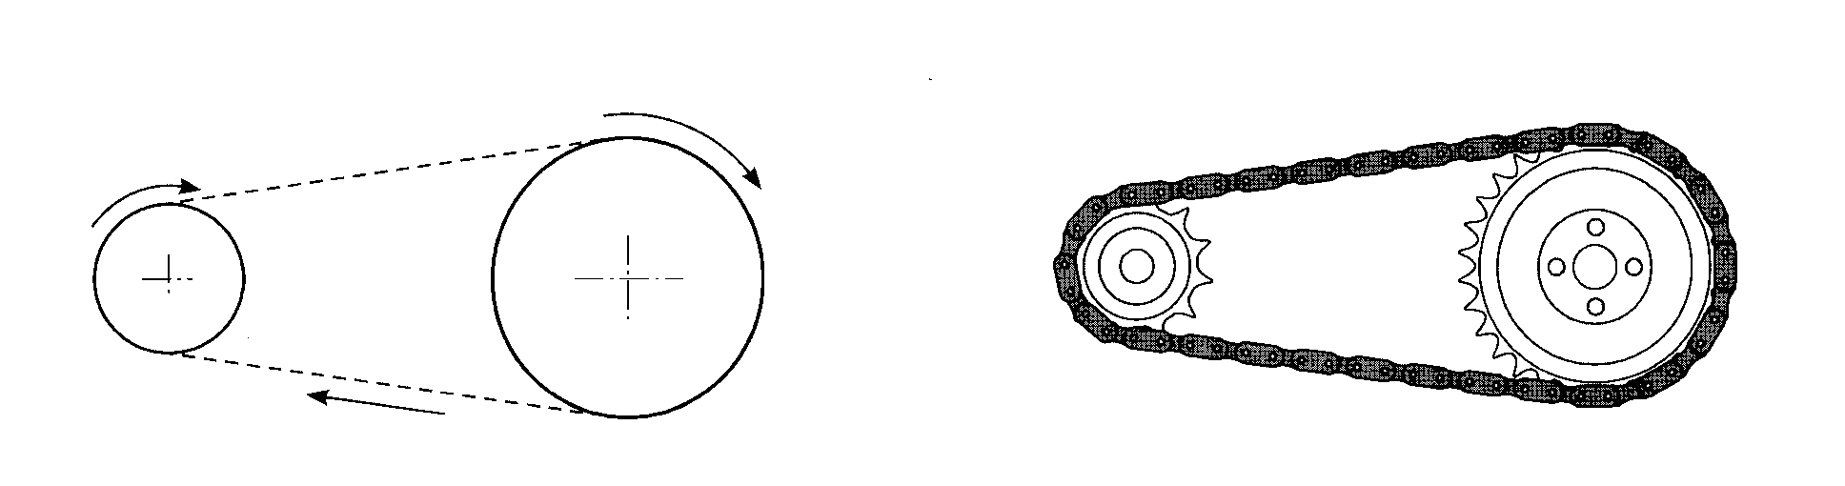

***Construct a Chain drive and observe how it operates***

**Belt Drives**

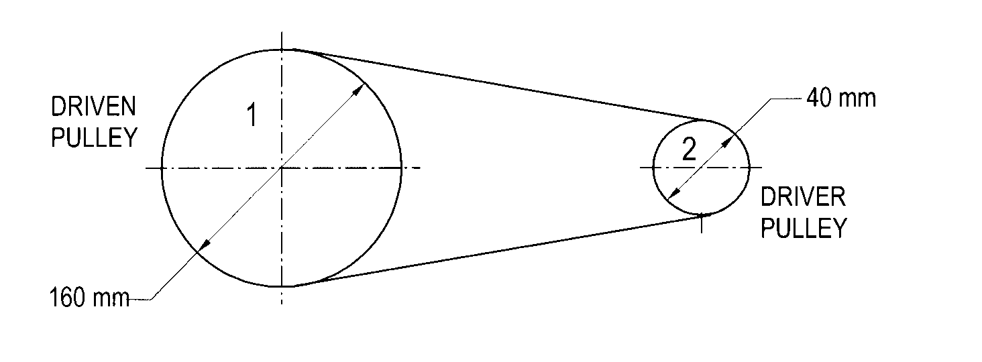To make rotary motion useful it has to be transmitted from one part of a machine to another, often with a change in speed. Belt Drives are used in many machines a pillar drill and the washing machine are two examples.

***Construct a belt drive and observe how it operates***

The ratio between the number of revolutions made by the input and output wheels is called the**Velocity Ratio**

VR = Number of input revolutions (input motion)

Number of output revolutions (output motion)

The Velocity ratio is based on the Diameters of the input and output pulleys.

Therefore we could say: VR = Diameter of input pulley

Diameter of output pulley

Example VR = 200mm Diameter = 2 = 2:1

100mm Diameter 1

Calculate the velocity ratios of the following pulley drives

|  |  |  |
| --- | --- | --- |
| Diameter of Driver Pulley in millimetres | Diameter of Driven Pulley in millimetres | Velocity Ratio |
| 400 | 100 |  |
| 240 | 60 |  |
| 200 | 400 |  |
| 160 | 80 |  |
| 300 | 100 |  |
| 100 | 200 |  |

**Levers**

The figure below shows a lever system. The large boulder is too heavy to move by pushing it. By using a small boulder as a pivot point and a branch as a lever, it is possible to amplify the force applied to the rock**. The further from the pivot the effort is applied, the easier it is to move the large rock or load.**

Page4

Page4

A universal systems diagram of a lever is shown.



**The point that a lever pivots about is called a fulcrum.** A line diagram of a lever is shown below.

The **input force** is called the **effort** and the **input motion** is the **distance moved by the effort.**

The **output force** is called the **load** and the **output motion** is the **distance moved by the load**



**Example.** Calculate the force FA required to place the beam in equilibrium

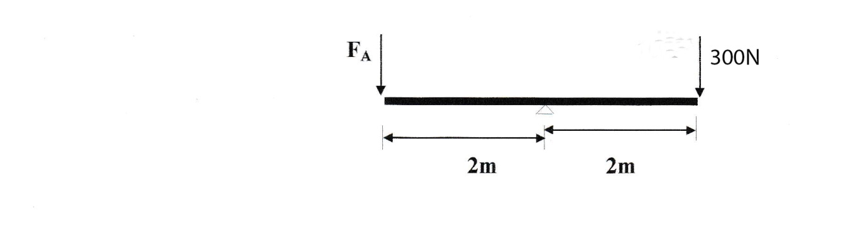

Clockwise moments = Anticlockwise moments

300N x 2m = FA x 2m

600Nm = FA x 2m

600Nm = FA

2m

300N = FA

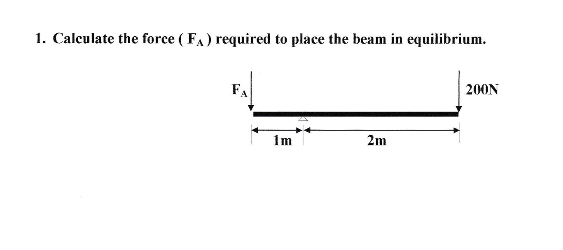

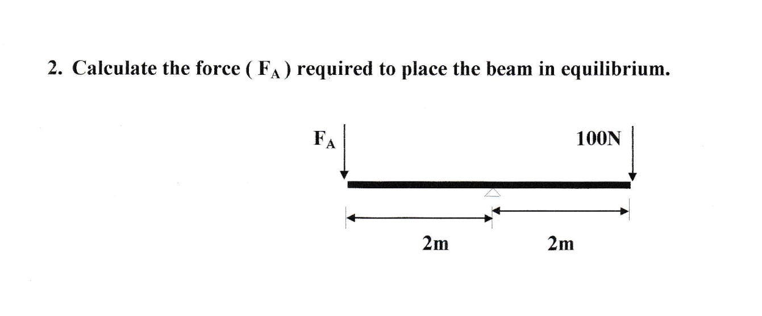

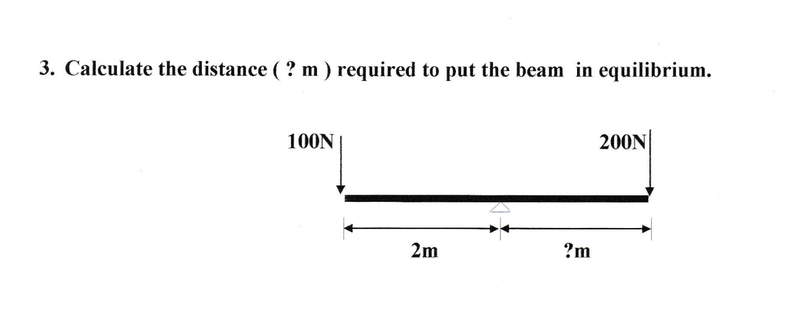

**Summary of your Knowledge and Understanding of this unit.**

|  |  |  |  |
| --- | --- | --- | --- |
|  |  |  | ***I can…*** |
|  |  |  | Understand the four types of motion |
|  |  |  | Construct basic mechanical systems |
|  |  |  | Understand the inclusion of an idler gear |
|  |  |  | Calculate gear ratios mathematically |
|  |  |  | Understand the principle of the worm and wheel |
|  |  |  | Construct a rack and pinion and understand its operation |
|  |  |  | Construct a crank and slider and understand its operation |
|  |  |  | Construct a cam and follower and understand its operation |
|  |  |  | Calculate the velocity ratio of a pulley drive |
|  |  |  | Calculate the force or distance required to place a lever in equilibrium |

**On a scale of 1 to 10 in which 1 is very poor and 10 is the best how do you think you performed.**

**Achievement**

**Effort**

**Behaviour**

**Completion of Unit Yes No Teachers Signature**: