St. Machar Academy
Homework 2
Logic Gates
Complete the truth table for the following gates

The Inverter
Input A | Output Z
0
1
Input A
Output Z

The AND gate
A | B | Z
0  0  1  1 | 0  1  0  1
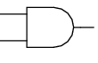
A

B
Z

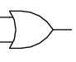The OR gate
A

B
A | B | Z
0  0  1  1 | 0  1  0  1
Z

The NAND gate
A | B | Z
0  0  1  1 | 0  1  0  1

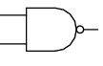
A

B
Z

A | B | Z
0  0  1  1 | 0  1  0  1
The NOR gate
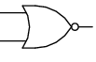
Z
A

B
Z

