Companies, Designer and Photographers who use CAG and CAD must protect themselves through Intellectual Property Rights.
- Identify the IPR that a photographer would apply to their images. 1 mark
___________________________________________
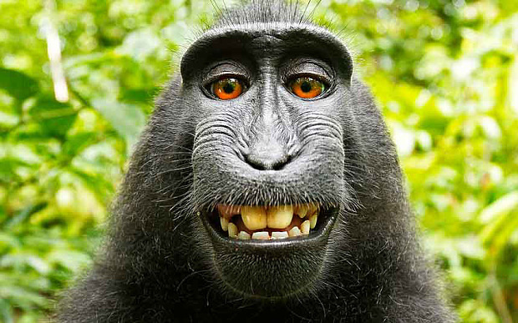

Try to find out why this monkey image caused controversy in America.

- To make it known to the public that a photographer owns this image and does not want it used without their permission, what could the photographer do to the image? 1 mark
___________________________________________

- Third parties such as publishing houses often see photographs or images that they wish to use however they do not have the intellectual rights to the image. How would they be allowed to use the image? How frequently could they use the image and would they be allowed to share the image with other companies? 5 marks

___________________________________________________________________________________________________________________________________________________________________________________________________________________________________________

