The first image below was an early working rough; the second is a final copy. Identify 5 new DTP features that have been made between the first and the second and explain the impact they have on the page.
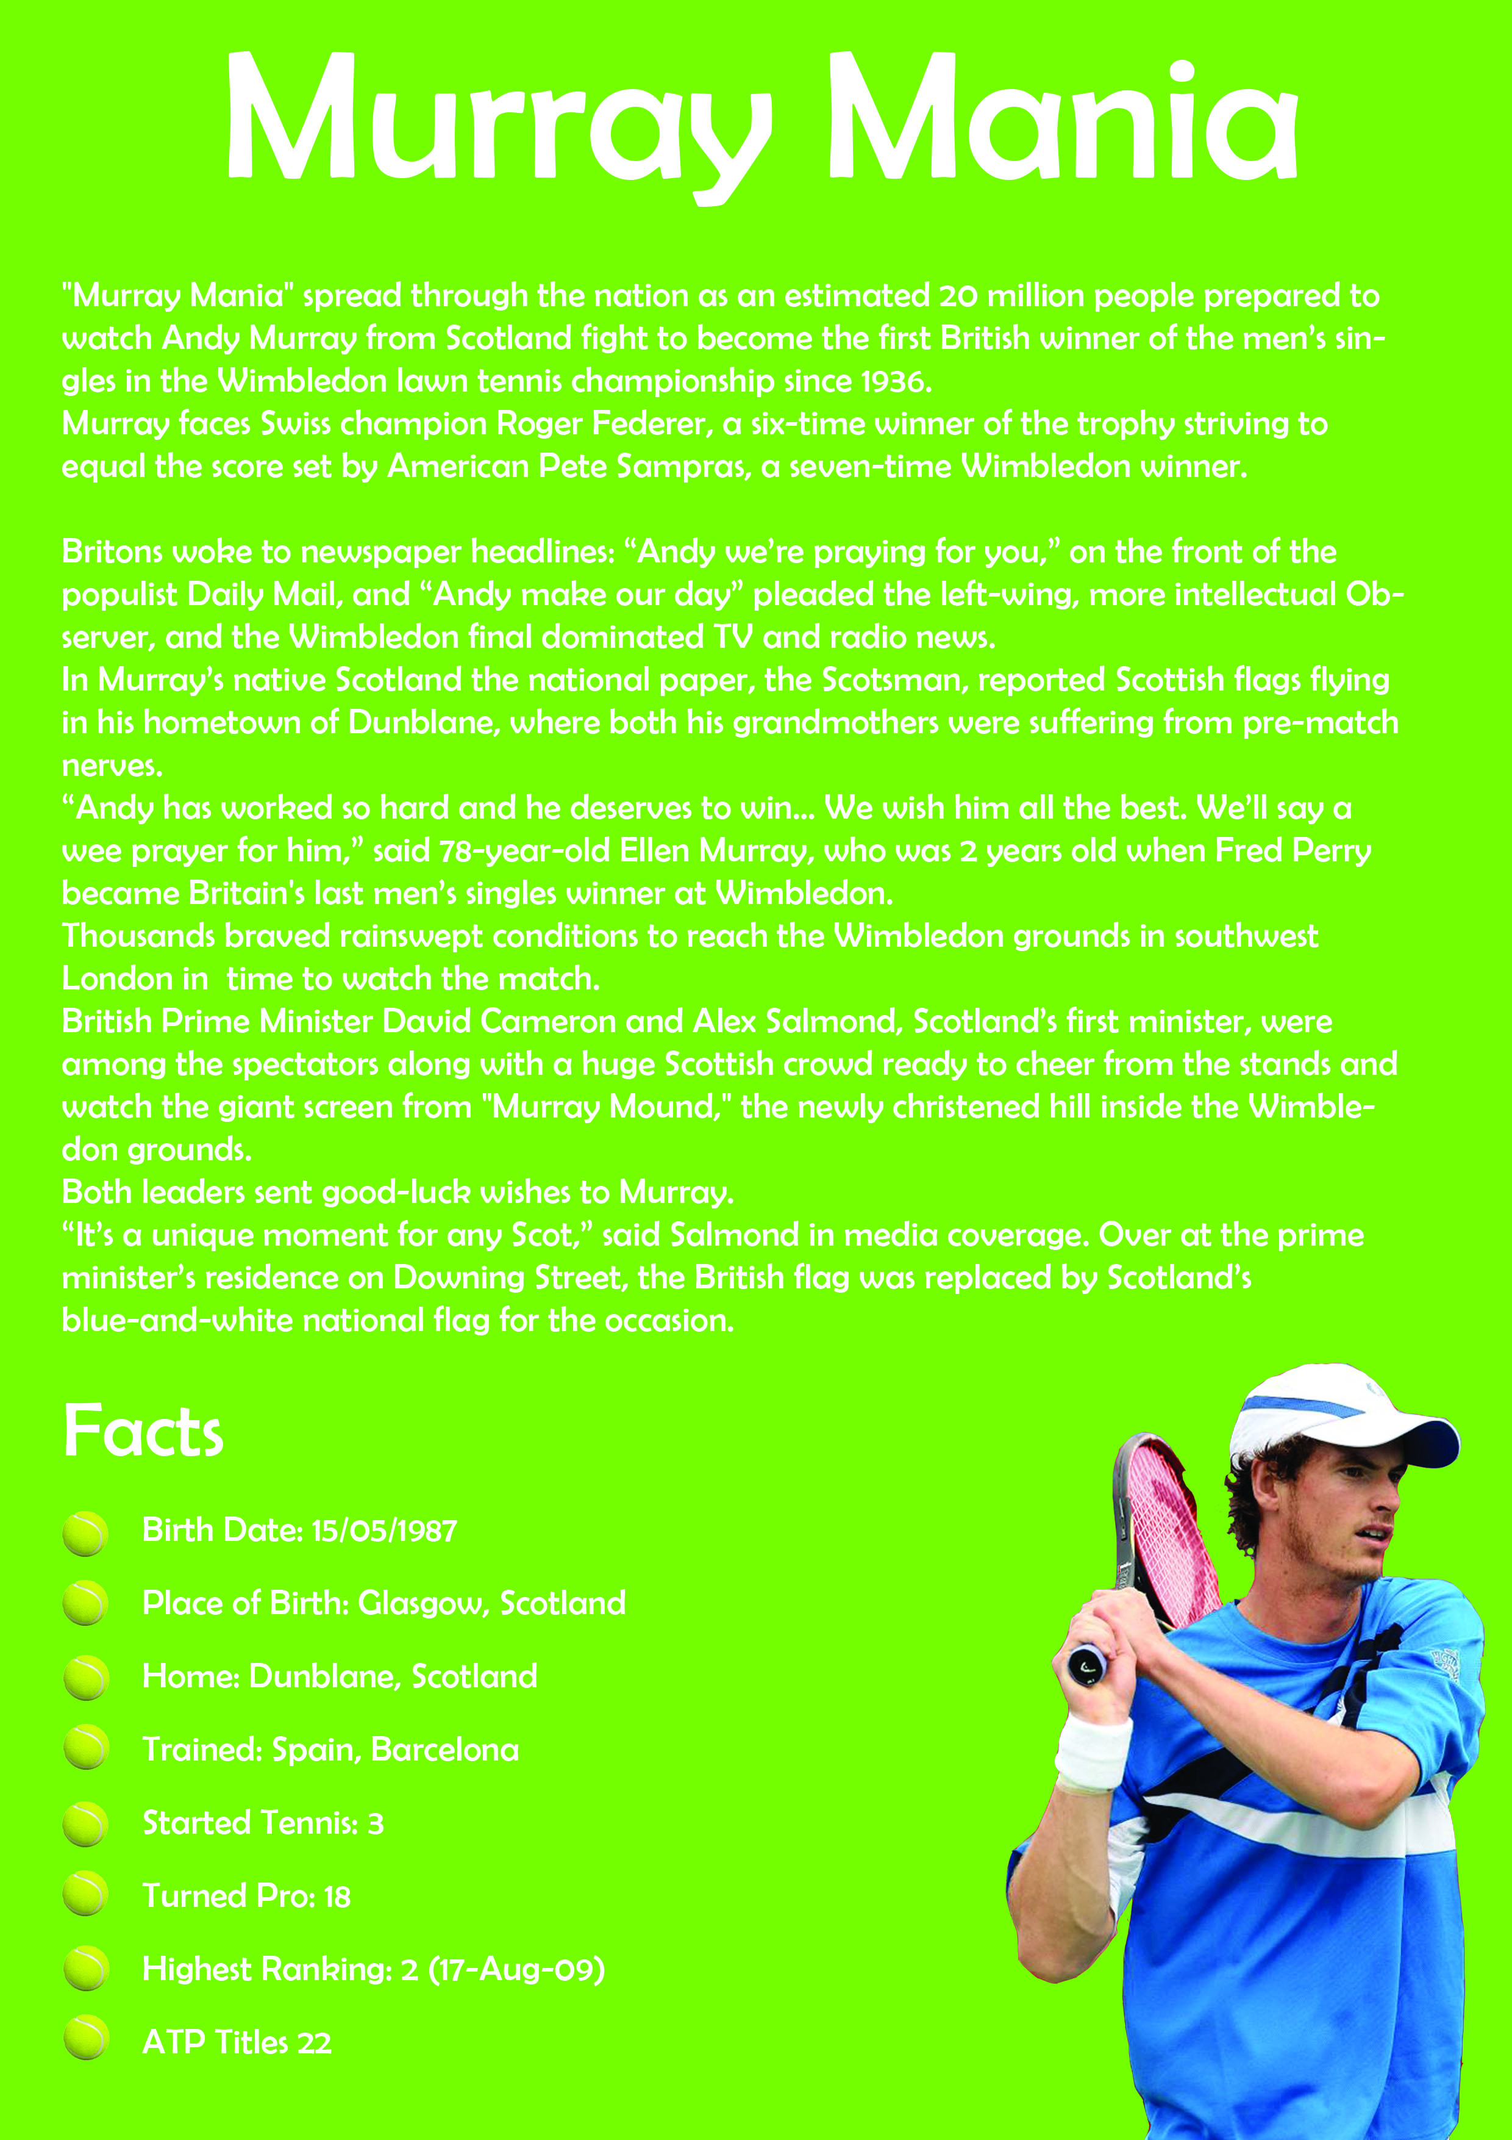
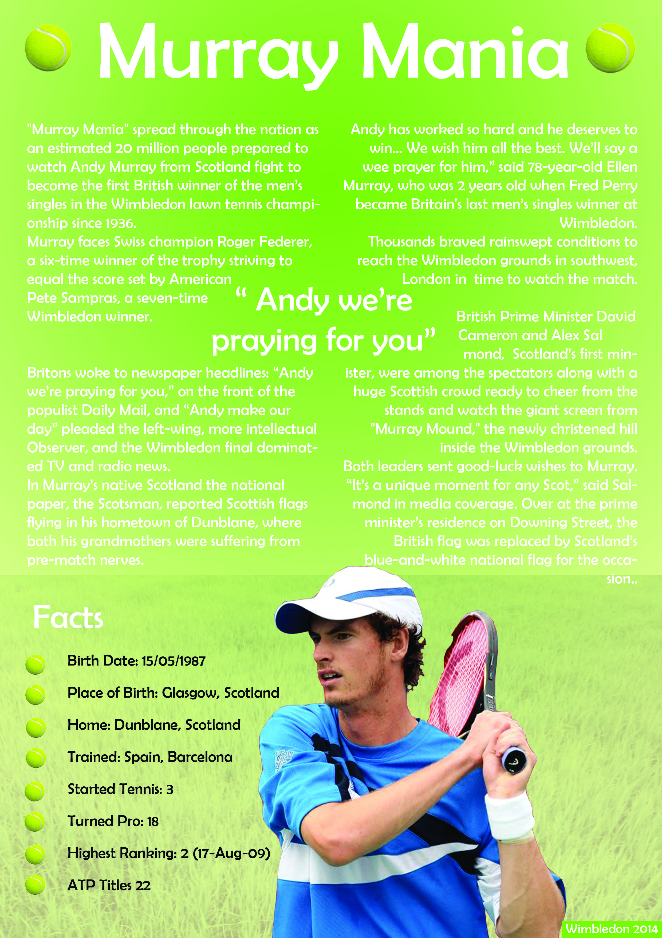
Final Idea
Working Rough

