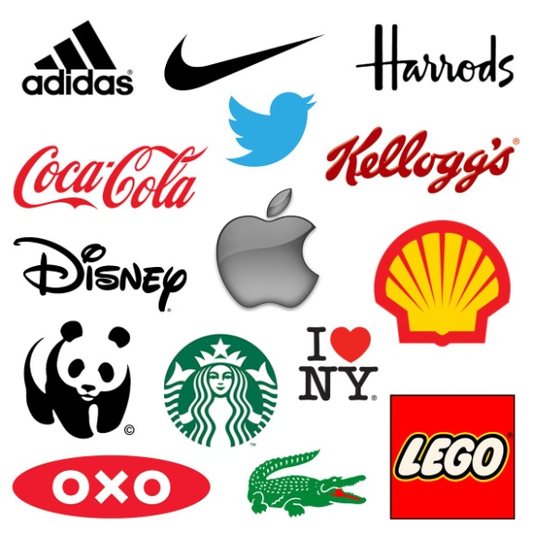
Intellectual Property Rights is also applied to logos.
- Identify what IPR would be applied to a logo? 1 mark
______________________
- Identify when used what type of IPR the logo turns into? 1 mark
______________________

- Explain within a branding sense, what benefits applying IPR would have to a company. 3 marks

______________________________________________________________________________________________________________________________________________________________________________________________________________________________________________________________________________

- Occasionally companies further their branding by using Pantone Colours. Explain what a Pantone colour is and how it aids branding. 4 marks

______________________________________________________________________________________________________________________________________________________________________________________________________________________________________________________________________________
____________________________________________________________________________________________________________

