St. Machar Academy
Homework 4
Gear Ratios
- In the table below insert all the gear ratios.
Number of teeth on Driven Gear | Number of Teeth on Driver Gear | Gear Ratio
60 | 30
100 | 25
50 | 100
30 | 30
60 | 10
10 | 1

- Calculate the gear ratio of the compound gears shown below.
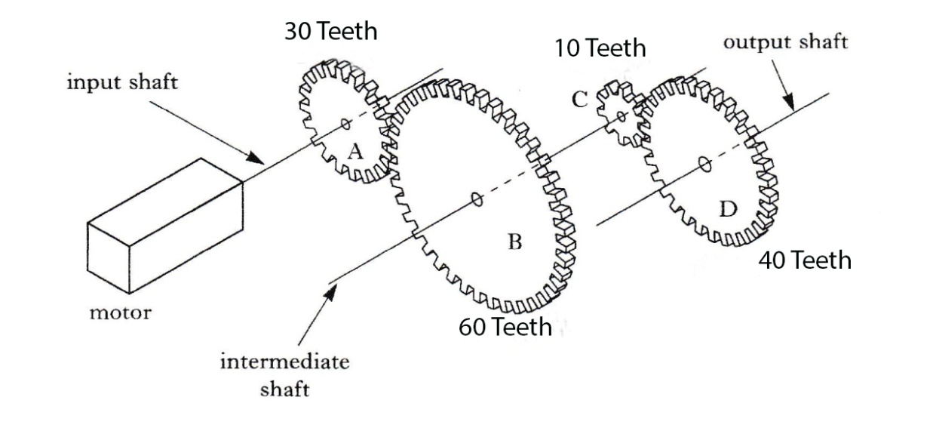
Write your answer on the back of this sheet
TOTAL MARKS 7

Example for Homework
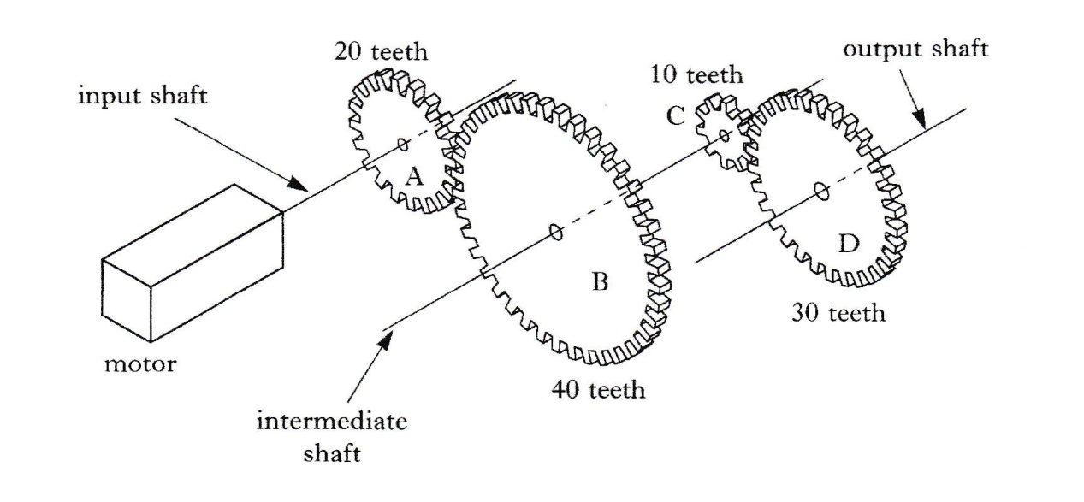

To calculate the gear ratio of the above example:

G.R. = Number of teeth on driven gear

Number of teeth on driving gear

Between A & B = 40 = 2 Between C & D = 30 = 3

20 1 10 1

Because B and C are on the same axle then they must be going the same speed

The Gear Ratio between D & A is found by multiplying: 2 x 3 = 6

1 1 1

Therefore we have a gear ratio of 6:1. Meaning the driven gear D is six times faster than the driver gear A.

If you only have two gears you only need to do the calculation for A & B

