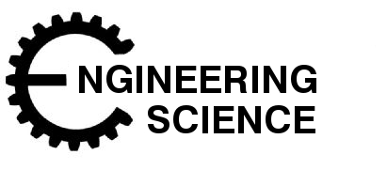

**Energy**

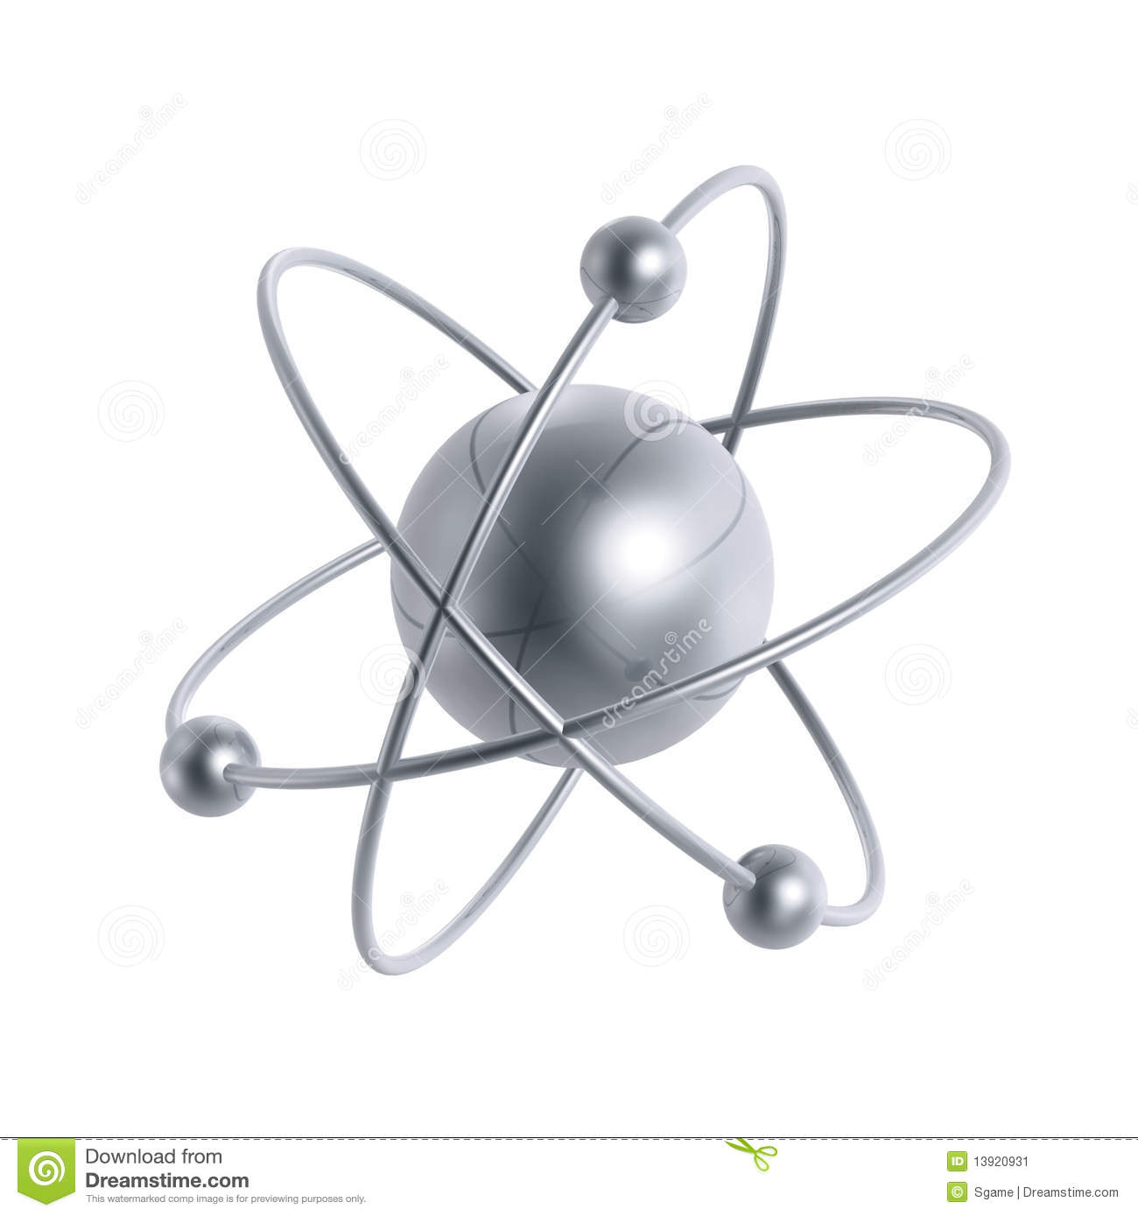

**What is Energy?**

Energy is all around us and comes in many forms.Energy fuels our cars, our homes and buildings, or bodies, and our economy. **‘Energy is the ability to do work.’** **Energy can be converted from one form to another, but it CANNOT be created or destroyed.**

Listed below are the main forms of energy:

**Sound                                  Heat                            Light**

**Electrical                             Chemical                         Nuclear**

**Work                             Kinetic (movement)       Potential (stored)**

##### *Where does it come from?*

###### **All the energy found on earth in the food we eat and the fuels we use originally comes from the sun.** **There are 3 main ways in which the suns’ energy is found on earth:**

**Biosphere Fuels and Fossil Fuels -coal, oil, natural gas and peat.**

Photosynthesis is where plants make chemical compounds that store a lot of energy and can be made available to the Earths living system or biosphere. Fossil fuels (coal, oil, natural gas, peat) also store the suns energy because they are made from materials that were once living. They too are biosphere fuels.

**Renewable Energy - wind, wave, solar, tidal, hydro, geothermal.**

We can capture the suns energy every day through the use of solar panels, wind turbines, wave and tidal power stations. This type of fuel can be used over and over again as long as the sun shines and the Earth is still alive. This is also known as ‘alternative Energy’. With technological advancements, this is becoming more widely used, with Scotland quickly becoming one of the world leaders.

**Nuclear Fuels - fission and fusion**

This energy comes from the ‘Big Bang’ when radioactive atoms were left behind. Uranium is mined and is ideal to use as an energy source as a huge amount of energy can be created from a small amount of ore. The Nuclear power station splits the uranium atoms to speed up the decay process and capture the energy. This is known as Nuclear Fission. The heat produced is used to produce steam, which in turn is used to turn a generator and produce Electricity. This is a very dangerous method to get energy though and creates a lot of extremely dangerous waste, however the amount of energy that can be gained from nuclear sources is incredibly large making it an attractive option.

**National Grid and the Changing Forms of Energy Supply**

**Total primary energy consumption by fuel, UK, 1970 to 2013**



The diagram below shows the way in which electrical energy arrives at our home via the national grid. The power generated in the station can come from many different types of energy for example nuclear, hydro and solar. Some homes generate their own energy (power), they can also gain income (money) by giving their excess to the national grid.

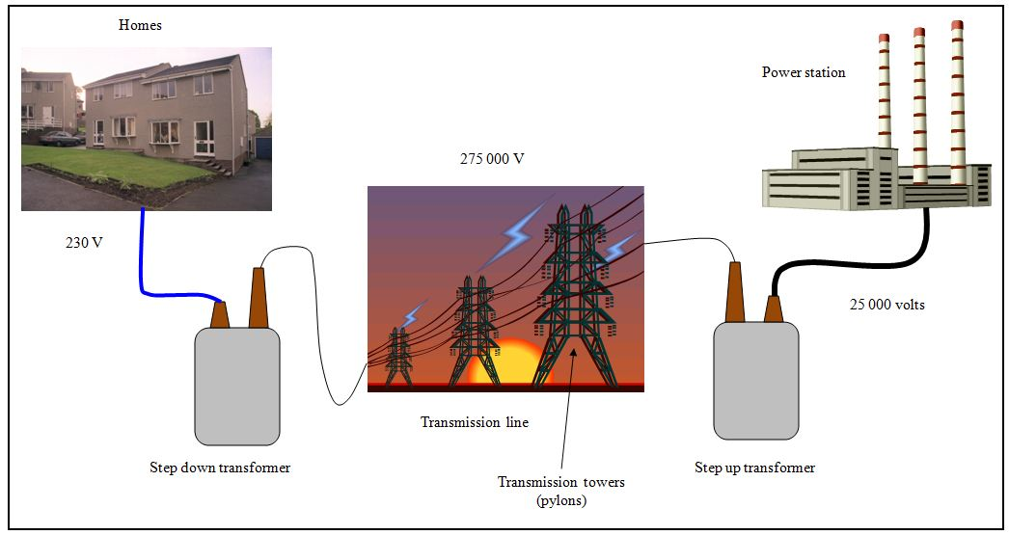

**Assignment 1 - Collaborative learning task**

For this task you will be working in groups of 4. Each member of your group will be given a topic to research and produce a powerpoint presentation for. At the end of the activity each member will present to the group what they have learned, and you will be asked to write notes in the space below. Finally your group will debate which form of energy extraction  you think is best.

**Fossil Fuels - coal, oil, gas and peat                            Researcher:**

**Renewables - Solar, hydro and geothermal                     Researcher:**

**Renewable - Wind, wave and tidal                              Researcher:**

**Nuclear - fission and fusion                                     Researcher:**

**Energy Calculations - Work (Ew)**

As you move through S4, 5 and 6 you will learn how to calculate various form of energy including kinetic energy (Ek), potential energy (Ep), electrical energy (Ee) and heat energy (Eh). The first form of energy you will learn to calculate here is called work (Ew).

Work energy is used when a force is exerted to move an object from one point to another - lifting a weight, pushing a car.

Consider the example to the right.

Force (F)

fig2afig2a The amount of work you will do will depend on

how difficult the car is to push (the size of

Distance (d)

the force) and on how far you have to

push it (the distance).

The amount of work done can be

calculated using the following formula:

Ew = F x d

Ew

d

F

Ew is work done, measured in Joules (J)

F is force, measured in Newtons (N)

d is distance, measured in metres (m)

**Worked example - Work (Ew)**

**Step 1 - write down known values**

F = 6000N        d = 25m              Ew = ?

**Step 2 - construct equation from triangl**

Ew = F x d

**Step 3 - solve**

Ew = F x d

     = 6000 x 25

     = 150000J

     = 150kJ

In the example shown a force of 6kN is applied to move the car a distance of 25m. Calculate the total work done to move the car.

**Assignment 2 - Work done (Ew)**MCj02909300000[1]

Complete these questions. Remember to show all your working and units!

1.Calculate the amount of work done when a force of 150 newtons is used to pull a bag of sand 20 metres.

2.In lifting an engine out of a car a mechanic uses a block and tackle. How much work is done if a force of 500N is used to pull the rope a distance of 4m?

3.During the loading process, a fork lift truck lifts a pallet of bricks a height of 2m. The force exerted by the lift is 7.2kN. How much work is done?

4.In the scenario in question 3 the work done by the motor is higher than expected, suggest a reason for this.

5.During a test on the Edinburgh tram network it is discovered that the amount of work done to move the tram along a 150m stretch of track is 29kJ. What force does the tram motor exert?

6.An offshore drilling rig exerts a constant drilling force of 63kN and after a certain period the energy consumed is 192kJ. How far has the drill travelled?

7.It is discovered that the drill has not travelled as far as expected as energy has been lost. In what forms has the energy been lost?

8.In a manufacturing plant a pneumatic cylinder exerts a force of 183N to stamp markings into metal. The depth of the stamp is 3mm. How much work is done?

**Energy Calculations - Potential Energy (Ep)**

fig2b

When work is done to lift an object the

force applied must be enough to overcome

the force exerted downwards by gravity.

This force is known as the weight.

When the object has been lifted to

a certain height it has potential energy (Ep).

To calculate the total amount of energy used

to lift an object there are 2 methods

that can be used:

A winch raises a lift of mass 100kg a height of 20m. Calculate the minimum amount of energy used to raise the lift

**Method 1 - calculate weight then work done (Ew)**

W= m x g = 100 x 9.8 = 980N

Ew

w

Ew= F x d

d

F

g

m

= 980 x 20 = 19600 J

w is weight in Newtons (N) Ew is work done in Joules (J)

F is force in Newtons (N) m is mass in kilograms (kg)

g is gravity (9.8) d is distance in metres (m)

**Method 2 - calculate potential energy (Ep)**

Ep is potential energy in Joules (J) Ep = m x g x h

Ep

m is mass in kilograms (kg) = 100 x 9.8 x 20

g is gravity (9.8) = 19600 J

m

g

h

h is height in metres (m)

MCj02909300000[1]You should see that both methods give exactly the same answer. This tells us that all the work done to raise the lift has been converted into potential energy when the lift is at the top. This also means you can use the method you find easiest!

**Assignment 3 - Potential Energy (Ep)**

Baggage handlers at an airport place suitcases onto a conveyor belt which lifts them up to the hold of an aeroplane as shown below. Calculate the potential energy stored when a 20kg case is moved up the belt.

1.



2. At what height must a drum of mass 100kg be suspended above the ground if it possesses 4kJ of potential energy?

3. How much potential energy is stored in a reservoir holding 1800 litres of water at a height of 260m? (1 litre of water has a mass of 1kg)

4. Metal piles are driven into the ground using a pile driver. The driver is raised to a height of 5m above the ground and is then released. Calculate the weight of the driver if the potential energy stored when it has been lifted is 9800 Joules.

5. A fairground rollercoaster has many high and low points on the track. At the highest point on the ride the track is 50m above ground. At the lowest point the track is 5m above ground. Calculate the potential energy for a person of mass 80kg at the highest point, the lowest point, and the change in potential energy between these two points.

6. If a steeplejack has a potential energy of 2000J when he scales a ladder to a height of 10m, what amount of potential energy will he possess at a height of 15m?

**Energy Transfers and Losses**

The law of conservation of energy states that **energy cannot be created or destroyed, it can only be transferred from one type to another.** The food we eat has grown because of the energy it received from the sun as light and heat. This caused a chemical reaction allowing plants and animals to grow, storing the energy within them. In eating the food we are able to extract the energy from our food, storing it in our bodies as chemical energy which in turn allows our muscles to move. This energy transfer can be shown like so:

Kinetic

Muscles

Digestive system

Food

Heat

Light

Chemical

Kinetic

Chemical

Chemical

MCj02909300000[1]

Page 2 lists the different forms of energy. Ask your teacher if there are any you’re unsure about.

In an ideal world systems would be 100% efficient, meaning all the energy put into the system would be converted to energy at the output. In practice however, nothing is 100% efficient as some energy will be lost. In today’s society engineers and scientists are constantly striving to achieve higher efficiencies. Consider the example below:

Electrical

Light

Light bulb

**The Ideal Lightbulb**

In an ideal lightbulb all of the electrical energy supplied to the bulb will be converted into light energy. If this were the case the bulb would be 100% efficient.

**The Realistic Lightbulb**

In practice, a bulb cannot be 100% efficient as some of the electrical energy supplied is lost as heat and sound. That’s right, bulbs buzz! If we can reduce the amount of energy lost we increase

**The Realistic Lightbulb**

In practice, a bulb cannot be 100% efficient as some of the electrical energy supplied is lost as heat and sound. That’s right, bulbs buzz! If we can reduce the amount of energy lost we increase the efficiency of the bulb

Light

Heat

Sound

Light bulb

Electrical

Efficiency (η) can be calculated like this:                    **η = energy out /energy in**

Efficiency is always expressed as a percentage

**Assignment 4 - Energy Transfers**

Copy and complete the following systems diagrams showing the energy conversions taking place

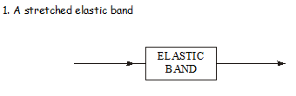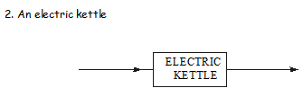

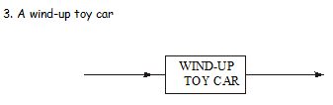

4. Water passing over a waterfall

WATERFALL

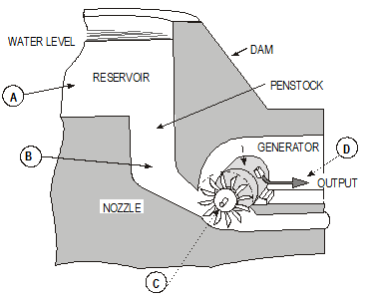

5. A hydro electric power station is shown.

State the form of energy at A, B, C and D

The diagram shows a method of extracting energy from the wind.

Identify the forms of energy at A (wind turbine), B (generator), C (pump), D (water tank), E (water wheel) and F (generator)

Describe where energy is lost in this system and what could be done to reduce these losses.

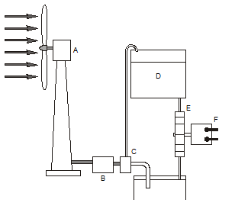 6.

7. The diagram below shows the main sub-systems in a hydro- electric power station. Complete the diagram to show how much energy is transferred between each sub-system. Calculate the efficiency of the power station.

Energy lost 44KJ

Energy lost 18KJ

Energy lost 20KJ

Generator

Potential energy

500kJ

Generator

Turbine

Reservoir

ElectricalEnergy

KJ

Kinetic Energy

KJ

Kinetic Energy

KJ

8. In your own words describe why the efficiency of a system is always less than 100%

A deep fat fryer uses 2kJ of electrical energy every second, and takes 6 minutes to complete a cooking cycle. If the total amount of heat energy transferred to the cooking oil is 480kJ how efficient is the fryer?

9.

A new design for petrol engine gives an energy output of 520J and is 64% efficient. How much energy does the fuel supply to the engine?

10.

**Calculating Power**

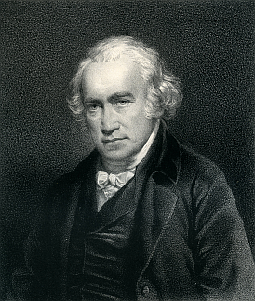

Power is a measure of the rate of energy transfer. It gives an indication of how quickly it is changed or consumed.

The units of power are Watts (W) after the famous Scottish inventor and mechanical engineer James Watt.

P is power, measured in Watts (W)

E is energy, measured in Joules (J)

t is time, measured in seconds (s)

E

P

t

**Worked example - Power**

MCj02909300000[1]

If an electric lightbulb uses 60kJ of energy in 10 minutes, what is the power rating of the bulb?

**Step 1 - write down known values**

E = 60kJ = 60000J

t = 10 minutes = 600s

P = ?

**Step 2 - Construct equation from triangle**

P = E / t

**Step 3 - Solve**

P = E / t

  = 60000 / 600

  = 100W

1. An electric motor consumes 18kJ of energy in 1 minute. What is the power developed by the motor?

1. A car stereo system consumes 72kJ from the car battery during a 10 minute journey. What is the power rating of the car stereo?

1. A winch lifts a 500kg pallet of bricks to a height of 10m in a time of 15 seconds. Calculate the minium output power from the winch.

1. An electric heater is rated at 3kW. How much heat energy can the heater provide in one hour?

**Summary of your Knowledge and Understanding of this unit.**

|  |  |  |  |
| --- | --- | --- | --- |
|  |  |  | ***I can…*** |
|  |  |  | Explain where energy comes from. |
|  |  |  | Understand how the National Grid works |
|  |  |  | Explain the difference between fossil, renewable and nuclear. |
|  |  |  | Understand the difference between Kinetic and Potential energy |
|  |  |  | Use equations to solve problems with regards to Work Done |
|  |  |  | Use equations to solve problems with regards to Potential Energy |
|  |  |  | Understand the principle of Energy Transfer and Losses |
|  |  |  | Use equations to solve problems with regards to Power |

**On a scale of 1 to 10 in which 1 is very poor and 10 is the best how do you think you performed.**

**Achievement**

**Effort**

**Behaviour**

**Completion of Unit Yes No Teachers**