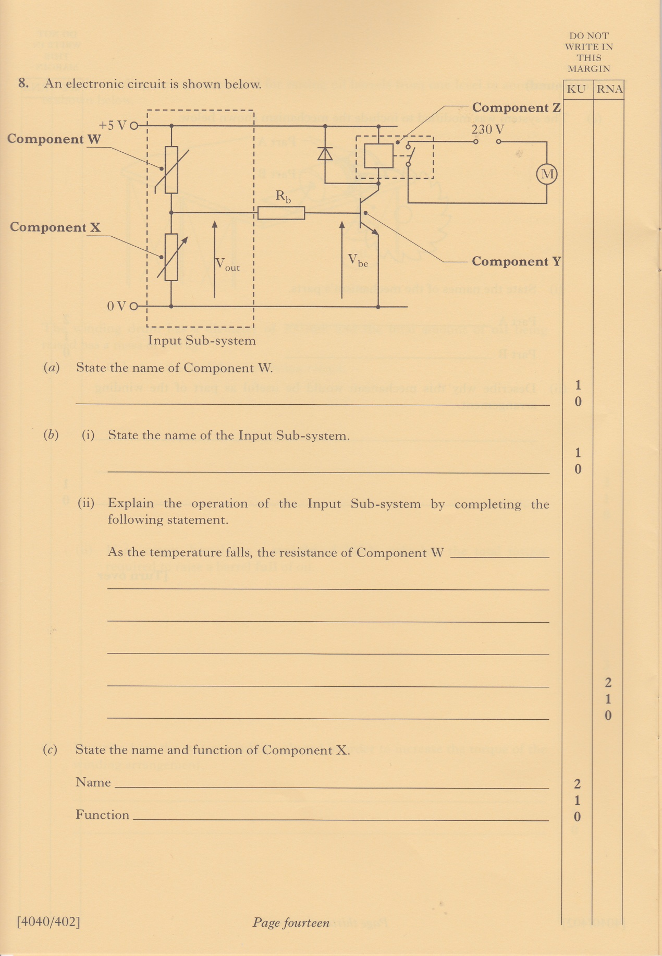

**National 5 Engineering Science**

**Homework 6**

**Understanding an electronic circuit**

