

**Electronics**

[](http://thumbs.dreamstime.com/z/man-resistor-18059520.jpg)

**Basic Circuits**

In this section we will look at electronics and how electronic devices work.

To help understand how electronic circuits work we will first look at basic circuits.

This is a basic circuit diagram for a light:

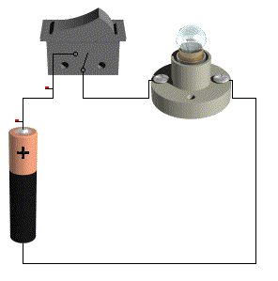It shows where the battery, the light and the switch will be placed and connects them all together to make a circuit.

If we were to draw detailed diagrams for each circuit we created the diagram would get pretty complicated. Engineers and electricians use symbols to explain how circuits work instead.

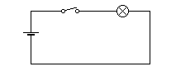Here is the same circuit below but drawn using symbols:

Switch

Bulb

Battery

We will use this circuit to help understand how to work out the Voltage, Resistance and Current going through the circuit.

Build this circuit using a 6V battery and a push switch.



6V

Now collect a multimeter.

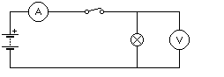Set the multimeter to **Voltage** and measure the voltage across the battery and the voltage either side of the bulb as shown below



**V**

6V

Write down the readings in the box below.

Now build this series circuit and measure the voltage either side of each bulb.

**V**





Bulb 1

6V

**V**



Bulb 2

Write down the Voltage for Bulb 1 and for Bulb 2.

Bulb 1:­­­­­­­­­­­\_\_\_\_\_\_\_\_\_\_\_\_\_\_\_\_\_\_\_\_\_

Bulb 2­­­­­­­­­­­:\_\_\_\_\_\_\_\_\_\_\_\_\_\_\_\_\_\_\_\_\_

1. What has happened to the Voltage? Why do you think this has happened? Write your answer in the box provided?

2. Remove one of the bulbs does the circuit still work when the switch is pressed.

Build this parallel circuit.

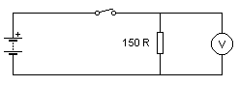

Measure the voltage across the two bulbs separately using a multi meter. Write down your answers in the boxes below.

Bulb 2:

Bulb 1:

Now measure the Resistance over each bulb, when the circuit is off. Write down your answer in the boxes below.

Bulb 2:

Bulb 1:

Now measure the Current over each bulb. Write your answers in the boxes below.

Bulb 2:

Bulb 1:

Remove one of the bulbs from the circuit and observe the other bulb does it remain on or off.

ANSWER:

## Electric current

Electric current is the name given to the flow of negatively charged particles called electrons. *Conventional current* is known to flow from positive to negative.



**Electric Circuits**

An electric circuit is a closed loop made up of electrical components such as batteries, bulbs and switches.

**Current( I)** is measured in amperes, usually referred to as amps (A). Current is the rate of flow of the electrons through the circuit.

Voltage is used to drive/push the electrons through components in the circuit. **Voltage ( V)** is measured in volts (v).

Resistance is the measure of how much voltage is required to let current flow in a circuit. **Resistance(R)** is measured in ohm s(Ω).

**What is the difference between AC and DC?**

AC means Alternating Current (Mains) this changes direction 50 times per second. It easier to use and is cheaper

DC means Direct Current (Battery) goes directly from one terminal to another

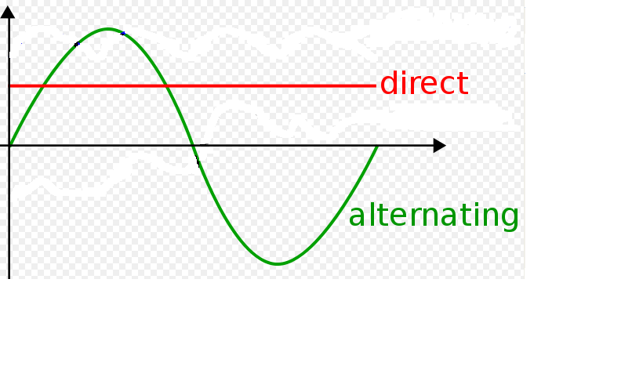

**Resistor Colour Code Chart**

When working with Resistors it is important that you select the correct one, otherwise the circuit may not work….or it could blow up!

Here is a colour code chart showing how you read the value of a resistor.

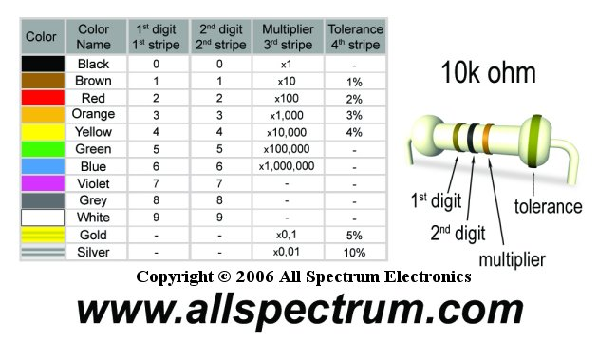



|  |  |  |  |  |
| --- | --- | --- | --- | --- |
| Resistor Value | Resistor Colours | | | Tolerance |
| 4K3 |  |  |  |  |
| 290 |  |  |  |  |
| 1500 |  |  |  |  |
| 10K |  |  |  |  |
| 47 |  |  |  |  |
| 120 |  |  |  |  |
| 200 |  |  |  |  |
| 5K5 |  |  |  |  |
| 880 |  |  |  |  |
| 850 |  |  |  |  |
| 7K5 |  |  |  |  |
| 62000 |  |  |  |  |

**Task**

Write down the colours for the following resistors:

**Electric Circuits**

These are some of the symbols you will need to remember when making/reading a circuit:

|  |  |  |
| --- | --- | --- |
| Name | Picture | Symbol |
| Single battery/cell | C:\WINDOWS\TEMP\\msotw9_temp0.bmp | C:\WINDOWS\TEMP\\msotw9_temp0.bmp |
| Multiple batteries/cells |  | C:\WINDOWS\TEMP\\msotw9_temp0.bmp |
| Voltage supply |  | C:\WINDOWS\TEMP\\msotw9_temp0.bmp |
| Resistors | C:\WINDOWS\TEMP\\msotw9_temp0.bmp | C:\WINDOWS\TEMP\\msotw9_temp0.bmp |
| Diodes | C:\WINDOWS\TEMP\\msotw9_temp0.bmp | C:\WINDOWS\TEMP\\msotw9_temp0.bmp |
| Light Emitting diodes (LED) | C:\WINDOWS\TEMP\\msotw9_temp0.bmp | C:\WINDOWS\TEMP\\msotw9_temp0.bmp |
| Push Switch | C:\WINDOWS\TEMP\\msotw9_temp0.bmp | C:\WINDOWS\TEMP\\msotw9_temp0.bmp |
| Bulb |  | C:\WINDOWS\TEMP\\msotw9_temp0.bmp |

**Breadboards**

Prototype circuit boards (often called breadboards) are used to build and test circuits. They have the advantage that they are non-permanent: the components can be moved and used again. This makes it easy to make alterations or corrections to circuits. Once a circuit has been proved on a prototype circuit board it is usually built by a more permanent method on stripboard or printed circuit board (PCB).

Here is a circuit Diagram



Here is how this circuit looks when attached on a breadboard.



**Construct this circuit on a breadboard.**

## Remember to connect the LED ‘the right way round’; that is the short lead (cathode) is connected to the zero volt line or negative battery terminal. The LED should light when the switch is pressed. You will also need to collect the correct resistor.

**Now measure the voltage across each component.**



**Measuring resistance**

When measuring resistance make sure that your circuit is **disconnected** from the supply, otherwise this will affect the reading. Do not touch the meter probes or the components when measuring, as your own electrical resistance will then be included.

Connect two resistors on a breadboard in series (as shown) measure the resistance across each then both together.



You should find that if Rtotal (or RT) is the total resistance measured across both resistors then the equation for adding resistances in a series circuit is:

**Rtotal = R1 + R2**

For three resistors in series

**Rtotal = R1 + R2 + R3**

and so on.

**OHM’s Law**

***Ohm's law*** states that the **current** through a conductor between two points is directly proportional to the **voltage** across the two points, and inversely proportional to the **resistance** between them

If you have two of the formulae then you can work out the third. (Just like your Speed Distance Time formulae in maths)

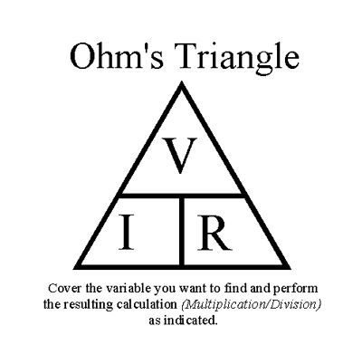

**V = IR**

**I =V/R**

**R =V/I**

**Task**

Calculate the total resistance (Rtotal = R1 + R2) and the current flowing through the circuit. You can verify your answer by physical measurement setting up the circuit and using a multimeter. Write your answer in the box provided.

R2

R1



Answer:

**Task**

Complete the following table:

|  |  |  |  |
| --- | --- | --- | --- |
|  | Voltage | Current | Resistance |
| Symbol |  |  |  |
| Unit |  |  |  |

Complete the table:

|  |  |  |
| --- | --- | --- |
| Voltage | Current | Resistance |
| 100V | 5A |  |
| 12V |  | 12Ω |
|  | 5A | 8Ω |
| 230V | 13A |  |
|  | 3A | 150Ω |
| 50V |  | 200Ω |

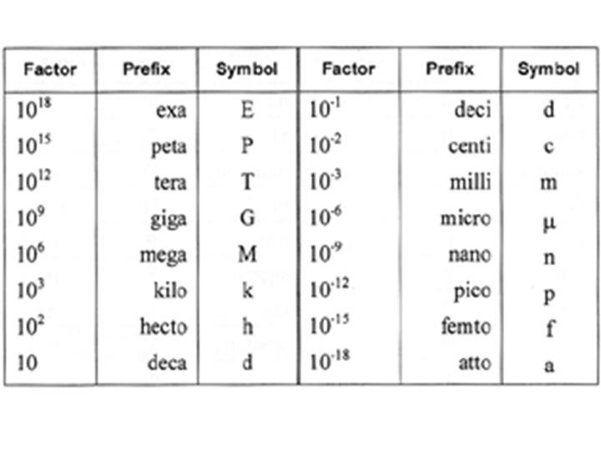**Decimal Prefixes.**

**Instead of writing lots of decimal points and numbers it is common practice to use prefix letters to show**

**Power in Electric Circuits**

Electrical power (P) is measured in watts (W). Electrical power can be converted into other forms of power using electrical circuits. A good example is an electric fire, which has a heating element- the power used in overcoming the electrical resistance can be converted into heat.

The power in an electric circuit depends both on the amount of current (I) flowing and the voltage (V) applied. To calculate the power in a circuit you can use the following rule.

P= IV

**Task**

Complete the table:

|  |  |  |  |
| --- | --- | --- | --- |
| Voltage | Current | Resistance | Power |
| 50V |  | 200Ω |  |
|  | 3.0A |  | 1kW |
|  | 0.5A |  | 2.5W |
| 250V |  |  | 62.5W |

Remember k means 1000

Remember to write the units

**Resistance in Series and Parallel Circuits**

**Resistors in Series:**

As resistors come in standard sizes, they are often connected in series to obtain a specific size that is required.

When resistors are connected in series you just add the resistance together.

**R total = R1 + R2**

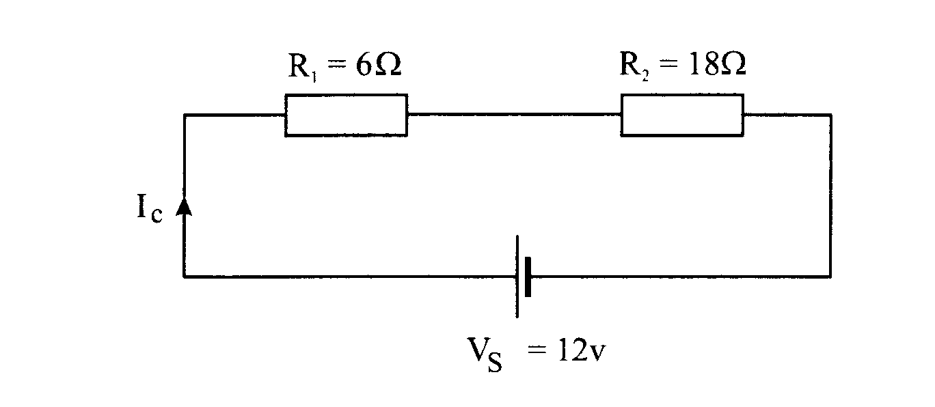

R1

R2

**Task**

Calculate the total current and resistance of each circuit



R1 = 10Ω

R2 = 17Ω



R1 = 75Ω

R2 = 21Ω



R1 = 50Ω

R2 = 25Ω



R1 = 50Ω

R2 = 250Ω

RT=

RT=

RT=

RT=

**Resistance in Parallel Circuits:**

When you have resistors connected in parallel the resistance needs to be worked out differently. As resistors come in standard sizes, they are often connected in parallel to obtain a specific size that is unavailable. The formula shown is used to calculate a resistance total in a circuit which only has two resistors.

**R1**

**R2**

Rt = R1 x R2

R1 + R2

**Task**

Calculate the total resistance of each circuit.

**R1 = 50Ω**

**R1 = 25Ω**

**R2 = 15Ω**

**R2 = 10Ω**

RT=

RT=

**R1 = 15Ω**

**R1 = 14Ω**

**R2 = 75Ω**

**R2 = 20Ω**

RT=

RT=

**Input Transducers**

Input transducers are devices that convert a change in physical conditions (for example a thermistor, LDR, or variable resistor) into a change in resistance and/or voltage. This is then processed by a voltage divider circuit.

**Voltage Divider**

If an input transducer changes its resistance as the physical conditions change, then the resistance change has to be converted into a voltage change so that the signal can be processed. This is normally done using a voltage divider circuit. A typical voltage divider circuit is shown below.



Vout

Vout = R2 x Vs

R1 + R2

The circuit above consists basically of two resistors connected in series. If the value of R1 is changed the voltage across it will change, as will the voltage of R2. In other words, the resistors divide the voltage up between them….this is why it is known as a voltage divider.

**Example**

Vout = R2 x Vs

R1 + R2

Vout = 25Ω x 6V

10Ω + 25Ω

Vout= 25Ω x 6V

35Ω

Vout=4.3V

10ΩV

25ΩV

V out

0V

6VV

**Task**

Calculate the missing value for each of the following circuits.



V out

V out

V out

Circuit 1:

Circuit 2:

Circuit 3:



Circuit 1:

Circuit 2:

Circuit 3:

**Digital Switches**

Simple switches can be used in voltage divider circuits to give a digital signal (that is definitely on or off) to another part of a circuit. See the diagram below.



Different types of switch can be wired up to suit their application. A switch with its contacts wired apart when it is not operating is called Normally Open. A switch with its contacts wired closed when it is not operating is called Normally Closed.



**Analogue Input Transducers**

The two most common analogue input transducers are the thermistor and the light dependent resistor (LDR).

Thermistor – a thermistor is a device whose resistance varies with temperature. It is a temperature dependent resistor. There are 2 main types,

**Negative temperature coefficient (-t or NTC) - where resistance decreases as temperature increases. These are the most commonly used.**

**Positive temperature coefficient (+t or PTC) – where resistance increases as temperature increases.**

The circuit symbols for and typical characteristics of the two types of resistors are shown below,



**Light Dependent Resistor**

The LDR (sometimes called a photo-resistor) is a component whose resistance depends on the amount of light falling on it. Its resistance changes with light level in bright light its resistance is low (usually around 1K). In darkness its resistance is high (usually around 1M).



**Variable resistor (potentiometer)**

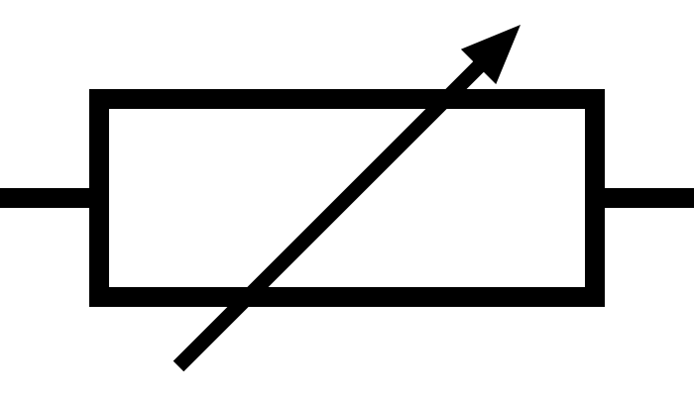A potentiometer/variable resistor can be used in a circuit as a voltage or current control device, for example a control. They are often used in voltage divider circuits to adjust the sensitivity of the input.

**Transistors (bipolar)**

The transistor is a semiconductor device. This means it is sometimes a good conductor and sometimes a poor conductor of electricity.

There are 2 types of bipolar transistor available: **pnp or npn**.

We will only deal with the **npn** type.

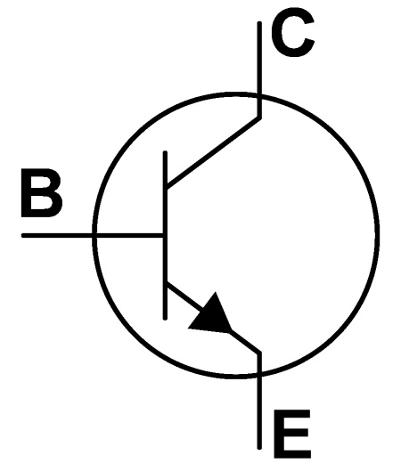

**B**

**E**

**C**

|  |
| --- |
| N |
| P |
| N |

C is the collector

B is the base

E is the emitter

Transistors are switches; they convert an analogue signal into a digital signal.

To allow voltage and current to flow from the collector to the emitter a voltage of **0.7v** or more must be applied across the base of the transistor. This is known as saturation.

**A transistor saturates at 0.7V.**

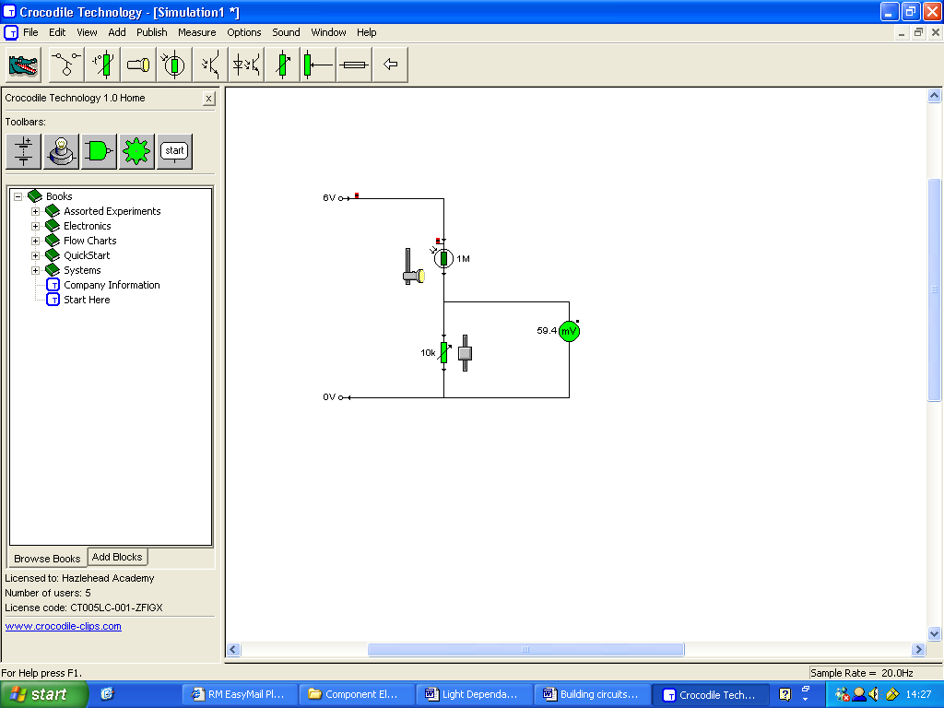

## *Light Sensor*

So if we wanted to make a light sensor we would have to swap the resistor and LDR over.

What you should have realised is that as it gets darker the LDR resistance increases and it therefore takes a larger share of the voltage.

Build and test the circuit to see what happens to the voltage as the light level changes.

**Use the breadboard below to plan your circuit before you build it.**

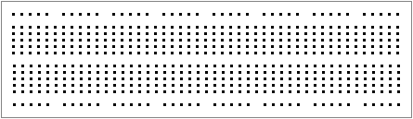

**Complete the sentence below.**

When light shines on the LDR the voltmeter reads….………..v.

When the LDR is covered the voltmeter reads………………..v.

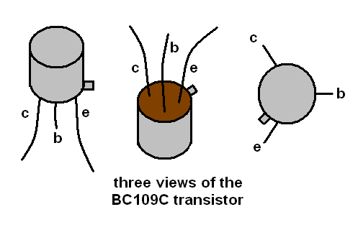

A transistor can have two basic jobs, it can be used as an electronic switch or it can be used as a current amplifier. This part of a system is known as the process sub system.

Build and test the circuit.

**Use the breadboard below to plan your circuit before you build it.**

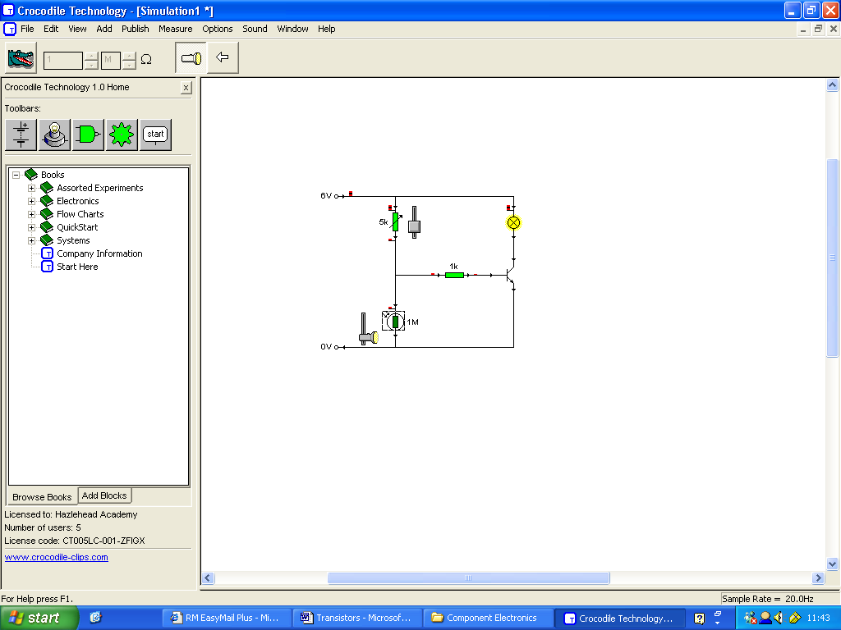

5v

To use a resistor in a real life situation we must connect the transistor (process) sub system to an input sub system (voltage divider circuit). The circuit opposite shows an automatic light which turns on when it gets dark.

Build and test the circuit.

0v

**Use the breadboard below to plan your circuit before you build it.**



**Complete the sentences below**

When light is hitting the LDR the bulb…………………………………

When there is no light hitting the LDR the bulb………………………

**Relays**

Although relays are often considered to be output devices, they are really output switches from electric or electronic circuits. These output switches are used as inputs for other circuits. In practice you can hear relays clicking on and off when a car’s indicators are used.

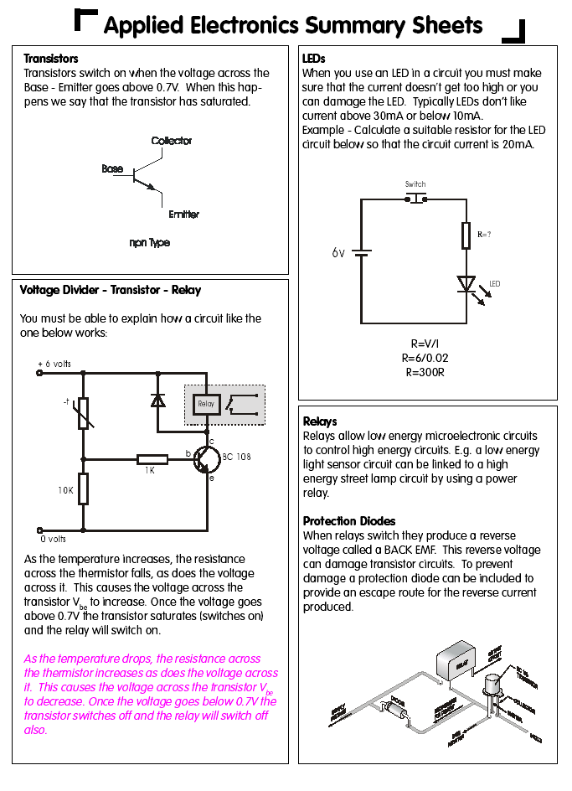



A relay has a coil that is energised and de-energised as the relay switches on and off. During this process the coil can generate a large reverse voltage (called back EMF). This reverse voltage can cause considerable damage to components, especially transistors. Sensitive components can be protected by the inclusion of a diode that provides a path for the current, caused by the reverse voltage, to escape.





**The relay is a very useful device and is particularly useful for energising devices that require substantial amounts of current.** It is perhaps the most commonly used switch for driving devices that demand large currents

# Single Pole Single Throw (SPST)

The SPST is used for any simple control system e.g. controlling a lamp, turning a heating element on etc.



**Double Pole Double Throw**



A DPDT relay is ideal for controlling a motor. As can be seen below the motor can run backwards or forwards.

# 555 Timers

An integrated circuit is simply an electronic package that contains a number of components on a silicon chip. The 555 Timer IC is versatile and can do many operations. 555 Timers can be used as a monostable device. This means that it is stable in only one state (normally off), that is, it jumps back to its initial state after a set time.



# 

# Capacitors

Capacitors are electronic components that store electricity for short periods of time within electronic circuits or networks. They are made from two metal plates or films separated by an insulator. In many capacitors, film is used so that the layers of metal film and insulator can be wound into a cylinder. Capacitors are especially useful in timer circuits with the 555-timer chip.



There are two basic types of capacitor normally used in timer circuits: electrolytic and polyester.

*Electrolytic capacitors* are polarity conscious. This means that they must be connected ‘the right way round’. The negative lead must be connected to zero volts with the positive terminal towards the higher voltage side of the circuit.

**It is very dangerous to reverse connect capacitors.**

Axial

capacitor



Radial

capacitor

*Polyester capacitors* are for small-value uses and can be connected without regard to polarity.



Capacitance in measured in farads, but because this is a very large measurement most capacitors are rated in μF (microfarads) or in nF (nanofarads).

555 timer − practical tasks

This 555-timer circuit is used to switch an LED on for a specific time when the chip is ‘triggered’. A typical application for this would be an egg timer.

Build the prototype circuit shown below.

## Instructions

* Briefly touch the bare end of the flying lead to 0 volts. The LED should light for a fixed period.
* Adjust the variable resistor to obtain the longest fixed time for which the LED will stay on.



* Change the capacitor to the values in the table below and record the maximum time period for which the LED lights.

|  |  |
| --- | --- |
| **Capacitor value (μF)** | **Maximum time** |
| 100 |  |
| 470 |  |
| 1000 |  |
| 2200 |  |
| 4700 |  |

* Draw a graph to illustrate your answers below
* Estimate what value of capacitor would give a time of approximately 60 seconds. Ensure you write down the capacitor value

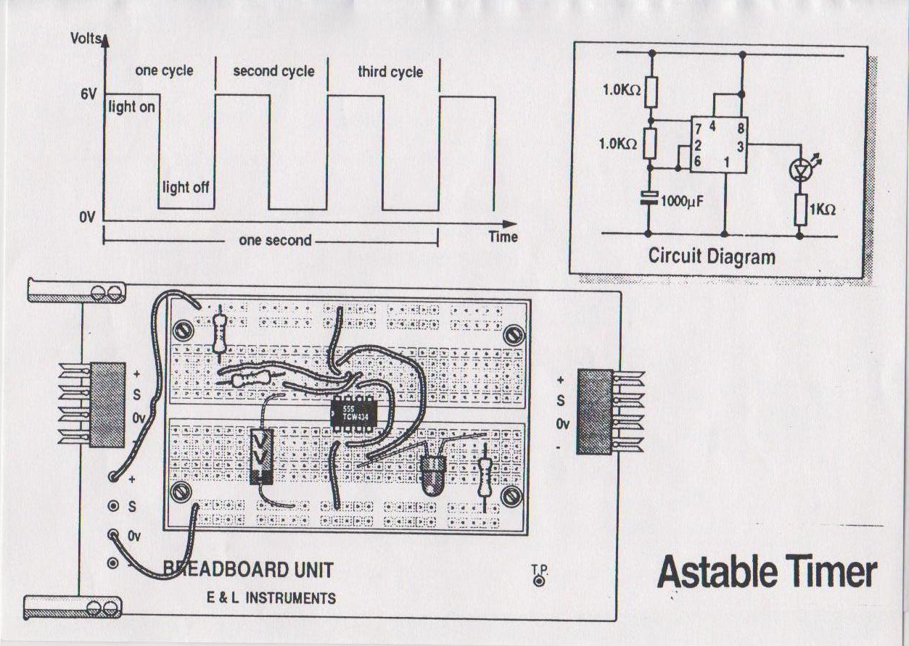Build the Astable Timer circuit shown below.

Observe the LED and calculate the time the light stays on for and the time it stays off. Write the times in the box below

Connect output leads from the circuit to the oscilloscope and observe the wavelength. Draw the wavelength your circuit produced below.

**Summary of your Knowledge and Understanding of this unit.**

|  |  |  |  |
| --- | --- | --- | --- |
|  |  |  | ***I can…*** |
|  |  |  | Build circuits in series and parallel |
|  |  |  | Work out Resistance Values |
|  |  |  | Understand the basic difference between AC and DC |
|  |  |  | Understand how a multimeter works on different settings |
|  |  |  | Use Ohms Law and the Power Equation to solve simple electronic circuits mathematically |
|  |  |  | Build and test a voltage divider circuit which includes an LDR |
|  |  |  | Build and test a circuit which incorporates a transistor |
|  |  |  | Build a circuit which will provide either a time delay or a light which will alternate between two states (ON/OFF) |
|  |  |  | Use a breadboard to build up various circuits correctly |
|  |  |  | Set up an oscilloscope to view the waveform of an electrical circuit |

**On a scale of 1 to 10 in which 1 is very poor and 10 is the best how do you think you performed.**

**Achievement**

**Effort**

**Behaviour**

**Completion of Unit Yes No Teachers Signature**: