Higher Graphic Communication
Homework 3 – British Standards 1

- Name the type of view shown  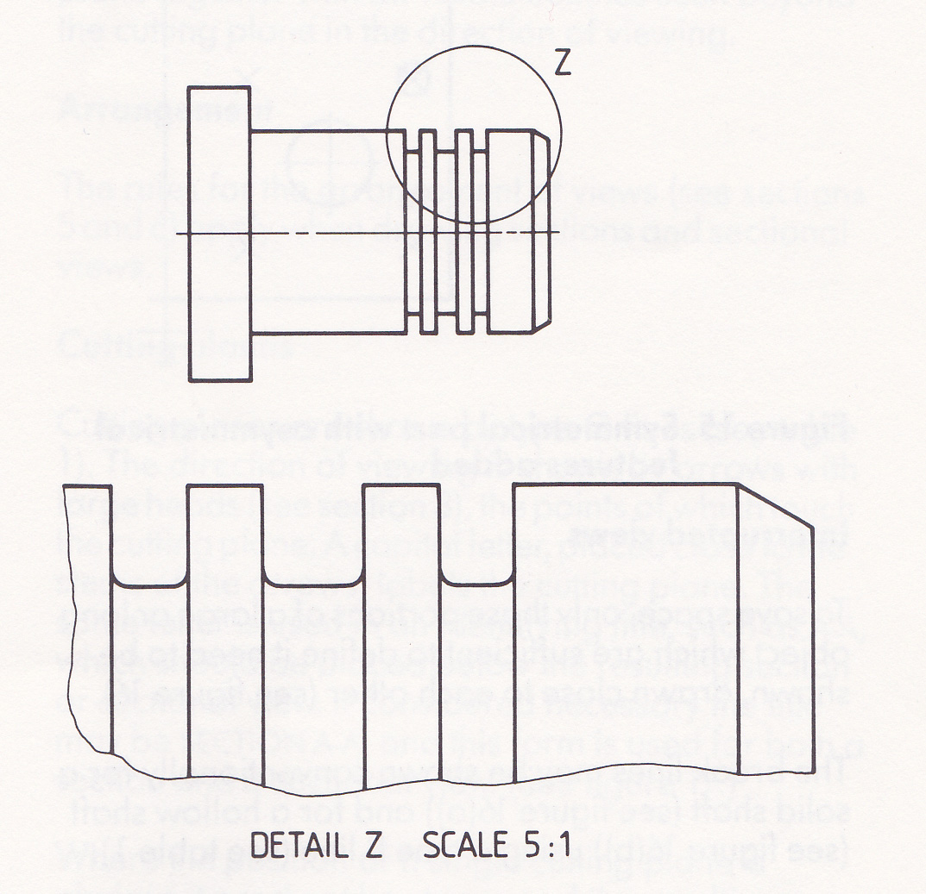 | - Name the two types of views shown  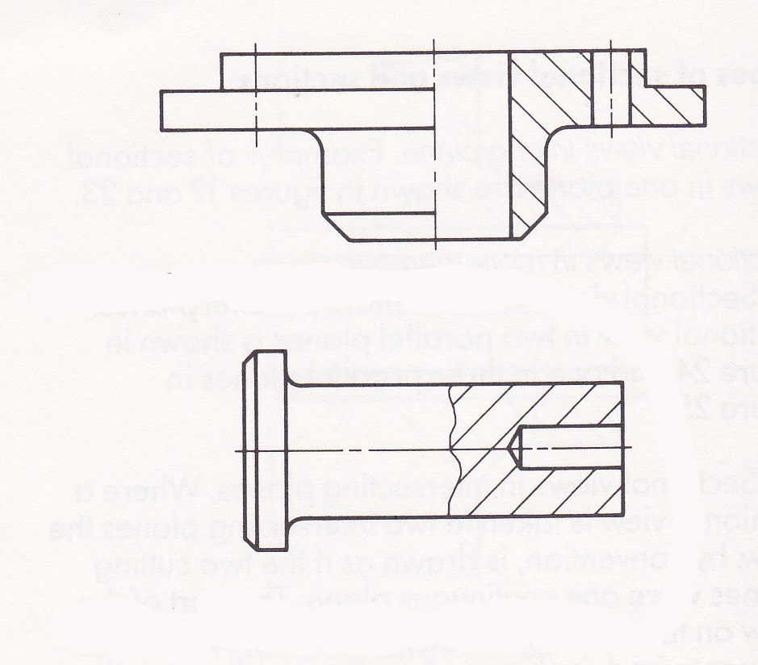
- Name the two types of views shown  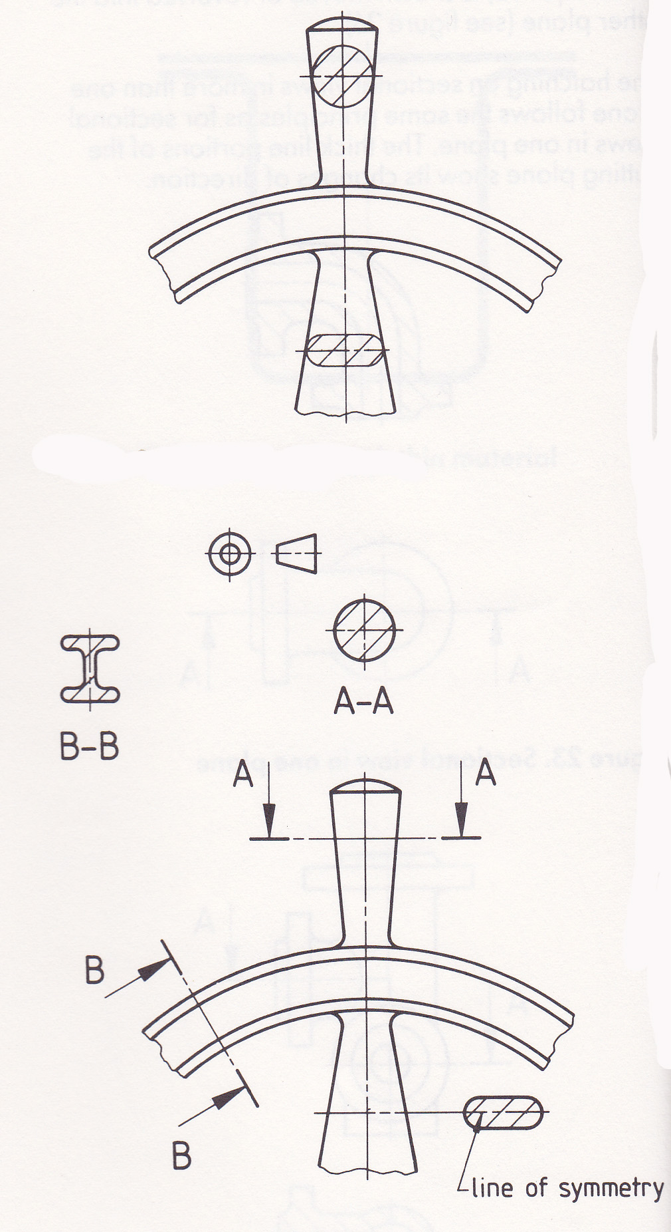 | 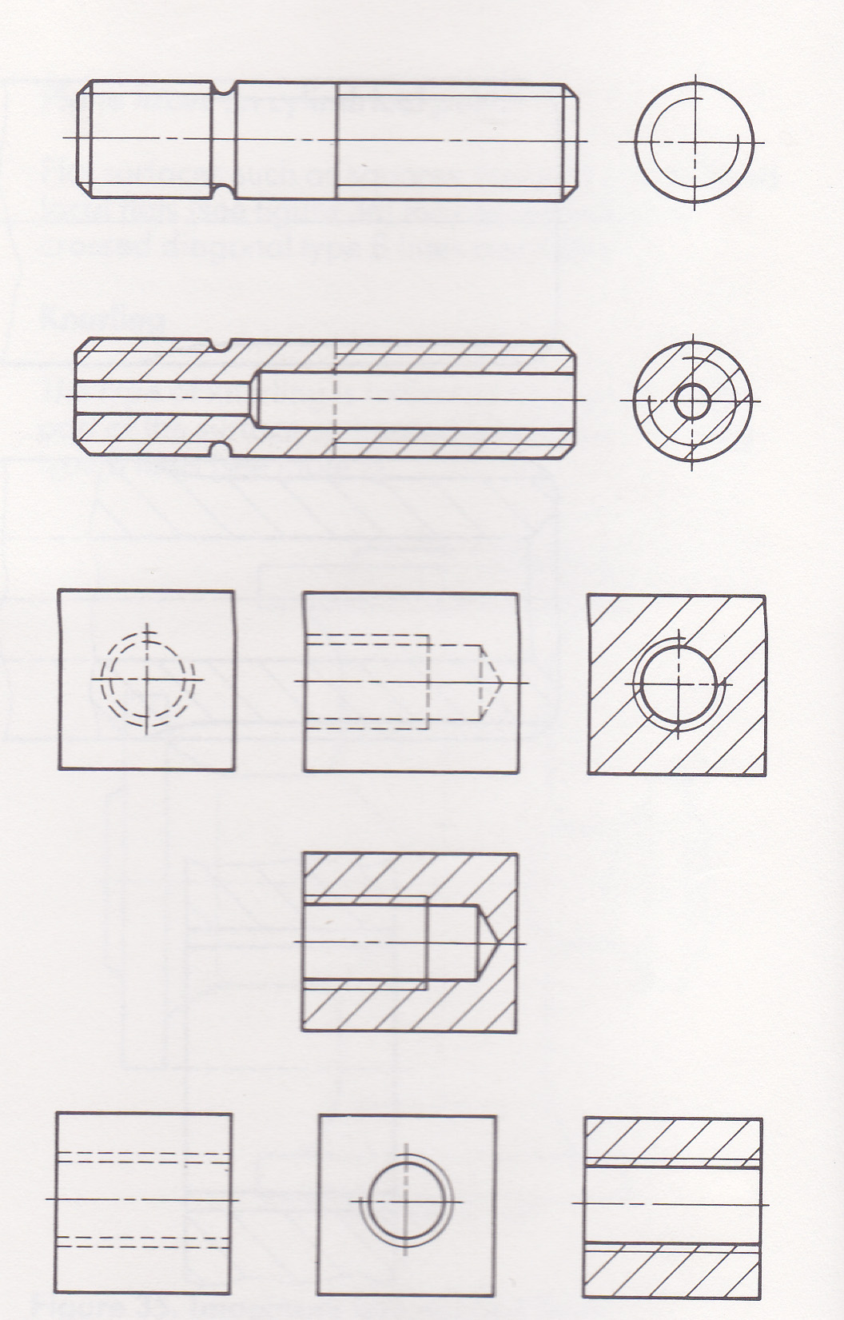  - What is represented in the drawings shown
- What is represented in the information shown below  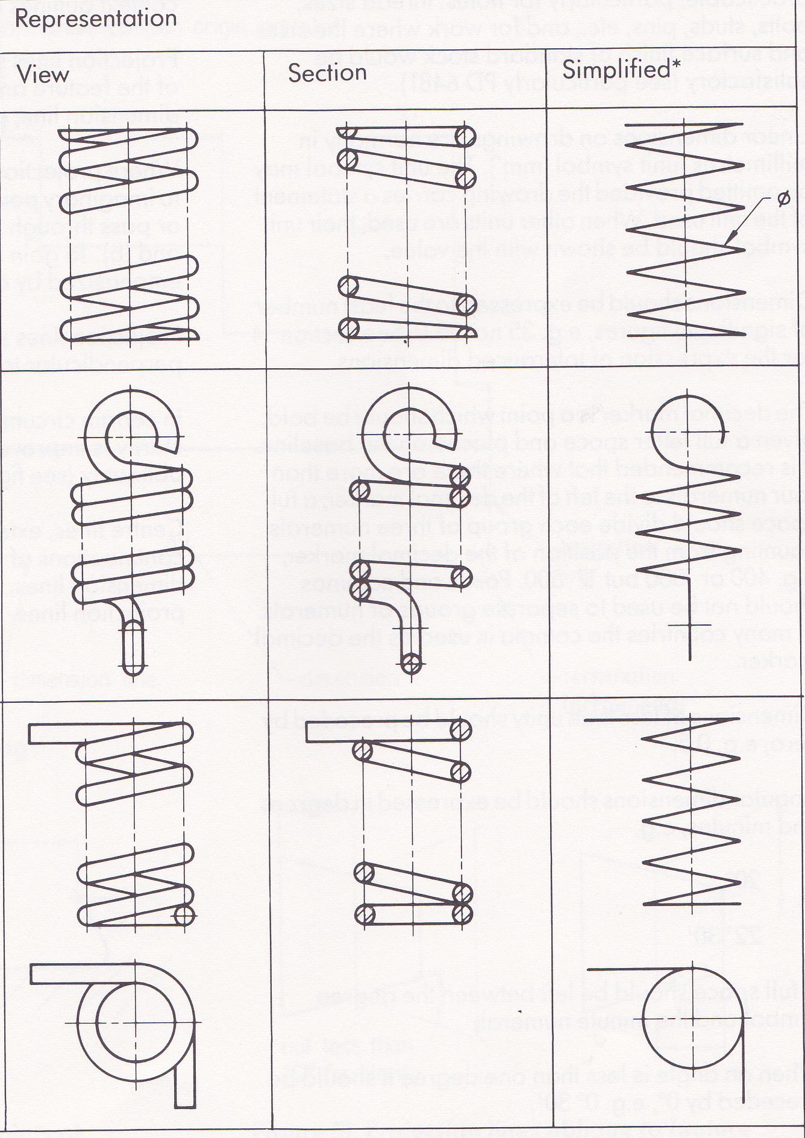 | - What is the name given to a feature at 45 degrees  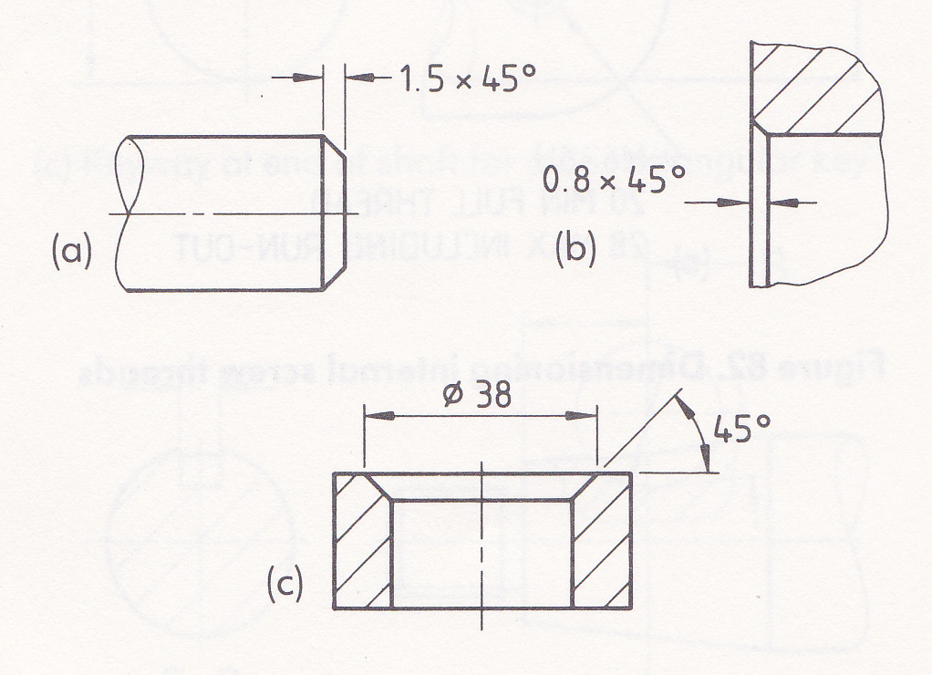

8 marks

